GUIDED INQUIRY AT WORK WITH THE AUSTRALIAN CURRICULUM
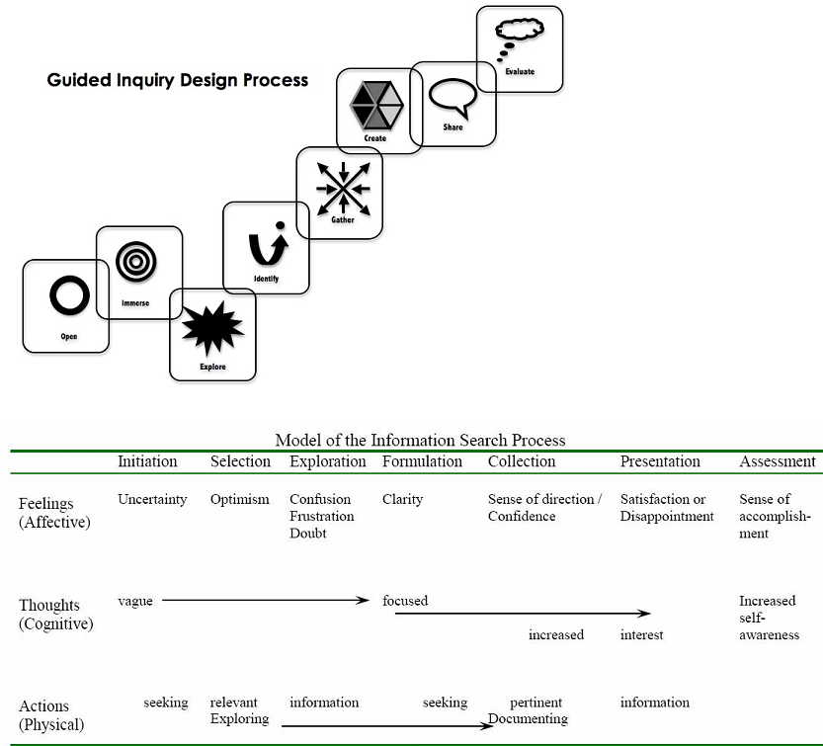 |  | UNIT OVERVIEW  Subject/Year level: History Year 9  Title of unit:  World Travel… Slave, Prisoner or Adventurer?  http://www.australiancurriculum.edu.au/humanitiesandsocialsciences/history/Curriculum/F-10#level9  Concept: (Big picture)  Movement of peoples (1750 – 1918)  The influence of the Industrial Revolution on the movement of peoples throughout the world, including the transatlantic slave trade and convict transportation  - mapping the movement of peoples in the transatlantic slave trade or in convict transportation to Australia  - explaining the role of the Industrial Revolution in creating a growing need for labour and transportation
Key Inquiry Questions (from the curriculum)  - What were the changing features of the movements of people from 1750 to 1918?  - How did new ideas and technological developments contribute to change in this period?  - What was the origin, development, significance and long-term impact of imperialism in this period?  - What was the significance of World War I?  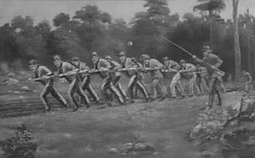  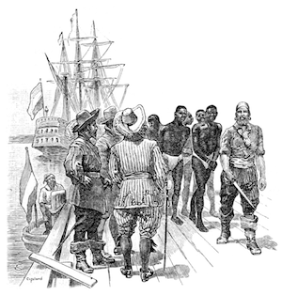  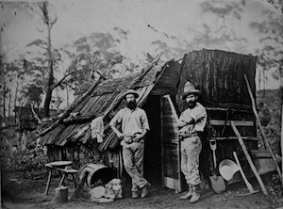 |  | Curriculum Skills (including general capabilities)  Skills  - Use chronological sequencing to demonstrate the relationship between events and developments in different periods and places  - Use historical terms and concepts  - Identify and select different kinds of questions about the past to inform historical inquiry  - Identify and locate relevant sources, using ICT and other methods  - Evaluate the reliability and usefulness of primary and secondary sources  - Identify and analyse the perspectives of people from the past  - Develop texts, particularly descriptions and discussions that use evidence from a range of sources that are referenced  - Select and use a range of communication forms (oral, graphic, written) and digital technologies  General Capabilities  Literacy  Comprehending texts through listening, reading and viewing  - Comprehend texts  - Navigate, read and view learning area texts  - Interpret and analyse learning area texts  Word Knowledge  - Understand learning area vocabulary  Numeracy  Estimating and calculating with whole numbers  - Understand and use numbers in context  Using spatial reasoning  - Interpret maps and diagrams  Critical & creative thinking  Inquiring – identifying, exploring and organising information and ideas  - Identify and clarify information and ideas  Intercultural Understanding  Recognising culture and developing respect  - Investigate culture and cultural identity  - Explore and compare cultural knowledge, beliefs and practices
Key Inquiry Skills  - explain patterns of change and continuity over time  - analyse the causes and effects of events and developments and make judgments about their importance.  - explain the motives and actions of people at the time.  - explain the significance of these events and developments over the short and long term.  - explain different interpretations of the past.  - sequence events and developments within a chronological framework, with reference to periods of time and their duration.  - develop different kinds of questions to frame an historical inquiry.  - interpret, process, analyse and organise information from a range of primary and secondary sources and use it as evidence to answer inquiry questions.  - examine sources to compare different points of view. When evaluating these sources, they analyse origin and purpose, and draw conclusions about their usefulness.  - develop their own interpretations about the past.  - develop texts, particularly explanations and discussions, incorporating historical interpretations. In developing these texts, and organising and presenting their conclusions, they use historical terms and concepts, evidence identified in sources, and they reference these sources. |  | Content description (from the curriculum)  Movement of People  The influence of the Industrial Revolution on the movement of peoples throughout the world, including the transatlantic slave trade and convict transportation (ACDSEH018)  The experiences of slaves, convicts and free settlers upon departure, their journey abroad, and their reactions on arrival, including the Australian experience (ACDSEH083)  Changes in the way of life of a group(s) of people who moved to Australia in this period, such as free settlers on the frontier in Australia (ACDSEH084)  The short and long-term impacts of the movement of peoples during this period (ACDSEH085)
Learning scenario
Slave, Prisoner or Adventurer? Looking at the HOW, WHY, WHEN and TO WHERE of the Movement of peoples (1750 – 1918)

You have just studied an overview of the historical period 1750 – 1918 including the nature and significance of the Industrial Revolution, European expansion and the economic, social and political ideas of the period

You will now investigate, through Guided Inquiry, national expansion and the movement of people - by choice or by force - in the period 1750 - 1918.

- Select which category of ‘traveler’ to study: Slave, Convict or Free Settler and join the related Inquiry Circle
You are to work within your circle to select a specific or group of travelers and to investigate WHY, WHEN, HOW and TO WHERE your specific group of travelers set out and to share this information within the group.

- You will then form groups of three – one from each Inquiry Circle – and share your expertise with one another.

- Finally you are required to make a 5 minute presentation to the class answering these questions:

1750 – 1918 was a period of time when large numbers of people moved long distances around the world.

Consider these points in your preparation for your speech.

- What caused them to move in large numbers? How many moved: when and where did they go?

- What were the main influences on travel and the movement of people between 1750 and 1918? What are the similarities and differences in the modern equivalents for the reasons for travel and travel destinations today?

- Are there modern equivalents to slaves, convicts and adventurers? If so, do we think better or worse of them than people in the past?

Assessment: Inquiry task – Overview – Description for students, with summary of key dates

- Choose your Inquiry Circle and organise your specific investigation within your Edmodo group Date________

- Share your WHY, WHEN, HOW and To WHERE stories and examples within your Edmodo group (Written investigation of two pages). Date________

- Share what you have learnt orally within your group of three (5 minutes each – illustrate if possible). Date ________

- Consider the question Do people travel today for similar reasons as they did between 1750 and 1918 – are there still ‘slaves’, ‘convicts’ and ‘adventurers’? Comment on the related social attitudes to people movement today compared to then.

- Deliver a three minute speech to the class in answer to this question and hand in your delivery notes. Date________

 | What the teaching team is doing - Strategies |  | What students are doing – Tasks
Description of OPEN: Create a powerful open that invites students to engage in the inquiry topic.
Open – (Initiation) | 1. Class discussion and brainstorm to revise an overview of the influence of the Industrial Revolution  - the nature and significance of the Industrial Revolution and how it affected living and working conditions, including within Australia  - the nature and extent of the movement of peoples in the period (slaves, convicts and settlers)  - the extent of European imperial expansion and different responses, including in the Asian region  - the emergence and nature of significant economic, social and political ideas in the period, including nationalism  2. View a selection of videos |  | Make a personal mind map as the brainstorm takes place.  View Videos selected
Resources
NSW 1819 - convict gulag or place of opportunity?( Scootle) http://dl.nfsa.gov.au/module/1619/

First Fleet arrives 1788 https://www.youtube.com/watch?v=4bD933tBZvQ

The First Australians.Ep1/7.pt.1/7 - They came to stay. (4min-10min) https://www.youtube.com/watch?v=VcslF8yQ1Tg

Journey through Slavery prt 1 - Terrible Transformation https://www.youtube.com/watch?v=ak1SlHjFBbU

William Wilberforce Documentary https://www.youtube.com/watch?v=8WR6fe-VaLE

What is Australia's national character? http://splash.abc.net.au/media?id=29439

Geraldine Doogue interviews historian John Hirst. They discuss his views about convict heritage, national character, the White Australia policy, racism, and recent immigration, refugee and asylum-seeker policies.

Description of IMMERSE: Students build their background knowledge by immersion in the content. Students reflect on the content and select a topic for further investigation.

Immerse (Selection) | Organise for formation of three Inquiry Circles after initial ‘Open’ activities (Slaves, Convicts, Free Settlers)  Call all students together and check that all main content descriptors of the topic are covered or ‘tweak’ choices so that they are. |  | Form Inquiry Circles  Within Circles:  Each student does overview searching within the topic area and reports back with brief notes (Evernote) to the group at the end of the session.  At the end of sharing the aspects that interest them, the group discusses preferences and allocates choices of topic areas to investigate further by individual students.
Resources
Students use Britannica Online, World Book online, Wikipedia or general History books for an overview of their selected area of study

What is Australia's national character? http://splash.abc.net.au/media?id=29439
Geraldine Doogue interviews historian John Hirst. They discuss his views about convict heritage, national character, the White Australia policy, racism, and recent immigration, refugee and asylum-seeker policies.

Description of EXPLORE: Students browse and scan through a wide range and variety of resources to explore interesting ideas around their topic. “Go broad”
Explore – (Exploration) | Inquiry Community:  Teacher Librarian input on  - sources to use as search goes deeper  - using the online Generator for Bibliographic details  - collections of resources for each topic area  - set up notetaking headings to direct notetaking in Evernote |  | Inquiry circles gather information from gathered resources and prepare to explore further as their curiosity is extended  Construct many sub-questions to assist in exploration – keeping in mind the Inquiry focus of the unit.  Divide questions between the group members
Resources:
- Evernote
- SLASA Online Generator (available from IRC website)

Description of IDENTIFY: Students develop an inquiry question or questions and form a focus for their research. The question or questions will frame the rest of the inquiry.

Identify – (Formulation) | Organise Inquiry Circles to share their  Information – make chart to summarise what each member has found out about his or her sub-question.  Bring whole class together to display and explain summaries  Guide discussion about where information is still lacking to answer focus questions of the unit. |  | Students (within each circle) makes a chart of knowledge – butcher’s paper  Students apply their findings to the inquiry focus of this unit and  - What were the changing features of the movements of people from 1750 to 1918?  - How did new ideas and technological developments contribute to change in this period?  - What was the origin, development, significance and long-term impact of imperialism in this period?  - What was the significance of World War I?
Resources

Description of GATHER: collect detailed information from a variety of information sources – “Go deep”
Gather – (Collection) | Organise the whole Inquiry community into groups of three with an expert on slavery, convicts and Free Settlers in each group. (Jigsaw Activity)  Facilitate - Share their gathered knowledge  Facilitate - Prepare for an Oral Presentation by students discussing their work with classmates. |  | Talk to peers about their topic area taking notes on what others relate about their topic area.  Return to original Inquiry Circle to share learning on each topic.  Gather information to individually to prepare a speech based on your learning:  - Consider the question… Do people travel today for similar reasons as they did between 1750 and 1918 – are there still ‘slaves’, ‘convicts’ and ‘adventurers’? Comment on the related social attitudes and problems associated with ‘people movement’ today compared to back then.
Resources

Description of CREATE/SHARE: Organise their gathered information to create their product – “Tell the story”
Create / Share – (Presentation)   | Listen to speeches and evaluate learning |  | Prepare a 5 minute speech as outlined above  Students deliver a speech relating their learning of the time period to ‘people movement’ today.
Resources
Individually selected resources

Description of EVALUATE: Students reflect on their content learning and the progress through the inquiry process.

Evaluate – (Assessment) | Culmination conversation (teaching team)  1. Teaching team: What worked – what did not? Online survey – Survey Monkey  - Note challenges and improvements discussed on the program for the next cycle |  | Culmination conversation (Students)  After speeches – reform into original Inquiry Circles and reflect on learning – general comments about what aspect interested you the most and something special that you learnt.  Complete the Survey Monkey Survey:  What could I have done better?  What am I proud of in this task?  What did I learn about my own research process?  How successful was our Inquiry Circle?  How successful was the Jigsaw activity?  What could make this Inquiry task better?
Evidence Strategies / Assessment (Formative / Summative; Informal, formal)
- Mind Map
- Bibliography
- Evernote Contributions
- Observation of student participation during Inquiry Circle time and Jigsaw Activity
- Oral Presentation
- Reflection on Learning

http://www.acara.edu.au/curriculum/worksamples/Year_9_History_Portfolio_Satisfactory.pdf

Rubric: 5 Minute Speech
Mark range | What you said | How you said it
9-10  A | - Accurate and detailed points relating to the reasons for travel both between 1750 -1918 and travel today.  - Accurate and detailed points comparing social attitudes of 1750 -1918 and today.  - Integration of relevant historical terms  - Relevant sources used as supporting evidence, including expert opinions  - Correctly formatted reference list | - Clear, audible and fluent expression of ideas  - Speech well-organised and presented  - Effective eye contact with audience, minimal use of notes  - Speech lasted for 3 minutes
7-8  B | - Accurate comparison of most relevant key points in relation to travel both between 1750 -1918 and travel today  - Uses some relevant historical terms  - Relevant sources used as evidence, including at least one expert opinion  - Reference list provided | - Clear and audible expression of ideas  - Speech well-organised  - Frequent eye-contact with audience, some use of notes  - Speech more or less than 3 minutes
5-6  C | - Compares some key points in relation to reasons for travel 1750 -1918 and travel today.  - Uses some relevant historical terms  - Mentions relevant sources, may include an expert opinion  - References list inaccurate or incomplete | - Competent expression of ideas, may be some hesitation  - Speech shows some organisation  - Some eye-contact with audience, some reliance on notes  - Speech well over or well under 3 minutes
3-4  D | - Identifies or describes rather than compares travel both between 1750 -1918 and travel today.  - Limited use of historical terms.  - May mention a source but not use it as evidence.  - Reference list inaccurate or incomplete. | - Parts of the speech poorly expressed, meaning difficult to follow in part  - Limited organisation of information  - Limited eye-contact with audience, heavy reliance on notes
1-2 marks  E | - Identifies some features of one example of travel between 1750 -1918  - little or inaccurate use of historical terms.  - May not refer to sources or expert opinion  - No reference list provided | - Speech difficult to hear and/or understand  - Lack of organisation of ideas and information  - Lack of communication with audience  - Speech well under 5 minutes

