.
Year 9 History Elective
Hitler, Hatred and The Holocaust
The overarching inquiry question: ‘The Holocaust is not only a tragedy of the Jewish people. It is a failure of humanity as a whole.’
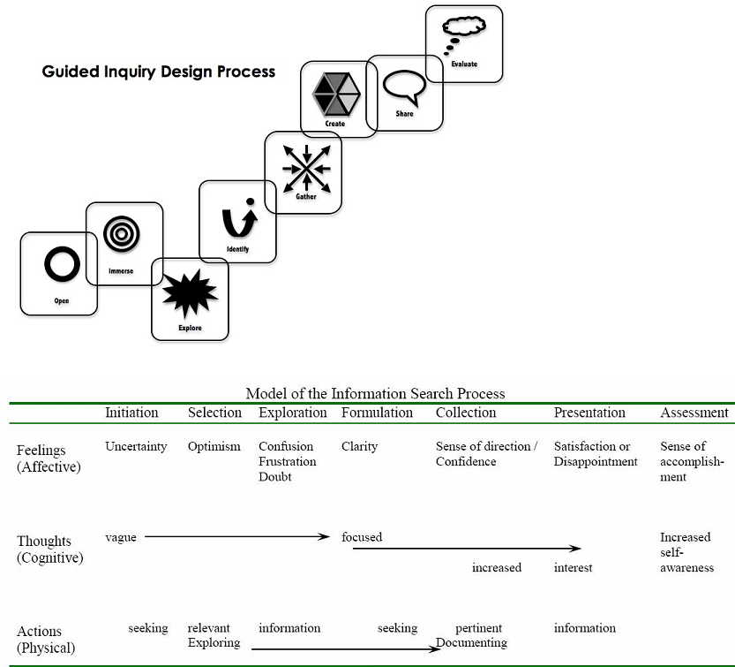 |  |  | Title of unit: Hitler, Hatred and The Holocaust (Topic 2)  Task Overview: The task in this topic:  - offers an opportunity to study the major features of The Holocaust. Integral to this study is the development of students’ understanding of the nature of historical inquiry. Of particular relevance is the study of historical causation and factors contributing to continuity and change.  - gives students an awareness of the enormity of the crimes committed during the Nazi Holocaust and to help them grasp the fact that thousands of ordinary people—teenagers, fathers, daughters, brothers— participated in perpetrating these crimes, while thousands more stood by and quietly witnessed the suffering and death of millions of innocent people.  Outcomes, particular focus on:  E5.1 applies an understanding of history, heritage, archaeology and the methods of historical inquiry  E5.3 sequences major historical events to show an understanding of continuity, change and causation  E5.4 explains the importance of key features of societies and periods, including groups and personalities  E5.5 evaluates the contribution of cultural groups, sites to our shared heritage  E5.8 selects and analyses a range of historical sources to locate information relevant to this historical inquiry  E5.10 selects and uses appropriate oral, written, visual and digital forms to communicate effectively for different audiences.
Key Inquiry Questions (from the syllabus 2013)  - How does the study of a modern society contribute to our understanding of the past?  - What can be learned from this study about continuity, change and causation in history?  Content description (from syllabus 2013)  The nature of historical inquiry  Students:  - identify relevant sources  - use historical sources appropriately in an historical inquiry.  Past societies and historical periods  Students:  - describe key features of the society and historical period  - sequence major events to show an understanding of continuity, change  and causation.  Events and people in the context of their own time  Students:  - explain how people of the past were influenced by different values,  attitudes and motives.  Significant historical issues in an historical context  Students:  - outline significant historical issues in the study.  Core Inquiry Skills in this unit  Identify/locate/ /compare/select/evaluate points of view  Use evidence/justify/work collaboratively/communicate(oral and written text)  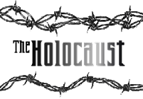 |  |  | Curriculum Skills (including general capabilities)  - Use historical terms and concepts  - Identify and locate relevant sources, using ICT  - Identify the origin and purpose of sources  - Locate, compare, select and use info from a range of sources as evidence  - Draw conclusions about the usefulness of sources.  - Identify and describe points of view, attitudes and values in primary and secondary sources.  - Develop oral and written texts that use evidence from a a range of sources that are acknowledged.  Critical and Creative Thinking Capability  - Organise and process information  - critically analyse information and evidence according to criteria such as validity and relevance  - explore viewpoints and viewpoints to construct well supported historical explanations  - Reflect on processes  - evaluate reasons behind particular thinking  Ethical understanding  - Engage with a range of human behaviours from past  - Examine motives and actions of personalities and groups to compare and strengthen students’ own ethical understanding  Personal and Social Capability  Work collaboratively  - assess the extent to which individual roles and responsibilities enhance group cohesion and the achievement of personal and group objectives  ICT Capability  Select and evaluate data and information  - assess the suitability of data or information using appropriate criteria
Student Tasks
Purpose: To give you an awareness of the enormity of the crimes committed during the Nazi Holocaust and to help you grasp the fact that thousands of ordinary people—teenagers, fathers, daughters, brothers, etc— participated in perpetrating these crimes, while thousands more stood by and quietly witnessed the suffering and death of millions of innocent people. We will be investigating four groups:
• Victims
• Perpetrators
• Bystanders
• Upstanders
The written task: You have been given the chance to tell the world what you have learnt about humanity, in both its’ positive and negative terms, through your examination of this dark period in human history. In your response consider using:
- understandings you have gained from the differing perspectives (victim, bystander, upstander, perpetrator)
- examples from particular readings
- specific historical events
- the unit’s overarching inquiry question as a focus or any other quote in your Student Journal and Student Readings Booklet

You may choose the presentation style, for example: poem, reflection, article for the newspaper, letter to someone (or their relative) involved in the Holocaust, letter to a Holocaust Museum. You are to hand in a correctly formatted bibliography, printed out from Easybib.

The oral task: You will be delivering a final oral reflection (2 mins max), which draws together the threads of what you have investigated. It will be one of the following questions. (Questions differ in difficulty, allowing for student differentiation)
- How might we explain why ordinary people participated in the mass murder of millions of children, women and men?
- Why do some people stand by during times of injustice while others try to do something to stop or prevent injustice?
- Who was responsible for the Holocaust?
- From hearing the personal stories of upstanders and survivors, what can be learnt about the importance of the human spirit?
- What is at least one life lesson that could be learned from the Holocaust?
- Something I discovered about victims and/or perpetrators and/or upstanders and/or bystanders that I had not considered before was...
- “Thou shalt not be a victim, thou shalt not be a perpetrator, but, above all, thou shalt not be a bystander.” (Yehuda Bauer).
Do you agree with Yehuda? Why or why not?

Due dates:
Choose your group Join your Inquiry circle. Date:
Discuss/ allocate/ share the work of researching. Date:
Share what you’ve found out with your inquiry circle. Date:
Share what you’ve found out in a jigsaw group, where you will be the only one who knows anything about your group! Date:
Share ideas in your jigsaw group on how your knowledge could be reconstructed for your tasks. Date:
Individually make your own conclusions about how you will address the inquiry questions in your tasks. Date of oral:
Guided Inquiry Stage | What the teaching team is doing – Strategies |  |  | What students are doing – Tasks
Description of OPEN: Create a powerful open that invites students to engage in the inquiry topic.
INITIATION – Open  Inquiry Community phase  ‘man’s inhumanity to man’  ‘the one truth in modern history that the world cannot afford to forget’ | Introduce a series of images to contextualize topic and generate discussion.  Look! Think! Wonder! activity. Images can include: swastika, Hitler, Star of David, Ayran, concentration camps, Nuremberg rallies  Exploring questions:  What is the holocaust? What is genocide?  Where/why it happened, who was involved, who was responsible? Why it is important to study the holocaust?.  Watch: http://www.youtube.com/watch?v=Mc1d1eDcUlk  What is the significance of using the symbol of the ambulance?  Teacher provides selected images and sources related to stages –journal thoughts and questions  Allocate a series of short youtube clips. TPS questions to be discussed in a group before plenary discussion.  Watch youtube Education for Death – what makes a Nazi?  - What does this cartoon reveal about the Nazi state? especially what is stands for and the means by which they achieve their goals  - How might we explain why ordinary people participated in such extraordinary crimes against humanity?  Issue Mix and Match Glossary page  Introduce concepts of Bystander, Upstander, Perpetrator and Victim. Present series of photos, names and roles played during the Holocaust – students try to determine from the data who is who. Discussion qs:  - What qualities do the faces display?  - What qualities to the photographs display?  - Can you tell what a person is like from their outward appearance?  - What conclusion can you make about a person’s appearance? |  |  | Look, Think, Wonder!  TPS: What do I know?  What do I want to know?  How will I find out?  Why would we learn about the Holocaust?  Discussion of Ambulance, its symbols and message (NB this clip may be confronting for your students)  TPS: From your youtube clip note:  what has been learned about Germany in the 1930s/40s?  what questions has been raised?  Paragraph response to Education for Death.  Glossary page introduced  Small group discussion – justifying answers
Resources - Youtube introductions:
http://www.youtube.com/watch?v=nQE9lvkyo0w – nazi school curriculum
http://www.youtube.com/watch?v=D8bCuNiJ-NI - Education for Death – what makes a Nazi?
http://www.youtube.com/watch?v=1c6s0LKnwo8
http://www.youtube.com/watch?v=aS98MAN3Xtg
Description of IMMERSE: Students build their background knowledge by immersion in the content. Students reflect on the content and select a topic for further investigation.

SELECTION – Immerse  Inquiry Community Inquiry Group  Inquiry Circles |  | Examine Timeline of Germany from 1933 -1945  ‘You cannot live amongst us as Jews – conversion  You cannot live amongst us – expulsion  You cannot live – annihilation’  Discussion of how Paul Hilberg’s quote relates to what has been learned from the timeline. Complete note taking guide: Stages of Mass Murder using the notetaking Guide  Definition Isolation Emigration Ghettoization Deportation Mass Murder.  Immersion in:  Who was Hitler – background, career path, ideology.  Research task  Introduce series of Holocaust sources:  Note taking/question making about the Holocaust  Silent conversation – what made the Holocaust possible? /How can you explain this accelerating racism? What could have prevented it? Share, then reflect again  Introduce Nuremberg laws – series of questions – consider why you think majority of German citizens remained silent and/or indifferent to such obvious persecution  Divide class into inquiry circles (Upstander, Bystander, Victim, Perpetrator), either via student choice/interest or teacher allocation using Hitler dictatorial style!  In inquiry circles, brainstorming for questions record questions for investigation, eliminating unsuitable or repetitive ones.  Introduce question creation strategy.  Teacher librarian shows students how to take notes/keep journal in Evernote, and to share a notetaking space there for each inquiry circle. Gather inquiry community together.  Revisit questions co-developed  Direct students to do overview searching |  |  | Complete Timeline of Germany 1933-1945 activity  Complete Hilberg’s Stages of Mass Murder using the notetaking Guide  Peer discussion: How is Hilberg’s quote reflected in the timeline.  Research activity on Hitler- mind map creation  Note 10 facts that you did not know before about the Holocaust and what questions you would like answers to.  Silent conversation questions–Peer share  TPS  Working in inquiry circles, students do Brainstorming activity to identify your research questions  - Ask /write down as many questions as you can.  - Do not stop to discuss, judge or answer the qs  - Change any statement into a question.  - Use open ended questions (they require an explanation and cannot be answered with ‘yes’, ‘no’ or one word)  - Prioritise: Choose three questions that will best help with your research.  When you are researching in your inquiry circles, all members are to answer all questions! Make this variable by using different sources. The reason for this is so that you have rich information to choose from, when you bring it all together.  Students learn how to use Evernote, create communal note taking page.
Resources
- http://www.bbc.co.uk/history/interactive/timelines/nazi_genocide_timeline/index_embed.shtml
- Yad Vashem Overview: http://www.yadvashem.org/yv/en/holocaust/about/index.asp
- United States Holocaust Museum – Introduction to the Holocaust: http://www.ushmm.org/education/forstudents/
- The Holocaust: A learning site for students: http://www.ushmm.org/outreach/en/
- 36 Questions about the Holocaust: http://motlc.wiesenthal.com/site/pp.asp?c=gvKVLcMVIuG&b=394663
- The courage to remember: http://motlc.wiesenthal.com/site/pp.asp?c=gvKVLcMVIuG&b=395221
- Timeline of the Holocaust: http://motlc.wiesenthal.com/site/pp.asp?c=gvKVLcMVIuG&b=394669
Youtube films:
- http://www.youtube.com/watch?v=1c6s0LKnwo8
- http://www.youtube.com/watch?v=3pD4V7v6ZVc
- http://www.youtube.com/watch?v=Ghv5RyNE_gk
- http://www.youtube.com/watch?v=39-oZCeDcUQ
Clickview: History/Germany, Holocaust and Europe

Description of EXPLORE: Students scan through a wide range and variety of resources to explore interesting ideas around their topic. “Go broad”

EXPLORATION – Explore |  | Inquiry community:  Teacher and teacher librarian input on what sources in each Inquiry Circle  Teacher librarian input on using Easybib to begin to record bibliographic details.  Set up library with stations for each topic, containing interesting resources from a variety of formats.  Inform students about Due Dates |  |  | Inquiry circles go to station in the library to discuss their research strategies /questions  Record brief notes in Evernote  Record bibliographic details in Easybib.
Specific resources:
More research: Investigate these websites, now that you are about to identify which inquiry circle you want to work in.
- PBS Auschwitz: http://www.pbs.org/auschwitz/learning/
- Nazi propaganda: http://www.calvin.edu/academic/cas/gpa/
- Holocaust chronicle: http://www.holocaustchronicle.org/
- Victims: http://www.pbs.org/auschwitz/40-45/victims/
- Perpetrators: http://www.pbs.org/auschwitz/40-45/victims/perps.html
- Witnessing the Holocaust: http://www.bbc.co.uk/archive/holocaust/index.shtml
- Yad Vashem: http://www.yadvashem.org/yv/en/exhibitions/album_auschwitz/multimedia.asp
- Some were neighbours: collaboration and complicity in the Holocaust from US Holocaust Museum: http://fcit.usf.edu/holocaust/people/people.htm
A teachers’ guide to the Holocaust/People: http://fcit.usf.edu/holocaust/people/people.htm
- Books
- Articles from ANZ Reference Centre
- Clickview videos
Description of IDENTIFY: Students apply their findings to the inquiry focus of this unit:

FORMULATION - identify |  | Call Inquiry community together to give them information on sharing their information in their inquiry circle, by creating a brief chart that summarises what each member has found out about their sub questions.  Inquiry circles to work together to collate information.  Inquiry circle reflection on overarching focus: “The Holocaust is not only a tragedy of the Jewish people. It is a failure of humanity as a whole.” To what extent is this true? |  |  | Students use summary chart to collate information in each Inquiry Circle.  Reflection question discussed in each Inquiry circle.
Resources:
Gelski, Sophie, Teaching the Holocaust, Revised edition. Sydney Jewish Museum, 2010\
Facing History and Ourselves Resource Book, Facing History, Massachusetts, 2012
Evernote/Easybib

Description of GATHER: collect detailed information from a variety of information sources – “Go deep”

COLLECTION - Gather  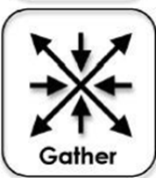 |  | Call inquiry community together to tell them about jigsaw, in which all members of the inquiry community will hear about each of the topics  Final sharing of information in each Inquiry Circle to create collation to be submitted to teacher for copying for whole class. Collation sheet is to have a wide margin left blank for student annotations. Each student to be given time to analyse notes from each Inquiry Circle. They are to annotate as they read, noting points of interest, questions to ask, points of disagreement. |  |  | Student jigsaw topics. Taking notes as they listen.  Return to original inquiry circle to share what they’ve learnt on each topic.  Ensure students know how to set up their collated notes with wide margin included.
Resources: These will be very specific by this stage and gathered individually and in inquiry circles, and kept on Easybib.

Description of CREATE/SHARE: Organise the gathered information from each Inquiry Circle to create their product – “Tell the story”

PRESENTATION – Create / Share  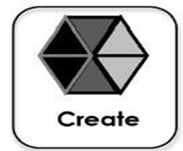 |  | Jigsaw activity to discuss annotated notes to gain big picture from the four different perspectives.  Discussion question: How did individuals, groups or nations explain the choices they made? What might they say if you asked them, ‘Why did you make this choice’?  Select specific evidence/individuals from their reading or from Student Journal/Reading Booklet to reinforce answer.  Call inquiry community together at the end to discuss requirements of oral an written tasks and answer any questions.  Students now operate on an individual level to create their finished products. |  |  | Jigsaw with 1 from each Inquiry Circle together.  Then make the groups larger – 2 from each Inq Circle to increase discussion ideas.  Individual work to use Evernote to craft their speeches.
Resources: These will be very specific by this stage and gathered individually and in inquiry circles, and kept on Easybib.

Description of EVALUATE: Students reflect on their content learning and the progress through the inquiry process.

Assessment – Evaluate |  | Culmination conversation (teaching team) - Teaching team (including teacher librarian) to meet soon after end of unit to evaluate it. Focus:  Evaluate strengths and weaknesses of task  Discuss individual students who had difficulty or exceptional success. |  |  | Culmination conversation (Students)  After all orals have been presented, students reform into their original inquiry circle and reflect on what they’ve learnt:  Answering these questions:  What did I learn about my own research process?  How successful was our inquiry circle?  How successful was the jigsaw activity?  Have a scribe record answers on butcher’s paper
Evidence Strategies / Assessment:
- Oral presentation
- Bibliography/ Evernotes
- Observation of students during inquiry circles and jigsaw
- Reflections on learning.
Marking criteria - Written |  |  |  |  |  | Marks
- Presents a comprehensive and coherent response about humanity, in both positive and negative terms, through the examination of this dark period in human history (Holocaust).  - Develops a sustained, logical and well-structured response that uses the appropriate characteristics of the chosen presentation style (e.g. letter, poem).  - Uses a breadth and depth of detailed information as evidence to support response (eg primary sources, specific events and individuals, quotes) |  |  |  |  |  | Excellent  13-15
- Presents a coherent response about humanity, through an examination of this dark period in human history (the Holocaust).  - Develops a logical, and well-structured response that uses most of the appropriate characteristics of the chosen presentation style (e.g. letter, poem).  - Uses varied information as evidence to support response (eg primary sources, specific events and individuals, quotes) |  |  |  |  |  | High  10-12
- Presents a sound response about humanity, through an examination of this dark period in human history (the Holocaust).  - Presents a structured response, using some of the appropriate characteristics of the chosen presentation style (e.g. letter, poem).  - Uses some information as evidence to support response (eg primary sources, specific events and individuals, quotes) |  |  |  |  |  | Substantial  7-9
- Presents a response about the Holocaust.  - Presents a structured response, limited adherence to the appropriate characteristics of the chosen presentation style.  - Makes mention of some information in response. |  |  |  |  |  | Satisfactory  4-6
- Demonstrates limited knowledge about the Holocaust.  - Structure of response limited. |  |  |  |  |  | Elementary  1-3
Marking Criteria - Oral
- Demonstrates high level of knowledge about events of the Holocaust.  - Demonstrates high level of knowledge about own inquiry circle, and interactions with the other groups – Bystanders, Upstanders, Victims, Perpetrators.  - Demonstrates advanced synthesis of information to answer oral inquiry question.  - Communication skills of a high level, demonstrating command of subject matter and strong ability to communicate empathy. |  |  |  |  |  | 9-10  A
- Demonstrates strong knowledge about events of the Holocaust.  - Demonstrates strong knowledge about own inquiry circle, and interactions with the other groups – Bystanders, Upstanders, Victims, Perpetrators.  - Demonstrates strong synthesis of information to answer oral inquiry question.  - Communication skills of a sound level, demonstrating knowledge of subject matter and ability to communicate empathy. |  |  |  |  |  | 7-8  B
- Demonstrates some knowledge about events of the Holocaust.  - Demonstrates some knowledge about own inquiry circle, and interactions with the other groups – Bystanders, Upstanders, Victims, Perpetrators.  - Demonstrates some ability to synthesise information to answer oral inquiry question.  - Communication skills of a reasonable level, with some gaps in knowledge of subject matter and in ability to communicate empathy in ad lib situation. |  |  |  |  |  | 5-6  C
- Demonstrates very little knowledge about events of the Holocaust.  - Demonstrates very little knowledge about own inquiry circle, and interactions with the other groups – Bystanders, Upstanders, Victims, Perpetrators.  - Little evidence of synthesis of information to answer oral inquiry question.  - Communication skills inadequate, because of lack of knowledge of subject matter, leading to low levels of empathy being conveyed. |  |  |  |  |  | >5  D

