.
Narrabeen Man Guided Inquiry task
(Unit of work already exists at AC History units)
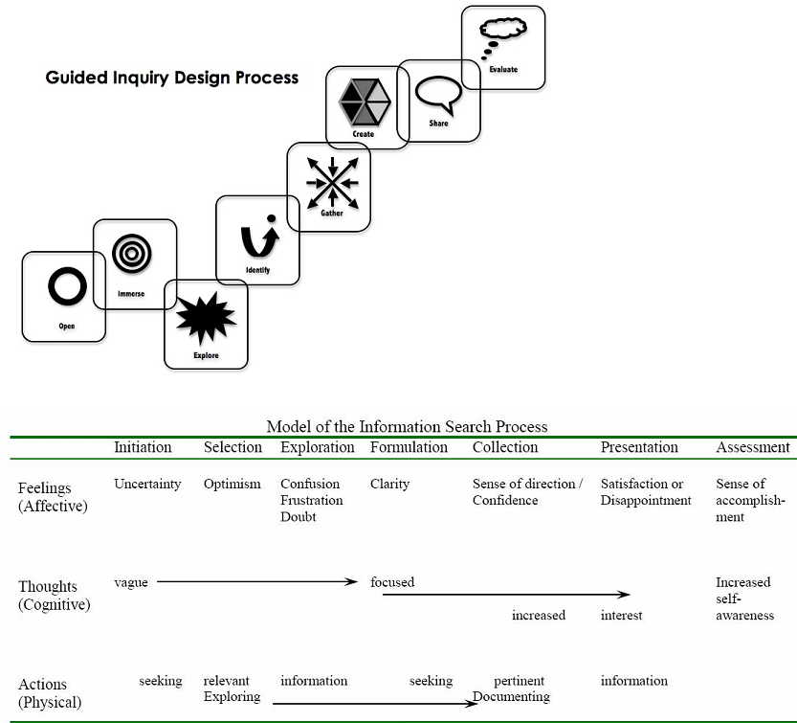 |  |  | Task overview.  Subject/Year level: History, Year 7  Title of unit: The ancient past – Narrabeen Man  Concept: The significance and reliability of archaeological discoveries.
Key Inquiry Questions (from the curriculum)  - How do we know about the ancient past?  - What emerged as the defining characteristics of ancient societies?  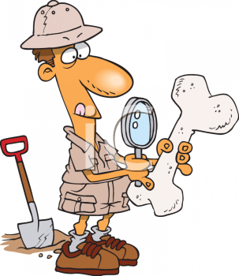 |  |  | Curriculum Skills (including general capabilities)  Historical skills Year 7 and 8  - Use historical terms and concepts  - Identify and locate relevant sources, using ICT and other methods  - Identify the origin and purpose of primary and secondary sources  - Locate, compare, select and use info from a range of sources as evidence  - Draw conclusions about the usefulness of sources.  - Identify and describe points of view, attitudes and values in primary and secondary sources.  - Develop texts, particularly descriptions and explanations that use evidence forma a range of sources that are acknowledged.  - Use a range of communication forms (oral)  Critical and Creative Thinking Capability  Organise and process information  - critically analyse information and evidence according to criteria such as validity and relevance  Consider alternatives  - generate alternatives and innovative solutions, and adapt ideas, including when information is limited or conflicting  Reflect on processes  - evaluate and justify the reasons behind choosing a particular problem-solving strategy  Personal and Social Capability  Work collaboratively  - assess the extent to which individual roles and responsibilities enhance group cohesion and the achievement of personal and group objectives  ICTCapability  Investigating with ICT  Select and evaluate data and information  - assess the suitability of data or information using appropriate own criteria
Core Inquiry Skills  Identify/locate/ /compare/select/evaluate points of view/use evidence/justify/work collaboratively/communicate(orally) |  |  | Content description Investigating the ancient past  - How historians and archaeologists investigate history, including excavation and archival research (ACDSEH001)  - The range of sources that can be used in an historical investigation, including archaeological and written sources (ACDSEH029)  - The methods and sources used to investigate at least ONE historical controversy or mystery that has challenged historians or archaeologists, such as in the analysis of unidentified human remains (ACDSEH030)  - The nature of the sources for ancient Australia and what they reveal about Australia’s past in the ancient period, such as the use of resources (ACDSEH031)  - The importance of conserving the remains of the ancient past, including the heritage of Aboriginal and Torres Strait Islander Peoples. (ACDSEH148)
Learning scenario World’s Most Exciting Archaeological Remains!

While you are working in class on Narrabeen Man, you are also to do a Guided Inquiry task!

You will choose from one of the following topics and join an inquiry circle related to it:
- Mungo Man
- Mungo Lady
- Otzi the Ice Man
- Tollund Man
- Lady Dai (Mawangdui China)
- An ancient Egyptian mummy, Ramesses II, Seti I, Thutmoses III, Hatshepsut, Sekenenre.

You are to work in your inquiry circle to investigate your chosen “old bones”, and share your knowledge with one another.

Then you are to work in jigsaw groups, where you will share your expertise on your one lot of “old bones’ and learn about all the other famous skeletons!

Lastly, you are to prepare a 3 minute speech answering this question:

- There are many exciting archaeological finds of human remains. But I consider that………. Is the most significant because:
In your speech, give reasons for your choice of World’s Most Exciting Archaeological remains.

You are to hand in a correctly formatted bibliography, printed out from Easybib.

Assessment: Inquiry task – Overview – Description for students, with summary of key dates
Choose your skeleton! Join your Inquiry circle: Date -
Share the work of researching it. Date:
Share what you’ve found out with your inquiry circle. Date:
Share what you’ve found out in a jigsaw group, where you will be the only one who knows anything about your particular bag of bones!
Date:
Leave your inquiry circle, and make your own conclusions about the answer to the inquiry question for this task. Date of orals:
Guided Inquiry Stage |  | What the teaching team is doing - Strategies |  |  | What students are doing – Tasks
Description of OPEN: Create a powerful open that invites students to engage in the inquiry topic.
INITIATION - Open |  | Gather class for a whole group session (inquiry community).  Engage them with interesting dilemmas/unanswered questions about the archaeological finds they will research.  Divide them into inquiry circles, based on interest.  After inquiry circle time, brainstorming for questions, return to whole group, and record questions for investigation, eliminating unsuitable or repetitive ones.  Teacher librarian shows students how to take notes/keep journal in Evernote, and to share a notetaking space there for each inquiry circle. |  |  | Students form into inquiry circles.  Brainstorm for questions to investigate, based on the ones they’ve used to investigate Narrabeen Man.  Record their questions in Evernote.
Resources: Youtube introductions:
Mungo Man: http://www.youtube.com/watch?v=73LfW84dkJg
Otzi the Iceman: http://www.youtube.com/watch?v=WA3AiNup7fY
Tollund Man: http://www.youtube.com/watch?v=H0m-UyJapKI
Lady Dai: http://www.youtube.com/watch?v=q6lzyWNN6fE
Egyptian Mummies: http://www.youtube.com/watch?v=AC8uM2QPPd4
Evernote: www.evernote.com
Description of IMMERSE: Students build their background knowledge by immersion in the content. Students reflect on the content and select a topic for further investigation.

SELECTION - Immerse |  | Gather inquiry community together.  Revisit questions co-developed  Direct students to as yet un-named inquiry circles to do overview searching, and to choose as a group which topic they will investigate.  After inquiry circle time, call community together, and discuss preferences, and allocate choices, ensuring all groups are covered. |  |  | Working in inquiry circles, students do broad overview searching of the six choices of archaeological finds open to them, and decide which one appeals to them the most.  Take brief notes in Evernote.
Resources

Students use Encyclopedia Britannica, or Wikipedia for overview on their topics.

Description of EXPLORE: Students browse and scan through a wide range and variety of resources to explore interesting ideas around their topic. “Go broad”
EXPLORATION - Explore |  | Inquiry community:  Teacher librarian input on what sources to use now that the topic is chosen and information needs to be found to answer the developed questions.  Teacher librarian input on using Easybib to begin to record bibliographic details.  Set up library with stations for each topic, containing interesting resources from a variety of formats. |  |  | Inquiry circles go to the station in the library for their topic.  Work together to divide up the questions between them to research.  Record brief notes in Evernote  Record bibliographic details in Easybib.
Specific resources:
- Books
- Articles from ANZ Reference Centre
- Clickview videos
Description of IDENTIFY: Students apply their findings to the inquiry focus of this unit: There are many exciting archaeological finds of human remains. But I consider that………. Is the most significant because…..
FORMULATION - identify |  | Call Inquiry community together to give them information on sharing their information in their inquiry circle, by creating a brief chart that summarises what each member has found out about their sub question.  After inquiry circles have worked together, call whole group together to show their summaries. |  |  | Inquiry circles summarise individual information, and gather it into one document – Butcher’s paper.
Resources: Evernote/Easybib

Description of GATHER: collect detailed information from a variety of information sources – “Go deep”
COLLECTION - Gather |  | Call inquiry community together to tell them about jigsaw, in which all members of the inquiry community will hear about each of the topics  Tell them they will have time at the end of the lesson to pool information in their original inquiry circles.  Visit each inquiry circle to facilitate sharing of information |  |  | Student jigsaw topics. Taking notes as they listen.  Return to original inquiry circle to share what they’ve learnt on each topic.  Time for working on Evernote space and Easybib.
Resources
Evernote, Easybib.

Description of CREATE/SHARE: Organise their gathered information to create their product – “Tell the story”
PRESENTATION – Create / Share  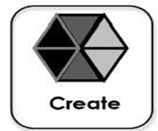 |  | Call inquiry community together at the end to discuss requirements of oral and answer any questions.  Tell them that from now they’re on their own, using what they’ve learnt to create an oral presentation. |  |  | Individual work to use Evernote to craft their speeches.
Resources: These will be very specific by this stage and gathered individually and in inquiry circles, and kept on Easybib.

Description of EVALUATE: Students reflect on their content learning and the progress through the inquiry process.

Assessment – Evaluate |  | Culmination conversation (teaching team)  Teaching team (including teacher librarian) to meet soon after end of unit to evaluate it:  Each person to speak on overall success or otherwise.  Agree on what worked, what didn’t.  Agree on action to fix it for next time.  Discuss individual students who had difficulty or exceptional success. |  |  | Culmination conversation (Students)  After all orals have been presented, students reform into their original inquiry circle and reflect on what they’ve learnt:  Answering these questions:  What did I learn about my own research process?  How successful was our inquiry circle?  How successful was the jigsaw activity?  Have a scribe record answers on butcher’s paper
Evidence Strategies / Assessment:
- Oral presentation
- Bibliography
- Evernotes
- Observation of students during inquiry circles and jigsaw
- Reflections on learning.

Rubric:
Mark range | What you said |  |  | How you said it
9-10 | Accurate and detailed comparison of all relevant key points in relation to explaining choice of World’s Most Exciting Archaeological Remains.  Integration of relevant historical terms  Relevant sources used as supporting evidence, including expert opinions  Correctly formatted reference list |  |  | Clear, audible and fluent expression of ideas  Speech well-organised and presented  Effective eye contact with audience, minimal use of notes  Speech lasted for 3 minutes
7-8 | Accurate comparison of most relevant key points in relation to explaining choice of World’s Most Exciting Archaeological Remains Uses some relevant historical terms  Relevant sources used as evidence, including at least one expert opinion  Reference list provided |  |  | Clear and audible expression of ideas  Speech well-organised  Frequent eye-contact with audience, some use of notes  Speech more or less than 3 minutes
5-6 | Compares some key points in relation to chose of World’s Most Exciting Archaeological Remains.  Uses some relevant historical terms  Mentions relevant sources, may include an expert opinion  References list inaccurate or incomplete |  |  | Competent expression of ideas, may be some hesitation  Speech shows some organisation  Some eye-contact with audience, some reliance on notes  Speech well over or well under 3 minutes
3-4 | Identifies or describes rather than compares features of archaeological sites leading to choice of favourite.  Limited use of historical terms.  May mention a source but not use it as evidence.  Reference list inaccurate or incomplete. |  |  | Parts of the speech poorly expressed, meaning difficult to follow in part  Limited organisation of information  Limited eye-contact with audience, heavy reliance on notes
1-2 | Identifies some features of one example of an Archaeological Remain.  Little or inaccurate use of historical terms  May not refer to sources or expert opinion  No reference list provided |  |  | Speech difficult to hear and/or understand  Lack of organisation of ideas and information  Lack of communication with audience  Speech well under 3 minutes

