Year 7 Inquiry Circles investigate…..

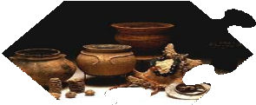
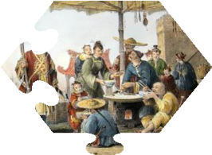
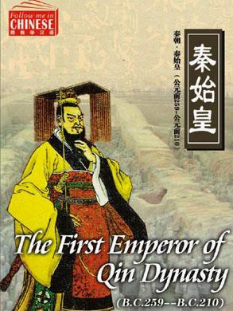
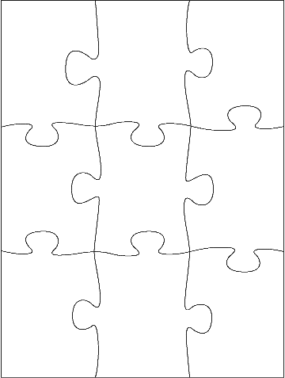
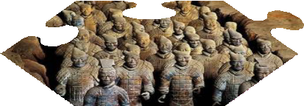
INQUIRY QUESTION: How does the physical features and construction tell us about life in Ancient China? How do we know?
INQUIRY QUESTION: Why and
How did Emperor Qin unify China? How do we know this?
INQUIRY QUESTION: What do the key social groups in China tells about the different roles and what they did? How do we know?
INQUIRY QUESTION: In what ways has Ancient China left an impact on today’s society? How do we know?
BIG INQUIRY QUESTION:
In what ways has Ancient China left an
impact on today’s society?
INQUIRY QUESTION: Why did Emperor Qin outlaw most forms of religion? How do we know?
INQUIRY QUESTION: What does Qin Shi Huang’s tomb reveal about his life and
achievements? How did he die? How do we know? Is his tomb a fitting memorial?
Adapted from Guided Inquiry Design Loreto Stage 3 Ancient Egypt Retrieved from https://guidedinquiryoz.edublogs.org/files/2015/12/Loreto-Stage-3-Ancient-Egypt-booklet-2015-1fxwx8y-1bt8wwq.doc

Created by Dr. Lynne Vey, Teacher Librarian, Cootamundra High School

Subject: History NSW and GUIDED INQUIRY AT WORK WITH THE AUSTRALIAN CURRICULUM http://www.australiancurriculum.edu.au/humanities-and-social- sciences/history/curriculum/f-10?layout=1
Year Level: 7 Unit Title: China 3B: The Asian World – China – Stage 4 http://syllabus.bos.nsw.edu.au/hsie/history-k10/content/809/

Rationale: Engaging with Asia  History is still being discovered, and to understand the past, we must read to be informed.  Understanding events and developments from the perspectives of different people who lived at the time, including Emperor Qin Shi Huang. Explain the role of the groups and the significance of particular individuals in society including peasants, skilled workers, craftsmen, merchants, women, scholars and emperors. | Unit Overview: This unit looks in depth at China – its past history, which it boasts has the longest recorded history and the impact it has on us today.  Five areas will be investigated:  - physical features  - roles of key groups  - the significant beliefs, values and practices  - contacts and conflicts within and/or with other societies,  - the role of a significant individual

Key Inquiry Questions (from the Syllabus p.57)  - How do we know about the ancient past?  - Why and where did the earliest societies develop?  - What emerged as the defining characteristics of ancient societies?  - What have been the legacies of ancient societies?  These questions will be investigated with a focus on China.  Core Inquiry Skills  - Initiation – initiating a research project  - Selection - selecting and refining a topic  - Exploration - exploring and narrowing a focus  - Formulation – formulating a focus on the ‘big inquiry question’  - Collection - collecting information and staying on point  - Presentation – preparing and reporting back findings  - Assessment - assessing the process (Kuhithau, 1985)  • | Curriculum Skills – From p. 60 Stage 4 Outcomes History K-10  - HT4-2 describes major periods of historical time and sequences events, people and societies from the past  - HT4-3 describes and assesses the motives and actions of past individuals and groups in the context of past societies.  - HT4-6 uses evidence from sources to support historical narratives and explanation.  - HT4-9 uses a range of historical terms and concepts when communicating an understanding of the past  - HT4-10 selects and uses appropriate oral, written, visual and digital forms to communicate about the past  CCA General Capability:  Critical and Creative Thinking capability (AC HH S119 )  Personal and social capability: (A CHH S083) Ethical Understanding: (AC HH S 087 ) Literacy: (ACH HS 086)  Information and Communication Technology (ICT) capability: (AC HH S087)  Intercultural Understanding: (AC HH S085)  Elements of Learning and Achievement  Quality Teaching (QT) Elements: assess authenticity of design/implement of assessment tasks. Quality Teaching Framework NSW

Pedagogical Framework (Guided Inquiry Design & Information Search Process  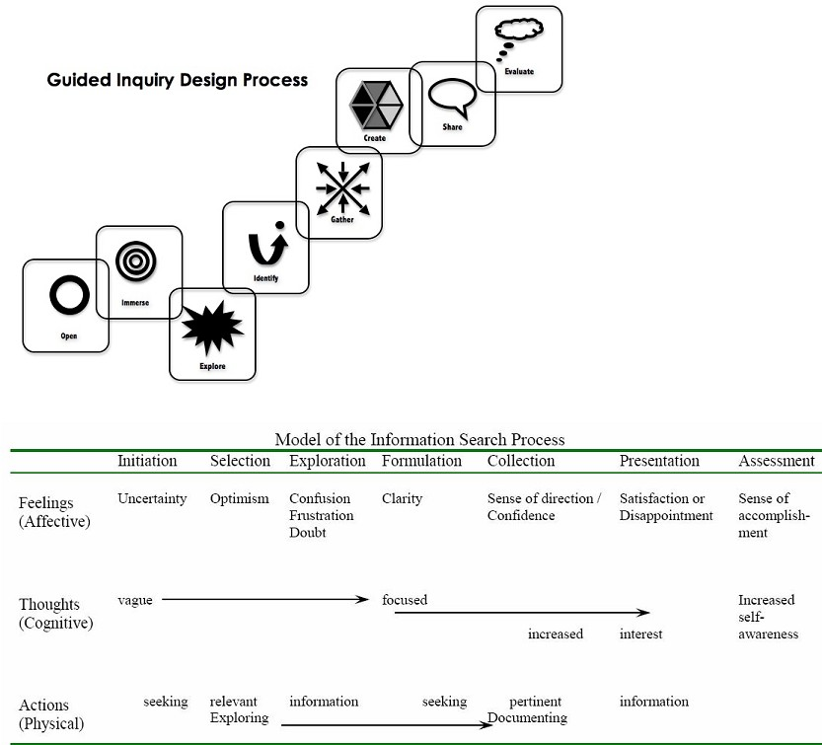 | Key Inquiry Skills – Australian Curriculum  Historical questions and research  Identify a range of questions about the past to inform a historical inquiry (ACHHS207)  Identify and locate relevant sources, using ICT and other methods (ACHHS208)  Analysis and use of sources  Identify the origin and purpose of primary and secondary sources (ACHHS209)  Locate, compare, select and use information from a range of sources as evidence (ACHHS210)  Draw conclusions about the usefulness of sources (ACCHS211)  Perspectives and interpretations  Identify and describe points of view, attitudes and values in primary and secondary sources (ACHHS212)  Explanation and communication  Develop texts, particularly descriptions and explanations that  use evidence from a range of sources that are acknowledged (ACHHS213)  Use a range of communication forms (oral, graphic, written) and digital technologies (ACHHS214)
Learning Scenario:
This Guided Inquiry Unit of work will look at five (5) aspects of life in Ancient China, including the impact and significance of archaeological finds and cultural awareness of China today.
Using Inquiry Circles, each group will have a piece of the ‘jigsaw’ puzzle in which they will investigate each of the five areas before narrowing the topic making sure the Research Question guides your research.
The Inquiry Circles will be used to collaborate and share your findings within your circle. Remember you are to become the ‘expert’ in your area of research.
A final ‘hot seat’ presentation will be used for students to come together to share their findings and ‘piece together’ and determine How Emperor Qin Shi Huang should be remembered?
Inquiry Circle member can ‘take questions from the floor’ about their topic.
After the presentations, the class with ‘connect the past with the present’, piece together the ‘jigsaw’ and ‘put posit’ notes around Emperor Qin Shi Huang to determine they have answered the BIG INQUIRY QUESTION: In what ways has Ancient China left an impact on today’s society? How do we know? e.g. significant individuals, artwork, government, canals, scientific discoveries, technologies etc.

Overview of Assessment: Inquiry Task - Inquiry Circles (Exposition) Explanation and Description of task and rubric for students understanding
- Scaffold 1 – Assessment for Learning Backward Map (Assessment Rubric) + SLIM Reflection Sheet 1 – explain process and the stages of scaffolded inquiry to
assist with students’ destination. the end of ‘product’ – Presentations to class
  - Identity desired results – focus on Inquiry Circles process of Inquiry and Big Inquiry Question – Stage 1 (Evaluate, Share, Create)
  - Determine acceptable evidence and importance of evidence – Stage 2 - aligned Stage 1 – (Gather, Identity, Explore)
  - Plan the experiences that align to Stages 1 and 2 – (Immerse and Open)
- Scaffold 2 – Assessment for Learning – Date - Narrative ‘hook’ – Napoleon quote - Hand in your scaffolded tasks of your interested topics

Inquiry Process – Invitation to Inquiry Process - 6 Questions – and Building Background - Complete Worksheets –
  - Think, Puzzle, Explore – more deeper inquiry – connect prior knowledge to engage interest
  - Construct Meaningful Choice Sheet and then construct a Mindmap – to summarise your ideas
- Scaffold 3 – Group Reflection and Brainstorming – K-W-L Chart and ‘Evaluator Inquiry Logs- Formative Assessment for Learning – Date
  - – Locating, Sharing and Evaluation Worksheet (4 column) - Formative Assessment for Learning - Date
- Scaffold 4 - Formative Assessment for Learning – Date: Hand in completed scaffold tasks for comment and suggestions
  - Scaffold Messenger Reflection – Inquiry moments: discuss with TL and teacher in collaboration with Inquiry Circle –
  - Connector – Flashcards, Dot Points or Cornell Notes - Formative Assessment for Learning - Date
- Scaffold 5 Participation and Presentation - Interpreter – Summative Assessment of Learning – Oral Presentation Date -
  - Inquiry Circle – ‘jigsaw puzzle formation - ‘Hot seat approach’
  - Final Reflection – Student, Peer, Teacher and TL
- Final Forum – Big Inquiry Question - and Connect Past with Present – Big Inquiry Question – Formative Assessment for Learning - Date

The Inquiry Circles: You are to choose one of the topics you have an interest in and then focus on the Inquiry Question.
All Inquiry Circles MUST also answer the overarching Big Inquiry Question as well as Inquiry Question, by looking at TWO primary sources: How do we know?
You will need to download and save two images of primary sources. Don’t forget to manage cite your evidence!
- Physical features and construction Inquiry Circle (ACDSEH005)
Inquiry Question: How does the physical features and construction tell us about life in Ancient China? How do we know?
- Chinese Society Inquiry Circle (ACDSEH041)
Inquiry Question: What do the key social groups in China tells about the different roles and what they did? How do we know?
- Beliefs and practices Inquiry Circle (ACDSEH042)
Inquiry Question: Why did Emperor Qin outlaw most forms of religion? How do we know?

Conflicts within/ and with other societies Inquiry Circle (ACDSEH043)
Inquiry Question: Why and How Did Emperor Qin unify China? How do we know this?

Role of Individual Emperor Qin - Inquiry Circle (ACDSEH132)
Inquiry Question: What does Qin Shi Huang’s tomb reveal about his life and achievements? How did he die? How do we know? Is his tomb a fitting memorial?

Legacy of Ancient China to modern life Inquiry Circle (ACHH S216 )
Inquiry Question: In what ways has Ancient China left an impact on today’s society? How do we know? e.g. government, canals, scientific discoveries, technologies etc.
Have fun inquiring and learning!!

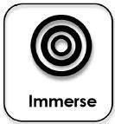
 | Alignment of Critical and Creative Thinking General Capability with the ISP/GI Design Process
GT Elements |  | C & C Organising Elements | INFORMATION SEARCH PROCESS (ISP)–  TL and Teacher | PHASES OF GUIDED INQUIRY (GID) -  Inquiry community |  | Enquiry and Information Skills – what the students are doing
Background Knowledge |  | Inquiring: identifying, and ideas Pose questions | INITIATION  Gather whole class for introduction lesson.  “Tell the story” (TL) + “Let China sleep, for when she wakes, she will shake the world’. (Napoleon)  Discovery of tomb in 1974. Archaeological Evidence  Introduce Documentary – Secrets of the First Emperor  Focus Questions: (T)  Discussion: End Product (T)  Connect Past with Present | OPEN  Your task: How should Emperor Qin Shi Huang be remembered?  Backward mapping (T) Marking Rubric Focus: process culminating in end product Storytelling/Predicting – Visual Images  Introduce and explain Inquiry Scaffold Tasks (TL) |  | REPRESENTATION, VIEWING AND COMMUNICATION  Reflection – SLIM Reflection Sheet1 and 2 View – Documentary/ies – observing  - Physical features  - Key social groups  - Beliefs and practices  - Conflict within/ and with other societies  - Significant people  - Archaeological find – ‘terracotta warriors’  Complete Scaffold Reflections (Literacy Standard 1 – Indicator 1) Construct Mindmaps of the topic areas.
High Expectations |  | Connect prior knowledge with new ideas
Cultural Knowledge |  | Identify and clarify information and ideas
Resources |  | Videos:  Clickview: Investigating History – Role of archaeologists and Key groups in Ancient China Secrets of the First Emperor: http://topdocumentaryfilms.com/secrets-first-emperor/ |  |  | Brainstorming – Mapping your Ideas https://www.youtube.com/watch?v=jj-F6YVtsxI&feature=youtu.be How Geography Isolated Ancient China: http://study.com/academy/lesson/how-geography-isolated- ancient-china.html
QT Elements |  | C & C Organising Elements | INFORMATION SEARCH PROCESS –  TL and Teacher | PHASES OF GUIDED INQUIRY -  Inquiry community |  | Enquiry and Information Skills – what the students are doing
Background Knowledge |  | Explore possibilities | SELECTION:  EXPLORATION – Thinking like an historian –  using sources – 10 Inquiry Questions to ponder (TL)  Explanation – (TL) Select a topic Primary and Secondary sources | IMMERSE:  Build background knowledge using  K-W-L Charts and Building Backgrounds  Connect to content and think/speculate Discover interesting ideas – (T) |  | REFLECTION AND BRAINSTORMING  Think about topic and explore further using charts (Literacy Standard 2 – Indicator 2))  Submit for feedback –  - KWL Charts  - Building Background Worksheet  - Evaluator Inquiry Log
Problematic Knowledge |  | Process information and consider alternatives
Resources |  | Videos:  Terracotta warriors: http://www.pbs.org/video/1411149610/ |  |  | Unification of Northern China under Shi Huangdi of the Qin Dynasty: http://www.youtube.com/watch?v=KdtgX9ORiW4|  Secrets of the First Emperor: http://topdocumentaryfilms.com/secrets-first-emperor/
Planning template developed by Karen Bonanno, Eduwebinar Pty Ltd. and Information Search Process and Guided Inquiry Design Framework, p29 Kuhltau, C., Maniotes, L. and Caspari, A. (2012)
Guided Inquiry Design: A Framework for Inquiry in Your School. Santa Barbara, CA: Libraries Unlimited Lee FitzGerald, 20

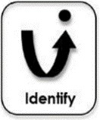
QT Elements | C & C Organising Elements | INFORMATION SEARCH PROCESS –  TL and Teacher | PHASES OF GUIDED INQUIRY -  Inquiry community |  | Enquiry and Information Skills – what the students are doing
Inclusivity | Exploring Information | Organise Inquiry Circles  Group by topic and interest area  Set up Google Classroom to share resources (TL)  Resources:  Placed in stations (TL)  Focus: TL to set up information stations (Courtesy: Services to Schools) | DISCOVERY:  Groups gather to have inquiry task explained further and allocate notecards with key search terms to each of the different inquiry groups.  Explain they have 2 lessons for this section of the inquiry task |  | SHARING AND COLLABORTING  Join Inquiry – using research terms  Move through the different stations – use 3 sources only (either books, texts or online sources).  Share and compare ideas (Literacy Standard 3 – Indicators 3 and 4)  Submit for Feedback:  ‘Evaluator’ – Use Worksheets – Inquiry Log Dot Points/Source
Connectedness | Clarify Information and ideas
Social Support | Organise and process information
Resources | SMART Notebook: The technological legacy of Ancient China Scootle  Macmillan History 7 Textbook – Ch 6 – Ancient China Retroactive 7 Australian Curriculum for History eBookPLUS |  |  | Encyclopedia Britannica.  Pearson’s Resource Centre – Pearson eBook 3.0 History 7.
QT Elements | C & C Organising Elements | INFORMATION SEARCH PROCESS –  TL and Teacher | PHASES OF GUIDED INQUIRY -  Inquiry community |  | Enquiry and Information Skills – what the students are doing
Student direction | Imagine possibilities and consider alternatives | FORMULATION:  Inquiry moments:  Focus: Apprehension and Anxiety Informal discussion | IDENTIFY:  Pause and ponder Identify inquiry question Decide direction.  Revisit – Inquiry and Big Inquiry Questions. |  | EXPLORATORY SEARCHING  Induce and Deduct – (Literacy Standard 4 – Indicator 2) Significant and/or Relevant (Literacy Standard 6 – Indicator 2)  Useful and/or Reliable (Literacy Standard 7 –  Indicator 2)
Student self- regulation | Seek solutions and put ideas into action
Resources | Websites:  Year 7 China – Teacher Librarian Help: https://teacherlibrarianhelp.com/research- guides/year-7-ancient-china/  Excavating the Tomb of China’s First Emperor: http://www.kaycorcoran.com/tomb- of-chinas-first-emperor.html |  |  | World Book Online: Qin Dynasty  China -Qin Dynasty: http://www.china-tour.cn/Chinese-History/Qin-Dynasty.htm Calthorpe Resource Centre: The Qin Dynasty Great Wall Of China: http://www.great- wallofchina.com/qin-dynasty.html
Planning template developed by Karen Bonanno, Eduwebinar Pty Ltd. and Information Search Process and Guided Inquiry Design Framework, p29 Kuhltau, C., Maniotes, L. and Caspari, A. (2012)
Guided Inquiry Design: A Framework for Inquiry in Your School. Santa Barbara, CA: Libraries Unlimited Lee FitzGerald, 201

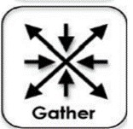
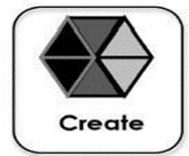
QT Elements | C & C Organising Elements | INFORMATION SEARCH PROCESS –  TL and Teacher | PHASES OF GUIDED INQUIRY -  Inquiry community | Enquiry and Information Skills – what the students are doing
Knowledge Integration | Collecting information – Evalulate | COLLECTION:  Focus: Can you communicate authentically and in a meaningful way about your topic | GATHER: Share  Support students as they investigate. | CONNECTOR:  Submit for Feedback:  Use Flashcards, Note, Taker, or Cornell Notes  Use Word Reference to recorded sources (Literacy Standard 8 –  Indicators 1,2 and 3)
Deep Understanding | Put ideas into action – expand on known and new information
Resources | UNESCO: http://whc.unesco.org/en/list/441
QT Elements | C & C Organising Elements | INFORMATION SEARCH PROCESS –  TL and Teacher | PHASES OF GUIDED INQUIRY -  Inquiry community | Enquiry and Information Skills – what the students are doing
High Order Thinking | Reflecting on actions and processes | PRESENTATION:  Focus: Inquiry and Big Inquiry Questions  Class Decision  Why should Emperor Qin Shi Huang be remembered?  Big Inquiry Question  In what ways has Ancient China left an impact  on today’s society? | CREATE:  Reflect on learning  Consider the Big Inquiry Question Teacher and Teacher Librarian mingle with groups  Tell your story’ creating a ‘big picture’ of  Ancient China and its First Emperor | INTERPRETER:  Inquiry Circles – Responses (Literacy Standard 9 – Indicators 1, 3 and 4)  Inquiry Group assemble in Jigsaw Pieces  “Hot Seat” and ‘Questions from the Floor’  Assemble Jig Pieces  CONNECT PRESENT WITH PAST
Deep Understanding | Transfer knowledge into new contexts
Substantive Communication | Applying logic and reasoning  Draw conclusions
Engagement
Planning template developed by Karen Bonanno, Eduwebinar Pty Ltd. and Information Search Process and Guided Inquiry Design Framework, p29 Kuhltau, C., Maniotes, L. and Caspari, A. (2012)
Guided Inquiry Design: A Framework for Inquiry in Your School. Santa Barbara, CA: Libraries Unlimited Lee FitzGerald, 201

QT Elements | C & C Organising Elements | INFORMATION SEARCH PROCESS –  TL and Teacher | PHASES OF GUIDED INQUIRY -  Inquiry community | Enquiry and Information Skills – what the students are doing
Substantive Communication | Giving and receiving feedback | ASSESSMENT:  Have you achieved your learning goals? What have I learnt? | EVALUATE:  Classroom Circle – Teacher and TL evaluation of inquiry unit and student processes  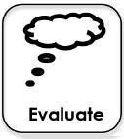 | REFLECTION:  Complete Peer and Student Evaluation (Literacy Standard 9 –  Indicator 4)
Narrative | Evaluating process
Planning template developed by Karen Bonanno, Eduwebinar Pty Ltd. and Information Search Process and Guided Inquiry Design Framework, p29 Kuhltau, C., Maniotes, L. and Caspari, A. (2012)
Guided Inquiry Design: A Framework for Inquiry in Your School. Santa Barbara, CA: Libraries Unlimited Lee FitzGerald, 201

 |  |  |  | Assessment Marking Rubric: Group work and Oral Presentation
 |  |  |  | A 25 - 21 | B 20 – 16 | C 15 - 11 | D 10 – 6 | E 5 – 0
Understanding and Information skills | Historical Knowledge and Understanding
 | Historical Skills | Inquiry Questioning and research | Describes and assesses the motives and actions of past individuals and groups in the context of past societies HT4-3  Skills AC (ACHHS212) | Comprehensive use of inquiry skills to demonstrate engagement with Guided Inquiry Process to analyse and evaluate key people and significant individuals | Thoughtful use of inquiry skills to demonstrate engagement with Guided Inquiry Process to analyse and evaluate key people and significant individuals | Some use of inquiry skills to demonstrate engagement with Guided Inquiry Process to analyse key people and significant individuals | Basic use of inquiry skills with Guided Inquiry Process to analyse key people and significant individuals | Little use of inquiry skills in Guided Inquiry Process and poor attempt to analyse key people and significant individuals
 |  | Analysing and interpreting | Uses evidence from sources to support historical narratives and explanations HT4-6 and  Skills AC (ACHHS210) | Outstanding evidence of understanding the contribution of each of the inquiry circles to a picture of life in Ancient China | Strong evidence of understanding the contribution of each of the inquiry circles to a picture of life in Ancient China | Some evidence of understanding the contribution of each of the inquiry circles to a picture of life in Ancient China | Basic evidence of understanding the contribution of each of the inquiry circles to a picture of life in Ancient China | Little evidence of understanding the contribution of each of the inquiry circles to a picture of life in Ancient China
 |  | Communicating | Selects and uses appropriate oral, written, visual and digital forms to communicate about the past HT4-10 and Skills AC  (ACHHS213)  CCA General Capabilities  (ACHH216) (ACHHS087) | Communicates clearly, effectively and convincingly using various mediums to draw conclusions about the past.  Acknowledges sources of all information and incorporates relevant sources | Communicates clearly and effectively using various mediums to draw conclusions about the past.  Acknowledges sources of most information and incorporates relevant sources | Communicates reasonably well using various mediums to draw conclusions about the past.  Acknowledges sources of some information and incorporates sources | Communicates using some mediums to talk about the past.  Only some sources acknowledged | Communicates using few mediums to talk about the past.  Little acknowledgement of sources

Dr Lynne Vey
Teacher Librarian
Cootamundra High School
CSU M.Ed.TL student.

