Year 10 Rights and Freedoms: The story of Freedom
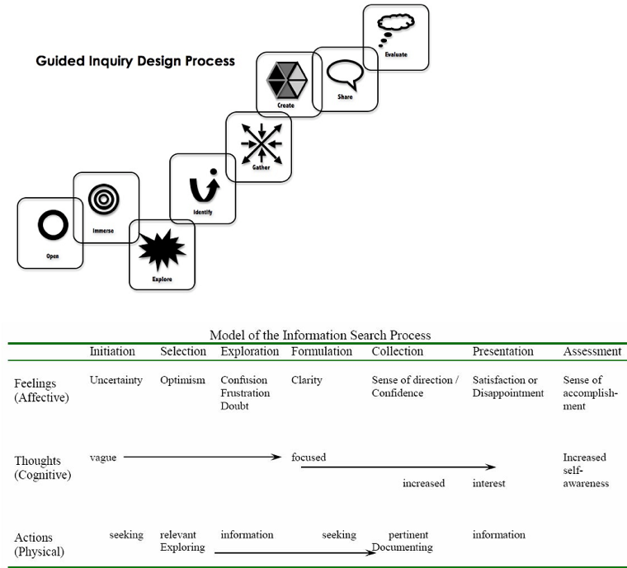 |  | UNIT OVERVIEW  The journey to freedom is difficult, aided by strong individuals, set back by  prejudice, affected by events in overseas struggles, and derives from the  Magna Carta, through to the Universal Declaration of Human Rights.  Concept: Rights and Freedoms begins with the development of the United Nations  after WW2, with a focus on Australia's role in the development of the Declaration of  Human Rights through the work of Doc Evatt. The unit then goes on to look at the plight  of Aboriginal and Torres Strait Islander people in Australia, and the long road toward  gaining human rights for them from 1788 to present day.  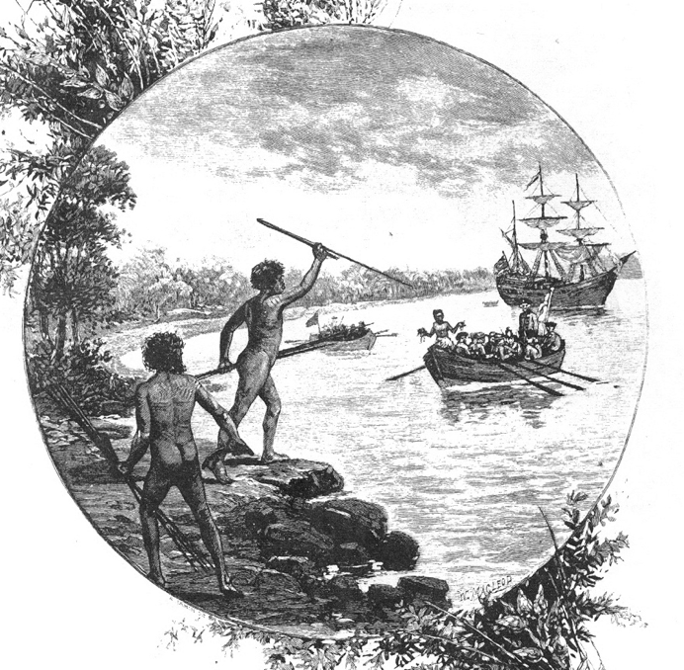
Core Inquiry Skills in this unit
Identify/locate/ /compare/select/evaluate points of view
Use evidence/justify/work collaboratively/communicate (oral and written text)
Key Inquiry Questions (from the curriculum)
How was Australian society affected by other significant global events and changes in this period? (1945 – present)
Curriculum Skills
https://acaraweb.blob.core.windows.net/resources/HASS_-_GC_learning_area.pdf

Content description (from the curriculum)  Stage 5 - Core Study - Depth Study 4: Rights and freedoms (1945-present)  The origins and significance of the Universal Declaration of Human Rights (UDHR), including Australia's involvement in the development of the declaration (ACDSEH023)  - outline the purpose of the United Nations and describe the origins of the Universal Declaration of Human Rights, including Australia's involvement  - explain the significance of the UDHR  Background to the struggle of Aboriginal and Torres Strait Islander peoples for rights and freedoms before 1965, including the 1938 Day of Mourning and the Stolen Generations (ACDSEH104)  - explain the purpose and significance of early twentieth-century Aboriginal activism including the 1938 Day of Mourning protest for Aboriginal and Torres Strait Islander peoples  - outline the rights and freedoms denied to Aboriginal and Torres Strait Islander peoples before 1965 and the role and policies of the Aboriginal Protection Board, eg the control of wages and reserves  - using a range of sources, describe the experiences of Aboriginal and Torres Strait Islander peoples who were forcibly removed from their families (Stolen Generations)  - describe the effects of the assimilation policy for rights and freedoms of Aboriginal and Torres Strait Islander peoples  The US civil rights movement and its influence on Australia (ACDSEH105)  - outline the aims and methods of the US civil rights movement |  | - explain how the Freedom Rides in the US inspired civil rights campaigners in Australia  - discuss the impact of the NSW Freedom Ride on the civil rights of Aboriginal and Torres Strait  Islander peoples  The significance of the following for the civil rights of Aboriginal and Torres Strait Islander  peoples: 1962 right to vote federally; 1967 Referendum; Reconciliation;  Mabo decision; Bringing Them Home Report (the Stolen Generations); the Apology (ACDSEH106)  - outline the background, aims and significance of key developments in Aboriginal and  Torres Strait Islander peoples' struggle for rights and freedoms  Methods used by civil rights activists to achieve change for Aboriginal and Torres Strait Islander  peoples, and the role of ONE individual or group in the struggle (ACDSEH134)  - outline common methods used by civil rights activists to achieve change for Aboriginal and  Torres Strait Islander peoples  - investigate and explain the role of ONE individual or group in the struggle for Aboriginal and  Torres Strait Islander peoples' rights and freedoms  The continuing nature of efforts to secure civil rights and freedoms in Australia and throughout  the world, such as the Declaration on the Rights of Indigenous Peoples (ACDSEH143)  - identify current struggles for civil rights and freedoms throughout the world, such as the  United Nations Convention on the Rights of the Child (1990) and the Declaration on the Rights  of Indigenous Peoples (2007)  - identify different methods used globally to attain civil rights and freedoms  - evaluate the methods and effectiveness of ONE campaign for civil rights and freedoms  in Australia or another country
Learning scenario
Students will research, using the Guided Inquiry process, an aspect of their choice within this topic. Through individual research and Inquiry Circle discussions they will relate their
topic area to the overarching question: How was Australian society affected by other significant global events and changes in this period? (1945 – present)

Aspects to consider would be:
What events led to freedom and equality?
Who were the leaders who helped in this and how did they contribute?
What events or incidents have occurred to assist in bringing about change?
Why are some struggles for civil rights successful, and some not? Has the aboriginal struggle for civil rights been achieved?
How have the Australian Aboriginal people compared to the African American people and what is the way forward in Australia?

“The road is long, with many a winding turn
That leads us to who knows where, who knows where
But I’m strong, strong enough to carry him
He ain’t heavy – he’s my brother”

Summary of Tasks and dates goes here:

Assessment: Inquiry task – Overview – Description for students, with summary of key dates

Content - Final Essay /20
Process - Scaffold completion and submission /20
Collaborative Contribution - Edmodo contributions particularly in Inquiry Circles sub groups /20
Guided Inquiry Stage | What the teaching team is doing - Strategies |  | What students are doing – Tasks
Description of OPEN: Create a powerful open that invites students to engage in the inquiry topic.
INITIATION - Open | Preliminary CSU data questionnaire – Alinda – Introduce CSU Research Study and permission forms  Link this topic to the previous unit through guided discussion  Show short video and infographic (students look at infographic on devices at their own pace then respond)  Post need for a reflection about the infographic on the Edmodo wall for student responses |  | Online questionnaire for CSU researchers.  Permission forms to get signed.  Watch video and then work through the infographic  Respond with one paragraph on the Edmodo wall  as a response to this. (As a reply to the teacher’s call for comments)  Homework: View this digibook with it’s embedded clips.  as an overview review http://splash.abc.net.au/home#!/digibook/618058/rights-and-freedoms  Later, you will join an inquiry circle based on  your choice of broad area.  For now,  - Get organised – download the scaffolds  from Edmodo  - Get organised with the notetaking and referencing scaffold as somewhere to  keep your references for your final  Bibliography  - Locate and bookmark the Diigo site for  this unit.  - Read the assessment guidelines for the GI.
Resources
http://www.humanrights.gov.au/magnacarta/video/

http://www.humanrights.gov.au/magnacarta/infographic/

http://splash.abc.net.au/home#!/digibook/618058/rights-and-freedoms

https://www.youtube.com/watch?v=x9_IvXFEyJo (Links WWII - Amnesty International)

https://www.theguardian.com/childrens-books-site/gallery/2015/jan/30/human-rights-in-pictures-we-are-all-born-free-amnesty

Description of IMMERSE: Students build their background knowledge by immersion in the content. Students reflect on the content and
select a topic for further investigation.

SELECTION - Immerse 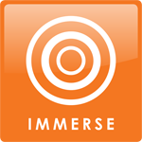  Aspects of study:  What were the origins and significance of the Universal Declaration of Human Rights  How did the US civil rights movement and its influence on Australia?  4.  What is the background, aims and significance of key developments in Aboriginal and Torres Strait Islander peoples' struggle for rights and freedoms?  What was the background to the struggle of Aboriginal and Torres Strait Islander peoples for rights and freedoms before 1965, including the 1938 Day of Mourning and the Stolen Generations?  3  What were the methods used by civil right activists to achieve change for Aboriginal and Torres Strait Islander peoples, and the role of ONE individual or group in the struggle?  What is the continuing nature of efforts to secure civil rights and freedoms in Australia and throughout the world, such as the Declaration on the Rights of Indigenous Peoples (UDHR), including Australia's involvement in the development of the declaration? | Give students an overview of all 6 aspects of the topic:  Class Activities Booklet - first five areas  1. United Nations formation: Universal Declaration of Human Rights  Assign ‘Rights’ to individuals (pull from the hat). Where was, or is your assigned ‘right’ violated? Share place and example with the class.  2. Indigenous Issues: Day of Mourning; Stolen generation  3. Civil Rights Movement – USA and Australia  4. Struggles for freedom in Australia  5. Individuals involved in change for Aboriginal and Torres Strait Islander peoples in Australia  6. Ongoing efforts to secure rights and freedoms in Australia and the world  Guide and direct students as they complete activities and briefly research into all of these key aspects of the topic |  | Complete the activities provided and research into the  six aspects of this unit.  Write answers or reflections into into  “Scaffold1_Immerse_MakingtheChoice” so they can  determine the topic area of most interest to them.  Select which of these areas interest them the most? They are free  to follow their own interest.  Tips:  - Keep to OVERVIEW information - Stay away from  Google, for now.  - Use encyclopedias, Wikipedia, Clickview and  Youtube, and books that provide overview information.  - Just browse! Look at several topics.  - Use the scaffold: “Scaffold1_Immerse_Makingthe  Choice” to help narrow interest.  - Use a Word Document to initially keep track of  resources for a future Bibliography.  - Complete a reflection of learning when it is  called for on Edmodo.  Select area of the topic and post this to Edmodo  when asked. Edmodo Inquiry Circle group is based on this.
Resources
Declaration of Human Rights poster; Rights separated on paper for task - 3 sets;
Booklet of activities divided into the 6 areas of the topic.
Diigo set of resources for each of these areas – textbook, Skwirk
http://www.nma.gov.au/__data/assets/pdf_file/0018/19440/Indigenous_rights_freedoms-all-BW.pdf
http://splash.abc.net.au/home#!/digibook/618058/rights-and-freedoms
http://indigenousrights.net.au/resources/teachers_resources/indigenous_rights_and_freedoms,_1957-1975
https://www.australianhistorymysteries.info/demo/downloads/AHM2_casestudy4_web.pdf
http://www.civicsandcitizenship.edu.au/cce/act_2_australias_indigenous_people,30082.html
http://aso.gov.au/titles/documentaries/freedom-ride-blood-brothers/
http://www.scootle.edu.au/ec/search?accContentId=ACDSEH134

Description of EXPLORE: Students browse and scan through a wide range and variety of resources to explore interesting ideas around their
topic. “Go broad”
EXPLORATION - Explore | Make sub groups in Edmodo for each Inquiry circle - enter students to their subgroup. Dialogue with students eg What aspect are you having difficulty finding information for?  Encourage contributions to each other within subgroups  Organise an Inquiry Circle time for sharing of wondering questions and aspects of topic of interest to their peers.  Ask for a reflection of learning on Edmodo at the end of this stage (Within the Inquiry Circle subgroup)  Assist students to find resources - particularly those who are in a ‘Dip’ |  | Students join an Inquiry Circle based on their topic area of choice in  Immerse, to share the work of preliminary searching.  Students search to find the scope of the topic area, to get a broad  picture of what happened when, and some indications of points  of view about this topic area.  Use the scaffold: “Scaffold2_Explore_Notetaking__Keeping_  Organised  Use the scaffold: “Scaffold3_Explore_Wondering questions” To get  Started and discuss aspects of interest in Inquiry Circles.  They can now use some specific sources relating to the topic area,  such as, Questiaschool, Skwirk and books.  It is likely that they will experience some information overload  at this stage, and it is good to remember that this is  completely normal, and is “The Dip”!  Complete a reflection of their learning when it is called for on Edmodo.
Resources:
“Scaffold2_Explore_Notetaking__Keeping_
Organised
Questia School
Databases
Books
Skwirk

Description of IDENTIFY: Students develop an inquiry question or questions and form a focus for their research. The question or questions will frame the rest of the inquiry.
FORMULATION - identify | Support students - assist in their clarification of aspects of their chosen topic as it links to the broad overarching question: How was Australian society affected by other significant global events and changes in this period? (1945 – present)  Organise Inquiry Circles to discuss Scaffold 4A from which they will formulate an initial research question.  Call Inquiry community together to give them information on sharing their information in their inquiry circle, by creating a brief chart that summarises what each member has found out about their sub questions.  Inquiry circles to work together to collate information.  Inquiry circle reflection on overarching focus: How was Australian society affected by other significant global events and changes in this period? (1945 – present)  Final sharing of information in each Inquiry Circle to create collation to be submitted to teacher for copying for whole class. Collation sheet is to have a wide margin left blank for student annotations. Each student to be given time to analyse notes from each Inquiry Circle. They are to annotate as they read, noting points of interest, questions to ask, points of disagreement.  Scaffold 4B - Individual student Interview  Interview individual students when they have a final research question assisting to refine the wording (Call in more teachers where necessary (Special Needs teachers need to be booked for these lessons/other Humanities teachers if available. |  | Students think about what they have in the way of information and  what they are going to do with it.  Read over notes, cull them, sort them, until a clearer picture  emerges of what they have and that they can be certain of  their focus.  Start to consider broad directions that their topic may take,  which will aid them in the later construction of the essay question.  Use Scaffold4A _Pair_share_protocol with a partner - This is to work  together to help each other understand open questions and to  formulate personal inquiry questions.  When they have a research question composed,  they put it through Scaffold4B_Identify_BigQuestionMachine  to refine it
Resources
Scaffold4A _Pair_share_protocol
Scaffold4B_Identify_BigQuestionMachine

Description of GATHER: Collect detailed information from a variety of information sources – “Go deep”
Description of CREATE: Organise gathered information to create their product – “Tell the story”

COLLECTION - Gather & Create | Collated information sheets given to students  Revision of PEEL essay writing  Go through marking criteria with students  Discuss research questions with students individually as they gather information and shape it into their essays.  Assist with Mind Mapping to frame answers - individually or in groups if similar questions are written.  Set up the assignment submission on Edmodo  Request a reflection on Edmodo from the whole class  Check submission of essays to Turnitin. |  | Revise in class: PEEL essay guide  Gather ONLY the information that answers the Inquiry question. Take notes in a shared format with the class teacher and Mrs Sheerman, and keep Bibliography list up to date.  Use a mind map to frame the answer - they may do this with others who have a similar research question.  It is here that they will use specific sources that may be hard to read. Have them ask for help in the access and understanding of them. Use Questiaschool, library books, the State Library online databases, e.g. Cambridge Histories, JSTOR and Proquest History.  Check originality on the class Turnitin  Submit the essay including Bibliography to Turnitin and on Edmodo by the due date  Reflect on the writing process on Edmodo.
Resources
Questiaschool, library books, the State Library online databases (e.g. Cambridge Histories, JSTOR and Proquest History.)
Description of SHARE: Learn from each other; Share learning; Tell your story
PRESENTATION – Share | Jigsaw Forum:  Organise students into jigsaw groups with representatives from each topic area.  Students contribute to a ‘conversation’ about the overarching question. (15 minutes) |  | Jigsaw Forum  Take part in a jigsaw group contributing to the overarching question  with information from the specific area personally studied for  the essay.
Resources
Key Inquiry Questions (from the curriculum)
How was Australian society affected by other significant global events and changes in this period? (1945 – present)
Curriculum Skills
https://acaraweb.blob.core.windows.net/resources/HASS_-_GC_learning_area.pdf

Description of EVALUATE: Students reflect on their content learning and the progress through the inquiry process.
Assessment – Evaluate | Culmination conversation  (teaching team)  In a class forum situation ask high order questions to which all students are required to take part during the ‘conversation’  Final student evaluation on SurveyMonkey |  | Culmination conversation  (students)  During a culmination conversation each student will answer a  higher order question relating to the area they have written their  essay about, and listen to their classmates respond to a  similar question about their area of research.  A final student evaluation questionnaire will be given  via a link on Edmodo
Evidence Strategies / Assessment (Formative / Summative; Informal, formal)
Formative:
Initial Questionnaire - SurveyMonkey
Summative:
Essay (written)
Culminating conversation (oral)
Informal:
Participation observations from contributions to Edmodo group, subgroup and Inquiry Circles
Two questionnaires at stages of the GI process

Program by A Sheerman based on the work of Kuhlthau, C.C., Maniotes, L.K., & Caspari, A.K. (2012). Guided inquiry design: A framework for inquiry in your school. Santa Barbara, CA: Libraries Unlimited.

