Inquiry task and lesson plan for Stage 4 English and CCP – Sustainability
By Sara Graf
Inquiry question: How are our lifestyles shaping and changing the planet?
Aim: To write a feature article on an aspect of how our lifestyles are shaping and changing the planet.
Class  😊 😊 😊  😊 😊 😊 | How much of what we purchase becomes rubbish, garbage or trash? How does this trash impact on our lives? We’ll look at some interesting ways people quantify and conceptualise trash.  Tasks: Explore artworks and comics, glossary, “Track my thinking” part 1
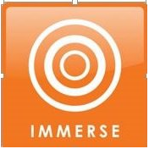  😊 😊  😊 😊 | How do you think about rubbish? We’ll do an opinionnaire and discuss our own perceptions in groups.  Then we’ll watch two films, discuss our thoughts and ideas about them, then write a personal response.  We will begin creating an annotated bibliography here.  Tasks: Opinionnaire, discussion groups, watch documentaries, summaries, personal response, annotated bibliography
😊 😊  😊 😊 | What is sustainability? What interests you so far: e-waste, how different countries recycle, microplastics, freegans, artwork from rubbish, living plastic-free? Choose your expert topic group to learn more – then share these new ideas with others in the class.  Tasks: Expert group research, discussions, mindmaps, add to bibliography, “Track my thinking” part 2
😊 | What can we learn from Brennan Bird? We’ll look at a feature article about how he has influenced his community.  You will develop a specific inquiry topic that you will focus your own feature article on.  Use KWHL chart to help focus and know what to search for.  Tasks: Character profile and opinionnaire for Brennan Bird, define inquiry topic
😊 | We will gather important information for our feature articles. What makes an effective feature article? You will find some quotes or statistics that can make your article more persuasive. Use your annotated bibliography here to help.  Tasks: Research, take notes and summaries, add to bibliography, “Track my thinking” part 3
😊 | We will write our feature articles individually and add pictures and quotes. This is your main assessment piece.  The articles will be published in a magazine and shared with the school and community to raise awareness of sustainability.  Tasks: Write article, type and format article on computer, peer appraisals
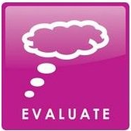  Class  😊 😊 😊  😊 😊 😊 | How do you think this unit went? We’ll complete an evaluation survey and give each other feedback on what we learnt and how we can further improve.  Tasks: “Track my thinking” part 4, class discussion and feedback, evaluation survey

What each student will produce throughout unit:
- Glossary of new and important terms
- Record of developing knowledge and thoughts with “Track my thinking” worksheet
- Opinionnaire results from multiple perspectives
- Annotated bibliography of all sources utilised in unit – includes summaries for each source (part of TL assessment)
- Personal response to documentary
- Mindmap from expert group activity (discussions used as part of TL assessment)
- Inquiry topic definer – teacher librarian developed scaffold and/or KWHL chart
- Researched notes including statistics and quotes for chosen inquiry topic (part of TL assessment)
- Peer reviews using the “Peer appraisal” worksheets before publication
- Feature article published in a class magazine (end product and summative assessment for English teacher)
- Evaluation survey

Assessment Rubric for Teacher Librarian standard: Inquiring – identifying, exploring and organising information and ideas

Criteria | Evidence/Task | Approaching standard | At level | Beyond expected
Pose questions | Participation in expert group research and discussions | Ask questions to clarify and interpret information and search for causes and consequences | Ask questions to examine assumptions and investigate complex issues | Ask questions to critically analyse complex issues and abstract ideas
Identify and clarify information and ideas | Notes and questions during research time | Identify and clarify relevant information by describing and giving reasons | Clarify information and ideas from texts or images by explaining and providing evidence | Clarify complex information and ideas by identifying and analysing assumptions and providing evidence
Organise and process information | Creating and using annotated bibliography | Analyse and combine relevant information from multiple sources | Critically analyse information and evidence by considering validity and relevance | Critically analyse information and evidence to determine bias and reliability

Introductory lesson plan:
Class: Yr 8 English (50 mins) | Date: |  | Topic: Sustainability | Inquiry stage: Open
Learning Intentions – What do I want students to learn and be able to do as a result of this lesson?
Students will be able to
- analyse and explore media texts to identify ideas and meaning
- understand the Guided Inquiry process
Success Criteria
How will I know whether the learners achieved what I wanted them to achieve?
You know you can do this when you
- Create captions for two comics about rubbish
- Explain how these comics relate to our inquiry question “How are our lifestyles shaping and changing the planet?
- Describe the steps we will take to explore our inquiry question
Lesson content
What are the key facts, concepts, procedures that I want learners to understand as a result of this lesson?
- Features and devices of media texts
- Our lifestyles (with particular focus on our use of rubbish) affect our environment and behaviours
Introduction/Hook – How will I get learners motivated, curious and ready to learn? How will I ‘hook’ the students?
Display the initial comic (Shopping, by Jan Gillbank – see resources) on the projector as students arrive.
Have pieces of rubbish scattered around the classroom to activate their senses and promote discussion.
Teacher activities  What are the teachers going to be doing during the lesson? (ET=English teacher, TL=Teacher librarian  Welcome students  ET: Introduce comic on screen – explain that many cartoons are satirical; that is, they present a critical but humorous perspective on a topic or issue.  Listen to student responses  ET: Describe learning intentions for the day  Show “Trash” comic on screen (see resources)  ET: Invite students to create their own captions to go with the cartoons: captions that highlight what they believe to be the key messages presented by the artists.  TL: Introduce inquiry question: “How are our lifestyles shaping and changing the planet?” (Write on board)  Connect the captions and student thinking back to the inquiry topic.  TL: Hand out overview of inquiry unit. Divide students into 7 groups.  Both: Answer questions. Assist as required.  TL: Randomly choose students to briefly describe each stage.  ET: Check on learning intentions  ET: Describe homework (posted on Edmodo for all students). See below for details.  Randomly choose students to repeat homework task to ensure understanding.  Instruct to pack up, wait to be dismissed. |  | Student activities  What are the learners going to be doing during the lesson?  Arrive in classroom (tables arranged in U shape), notice rubbish around and comic on screen.  Listen.  Think, pair, share using I see, I think, I wonder model about “Shopping” comic  Listen.  Ask questions for clarification  Class discussion - I see, I think, I wonder model  Students create and write captions in workbooks.¹ (Leave space for title of topic)  Share some with class.  Listen. Write title (question).¹  Class discussion of connections  (Jigsaw activity) ¹  Each group read and discuss one stage of GI plan.  Then share with others so all understand process. Ask any clarifying questions as class discussion.  Be prepared to describe any stage.  Hands show ratings between 0-5 on confidence with each learning intention.  Listen and check Edmodo.  Be prepared to repeat homework task.  Pack up, stand behind chairs. |  |  | Timing  How long will each task take?  2 mins  5 mins  3 mins  5 mins  10 mins  2 mins  5 mins  10 mins  4 mins  3 mins  1 min
Closure – How will I bring the lesson to a logical conclusion?
Review learning intentions for ‘hand’ reflection (see above)
Homework – Explore one of Chris Jordan’s artwork. Be ready to explain what it represents next class. Student with dyslexia may use text-to-speech on computer when investigating. (Success criteria for next class includes: Explore and explain the impact Chris Jordan’s artwork has on us as viewers)
Lesson evaluation – How will I evaluate the success of the lesson?
Completion of success criteria
²Student participation in discussions – use discussion chips, students must use 2 per class (in other words, must participate 2 times in discussions).
²Personal ‘hand’ reflection – if many students 3 or below on GI process, may need to review next class. Exploring media task will be continued next class, so low scores to be expected here.
Curriculum link – How are the learning goals linked to your state’s curriculum frameworks?
English:
- Analyse how the text structures and language features of persuasive texts, including media texts, vary according to the medium and mode of communication. ACELA1543
- Identify and evaluate devices that create tone; for example, humour, wordplay, innuendo and parody in poetry, humorous prose, drama or visual texts. ACELT1630
Critical and creative thinking
- Inquiring – identifying, exploring and organising information and ideas
  - Identify and clarify information and ideas
  - Organise and process information
- Analysing, synthesising and evaluating reasoning and procedures
  - Apply logic and reasoning
- Generating ideas, possibilities and actions
  - Imagine possibilities and connect ideas
  - Consider alternatives.

¹Teacher’s aide to specifically assist child with dyslexia in this activity. All other times to assist generally in student discussions.
²These are tasks/habits regularly performed in this English class so student are familiar with process

Resources

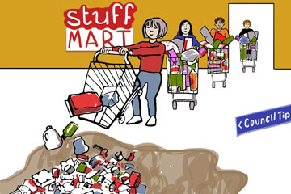
Shopping, by Jan Gillbank. http://e4ac.edu.au/units/year-8/sequence01.html

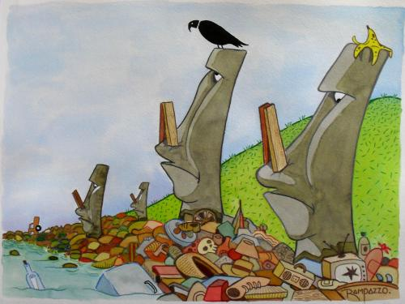
Trash, by Marcelo Rampazzo. https://www.toonpool.com/cartoons/Trash_56025

