**Stage 4 English and Critical and Creative thinking**

**Syllabus Outcomes**

**A student:**

2. Effectively uses a widening range of process, skills, strategies and knowledge for responding to and composing texts in different media and technologies.

5. Thinks imaginatively, creatively, interpretively and critically about information, ideas and arguments to respond to and compose texts.

8. Identifies, considers and appreciates cultural expression in texts.

**General Capability:**

**Critical and Creative Thinking**

* + *use comprehension strategies to compare and contrast information within and between texts, identifying and analysing embedded perspectives, and evaluating supporting evidence (ACELY1744, ACELY1754)*

**Intercultural** **Understanding**

**Recognising culture and developing respect**-

* + Explore and compare cultural knowledge, beliefs and practices *(ACARA, n.d.c)*

**Cultural Worlds – What makes cultures unique? By Lisa McKenzie**

**Inquiry Task and Lesson Plan**

|  |
| --- |
| **Learning Scenario/Student Information** |

**GUIDED INQUIRY TASK**

**Your Task:**

Our class is now an *Inquiry Community*.

We are focused on answering an Overarching Inquiry Question:

*“What makes cultures unique?”*

1. In introductory lessons, the class will gain some **background knowledge** about the concept of culture and learn some inquiry skills.
2. You will then choose one of the following *‘cultural worlds’* to explore.

You will work in an ‘inquiry circle’ with other students who have similar interests.

a) Modern Australian Culture

b) Indigenous Peoples and First Nations

(Including Aboriginal and Torres Strait Islander cultures)

c) Polynesia and Pacific Islands

d) Asia

f) South America

g) Europe

h) Sub- Cultures

(Lifestyle, Political and Social Behaviour groups)

1. As part of your ‘inquiry circles,’ you will learn inquiry skills including note taking, creating bibliographic references, evaluating sources and sharing your information with your circle through shared documents and discussions.

Focus on the following:

• *What* are the defining features of this ‘cultural world?’

(Knowledge, beliefs, and practices)

• *How* has this ‘cultural world’ changed over time?

• *Why* has this ‘cultural world’ changed?

1. Assessment:

Individually you will prepare a 3-5-minute speech accompanied by a visual representation, on a culture or subculture of your choice.

Answer these questions:

1. What are the defining features of this specific culture which make it

unique?

b) Explain *how* this culture has changed over time.

c) Explain *why* this culture has changed over time.

d) What is your personal interest and connection to the culture you have

researched?

e) How does your visual representation represent the unique nature of

this culture?

A Bibliography is to be included.

The engaging visual representation of the culture is to be a digital format, which you are expected to refer to throughout your presentation.

**Inquiry Skills Assessment Rubric**

*Outcome 2:* **A Student effectively uses a widening range of processes, skills, strategies and knowledge for responding to and composing texts in different media and technologies**

*Compare and contrast information within and between texts, identifying and analysing embedded perspectives, and evaluating supporting evidence (CCT)*

|  |  |
| --- | --- |
| **Marking Criteria – Inquiry Skills (Process)** | **Grade** |
| * **Exemplary use of Inquiry Log, demonstrating highly effective comparison, contrast, and evaluation of sources.** * **Exemplary use of Inquiry Log demonstrating a high level of competence**   **In collecting and organising detailed, relevant information from a high range of sources.**   * **Exemplary Participant in Inquiry Circle sessions** * **Exemplary use of Inquiry Journal demonstrating an extensive understanding of personal processes and strategies for inquiry.** | **A** |
| * **Accomplished use of Inquiry Log, demonstrating thorough comparison, contrast, and evaluation of sources.** * **Accomplished use of Inquiry Log demonstrating competence**   **in collecting and organising detailed, relevant information from a good range of sources.**   * **Strong Participant in Inquiry Circle sessions** * **Accomplished use of Inquiry Journal demonstrating an understanding of personal processes and strategies for inquiry.** | **B** |
| * **Sound use of Inquiry Log, demonstrating adequate comparison, contrast, and evaluation of sources.** * **Sound use of Inquiry Log demonstrating some competence**   **in collecting and organising relevant information from a range of sources.**   * **Adequate Participation in Inquiry Circle sessions** * **Sound use of Inquiry Journal demonstrating adequate understanding of general processes and strategies for inquiry.** | **C** |
| * **Basic use of Inquiry Log, adequate comparison, contrast or evaluation of sources.** * **Basic use of Inquiry Log to collect and organise information, source range is limited.** * **Limited participation in Inquiry Circles** * **Limited Inquiry Journal shows limited understanding of inquiry process.** | **D** |
| * **Very limited use of Inquiry Log/ many entries not complete.** * **Very limited use of Inquiry Log to collect or organise information from very limited source range.** * **No Engagement in Inquiry Circles** * **Elementary use of Inquiry Journal /No use of reflection or understanding of inquiry process.** | **E** |

**GUIDED INQUIRY UNIT OVERVIEW**

|  |  |  |  |
| --- | --- | --- | --- |
| **Phase of Inquiry** | **Inquiry Community Actions**  **(Student Tasks)** | **Resources/**  **Scaffolds** | **Tools** |
| **OPEN** | * Brainstorm own understanding of ‘culture,' answering the question ‘What is Culture?’ or, alternatively, finishing the sentence ‘I think culture is….’ * Think-pair-share: Students and share their understanding of the concept, deciding whether to change original definitions. * Responses shared visually through online posit – Lino. Responses recorded to model discussion note taking. * View ‘What is Culture’ and ‘Seven Aspects of Culture’ to expand understanding of defining features of cultures. * Pairs sort definitions into ‘observable’ and ‘invisible’ cultural aspects. Pairs create a new definition for ‘culture.' * Teachers introduce ‘inquiry task’ and ‘Inquiry Mountain’ and assist students in understanding task processes and requirements through annotation of keywords, ideas, concepts. * Inquiry Journal: Reflection on new understandings about culture, cultural aspects and what aspects of culture for o explore further in inquiry journal. | * YouTube Videos: * *7 aspects of culture* * *What is Culture?* * Inquiry Mountain * Inquiry Journal- Reflective Questions   (Full Bibliographic and Scaffold Details See Appendix 1 and 2.) | * Lino |
| **IMMERSE** | * Viewing/reading a text(s) in class time for the close study of forms of cultural expression within texts. * Use comprehension strategies to compare information concerning cultures within texts using Venn Diagrams and Comparison Charts, identify and analyse cultural perspectives, providing supporting evidence for arguments from texts. * Inquiry Journal: Reflection on understandings and feelings about cultural knowledge, beliefs, and practices from texts * Reread Inquiry Journal for possible areas of investigation. Select an Inquiry Circle to join. | Suggested Resources:  Short Stories   * *Neighbours* * *Going for Kebabs.*   Novels   * *Deadly Unna* * *Tev* * *Telesa: The Covenant Keeper*   Non-Fiction   * *The Happiest Refugee*   Film   * *Spirited Away*   (Full Bibliographic Details See Appendix)   * Venn Diagrams * Comparison Charts * Scaffolds: Persuasive Paragraphs. * Inquiry Journal- Reflective Questions |  |
| **EXPLORE** | * Inquiry Circles: brainstorm possible topics to answer inquiry questions given, appropriate search keywords and sources including print, digital and multi-modal texts (Reoccurring Task) * Inquiry Circles: Take notes on sources explaining and comparing source perspectives and relevance in Inquiry Log, recording bibliographic information of the source, recording in a Shared Google Doc. * Completion of further Inquiry Journal entries identifying understandings of the ‘Cultural World’ and areas of interest. | * Brainstorm Chart * Advanced Search Techniques Reference Sheet * Source Evaluation Reference Sheet * Question Prompts * Pathfinders * Inquiry Log (Scaffolded for relevant quotes, keywords, perspectives, bibliographic information, source evaluation and comparison) * Inquiry Journal – Questions * Library Collection (Books, Magazines, Videos) | * Bing * CC Search * Citation Machine * ClickView * DuckDuck Go * Google Arts and Culture * Google Classroom * Google Docs * Oliver Library   Catalogue |
| **IDENTIFY** | * Reread Inquiry journal and identify concepts and ideas of most interest. * Complete Inquiry Chart brainstorming, posing questions to guide research on a selected ‘Cultural World.' * Complete a *Reflection Sheet* in Google Forms at this point in Inquiry reflecting on current understanding of topic and task, paste copy into Inquiry Journal. | * Inquiry Journals * Inquiry Chart   (Sentence Starters) | * Google Classroom * Google Forms |
| **GATHER** | * Complete Inquiry Chart outlining research questions, useful sources from Explore Phase and information still required. * Identify search techniques to refine searches to the most relevant, accurate information (different search engines, Boolean Searches, filtering results). * Curate sources in a scaffolded Inquiry Log in a Google Docs, identifying 3-5 relevant quotes, keywords, bibliographic information, and on at least three occasions comparing a source to others, evaluating for accuracy and quality, justifying the choice of source. Must use at least one example of print, digital and multi-modal sources. * Complete a *Reflection Sheet* in Google Forms at this point in the process, identifying any difficulties, past a copy into Inquiry Journal. | * Inquiry Chart   (Sentence Starters)   * Advanced Search Techniques Reference Sheet * Source Evaluation Reference Sheet * Pathfinders * Inquiry Log (Scaffolded for relevant quotes, keywords, perspectives, bibliographic information, source evaluation and comparison) * Library Collection (Books, Magazines, Videos) | * Bing * CC Search * Citation Machine * ClickView * DuckDuck Go * Google Arts and Culture * Google Classroom * Google Docs * Oliver Library   Catalogue |
| **CREATE** | * Create visual representation illustrating the unique and changing nature a culture, utilising Creative Commons image sources and recording bibliographic information. * Using the range of information acquired through the inquiry write a speech to accompany the visual representation including: * identifying defining features of the specific culture, * how and why this culture has changed over time * reflecting on their personal interest and connection to the content researched. * how their visual representation reflects their speeches content. * Also submit a Bibliography of the sources used in their presentation and speech in Chicago Style. | * Speech Writing Scaffold * Bibliography Reference Sheet | * Glogster * Haiku Deck * Prezi * Microsoft PowerPoint |
| **SHARE** | * Present 3-5-minute speech and visual representation to the whole class. * In Pairs, complete peer evaluations of presentation and representation for content, quality, and credibility of information used by checking attached bibliographies. | * Peer Review Scaffolds |  |
| **EVALUATE** | * Complete final scaffolded Inquiry Journal entry reflecting on culture and research, new understandings new skills, areas of achievement and plans for improvement. Address the feedback provide by teachers and their peers in their reflection and provide reasons to support their views. | * Inquiry Journal – Scaffolded Questions |  |

**Lesson Plan**

**Inquiry Unit:** Cultural Worlds

**Lesson Number:** 1

**Stage of Guided Inquiry Process:** Open

**Learning Goals:**

*Process (Inquiry Skills*):

Students*:*

* Identify and group key concepts and ideas (Bonanno & Fitzgerald, 2014)
* Apply an information search process/framework to break down tasks into components (Bonanno & Fitzgerald, 2014)

*Curriculum Content:*

**Outcome 2**

A student effectively uses a widening range of processes, skills, strategies and knowledge for responding to and composing texts in different media and technologies

**Location:** Library

**Team**: Classroom Teacher, Teacher Librarian

**Duration:** 1 hour

This Open Lesson uses short animated video clips to engage students in considering the concept of culture and their understanding of it.

|  |  |  |
| --- | --- | --- |
|  | **Teaching Strategies** | **Student Tasks** |
| **Starter**  **( 10 Minutes)** | * Teachers have prepared an initial question on Smartboard/Projector Screen for students as they enter. Asking ‘What is culture and adding the sentence starter ‘I think culture is....’. The question screen will have visual images as prompts to engage background knowledge. * One teacher leads discussion/sharing of the responses, while the other makes notes based on responses on Lino. The responses are recorded to model discussion note taking. | * Brainstorm as an individual, an understanding of the concept of culture, answering the question ‘What is Culture’ or, alternatively, finishing the question ‘I think culture is….’ on paper. * Think-pair-share: Students share their understanding of the concept with another student, deciding whether to change their initial definition. * The student responses are shared visually through online post-it – Lino by the teacher. |
| **Work time**  **( 35 minutes)** | * Teachers show two short films ‘What is Culture’ and ‘Seven Aspects of Culture’ to students to expand their understanding of the defining features of cultures. * One of the teaching team reinforces the concept of 'observable' and 'invisible' cultural aspects verbally while the other provides the chart for student sorting and new definition. Both teachers assist the students in sorting the information. * Teachers introduce ‘inquiry task’ and ‘Inquiry Mountain’ sheets to students. * Teachers guide a discussion with students about the metaphor of climbing a mountain - you need lots of gear in your backpack. * Teachers model the highlighting and annotating of key words and concepts on task sheet. | * After viewing the animations students, returning to their pairs, students discuss and sort the original responses on Lino into examples of ‘observable’ and ‘invisible’ cultural aspects on a chart. Students may also add to the chart any areas which they feel are absent. * Based on this information pairs create a new definition for culture based on their new knowledge and share this on a new Lino board. * Whole class discussion of the meaning of the ‘Inquiry Mountain’ as a metaphor. Students read the task and highlight and annotate what they believe to be keywords, ideas, and concepts. Teachers assist students in understanding task requirements through annotation of task for keywords, ideas, and concepts. |
| **Reflection**  **( 10 minutes)** | * Teachers introduce students to the concept of an inquiry journal. Students answer the following questions to reflect.   + ‘What have you learned about culture this lesson?’   + ‘What do you think ‘observable’ and ‘invisible’ aspects of culture are?   + What aspects of culture would you like to know more about? | * In Inquiry Journals students reflect on what they have learnt about culture, grouping cultural aspects by ‘observable’ and ‘invisible’ and what aspects of culture they would like to explore further in inquiry circles. |
| **Tools** | | |
| *Lino*  *YouTube* (See Appendix 1for details) | | |
| **Resources** | | |
| *7 aspects of culture*  *What is culture?* (See Appendix 1 for details)  Lesson Resources (See Appendix 2) | | |

**Appendix 1: Resource List**

|  |
| --- |
| **‘Cultural Worlds’ Resource List** |
| **Video/ Film Texts**  Carr, R. (2015, July 25*). 7 aspects of culture* [Video file]. Retrieved from <https://www.youtube.com/watch?v=u2a9OP3_-U0>  Haug, E. (2014, March 29). *What is culture?* [ Video file] Retrieved from <https://www.youtube.com/watch?v=Me2HlTQPS40>  Suzuki, T. (Producer) & Miyazaki, H. (Director). (2005). *Spirited away*. [DVD] Collingwood, Vic: Madman Entertainment. |
| **Fiction Texts**  Glesson*,* L. (2005) Going for kebabs*.* In. Bernhardt, S. (Ed) *Storywizards.* South Yarra, Melbourne: Macmillan Education Australian. (pp. 4-8).  Available Digitally at <https://books.google.com.au/books?isbn=0732992672>  Gwynne, P.  (1998). Deadly *unna?*  Ringwood, Victoria:  Penguin  Murray, B. (2002). *Tev*. Fremantle, W.A: Fremantle Arts Centre.  Winton, T. (2007). Neighbours.In *Scission*. Melbourne, Victoria Penguin. (pp.81-85)  Young, L.W. (2014). *Telesa*. Charleston, South Carolina: Create Space  **Non-Fiction Texts**  Doh, A.  (2011). The *happiest refugee*.  Crows Nest, N.S.W:  Allen & Unwin |
| **Tools**  **Brainstorming**  Infoteria Corporation. (2017) *Sticky and photo sharing for you - lino.* Retrieved 19 from <http://en.linoit.com/>  **Citation & Bibliography Creation**  Chegg. (2017). *Citation machine: format & generate citations – APA, MLA, & Chicago.* Retrieved from <http://www.citationmachine.net/>  **Communication, Note taking & Curation**  Google. (n.d.a) *Google for education: save time and stay connected.* Retrieved from <https://classroom.google.com/>  Google. (n.d.b) *Google docs – create and edit documents online, for fre*e. Retrieved from <https://docs.google.com>  Google (n.d.c) *Google forms – create and analyse surveys, for free.* Retrieved from <https://docs.google.com/forms>  **Search Engines** Google. (n.d.d). *Google.com.au*. Retrieved from <http://www.google.com.au>DuckDuckGo. (n.d). *DuckDuckGo.* Retrieved from <https://duckduckgo.com/>Microsoft (n.d). *Bing*. Retrieved from <https://www.bing.com/> **Inquiry Tools**  ClickView Australia (2017) *Clickview: educational videos to boost student outcomes.* Retrieved from <https://www.clickview.com.au/> Google (n.d.e) *Google Arts & Culture*. Retrieved from <https://www.google.com/culturalinstitute/beta/>Department of Education NSW (2017). *Oliver library*. Retrieved from <https://www.library.det.nsw.edu.au/>Image Search ToolCreative Commons*.* (n.d) *CC Search*. Retrieved from <https://search.creativecommons.org/>Presentation Glogster (n.d). *Glogster: multimedia posters | online educational content.* Retrieved from <http://edu.glogster.com/>  Haiku Deck Inc. (2017) Presentation *software | online presentation tools | haiku deck.* Retrieved from <https://www.haikudeck.com/>  Prezi Inc. (2017) Presentation software | online presentation tools | Prezi. Retrieved from <https://prezi.com/> |
| **Selected Suggested Print Resources for Explore Phase**  **Modern Australian Culture**  Bradfield, S. & Brodie, L. (2011). *Faiths, religions, beliefs in modern Australia*. Trocadero Publishing, Sydney  Collyer, E. (2007). *Arts and culture*. Carlton, Vic: Echidna Books  Elder, B. (2005). *The A-Z of Australian facts, myths and legends*. Sydney: New Holland.  Hodge, R. (2006). *People and population*. Carlton, Vic.: Echidna Books.  Aboriginal and Torres Strait Islander Cultures  Albert, T. & National Museum of Australia (2010). *Making a difference*. Melbourne, Vic: Pearson Rigby.  Albert, T. & National Museum of Australia (2008). *Discovering Aboriginal Australia*. Melbourne, Victoria: Pearson Rigby.  Albert, T. & National Museum of Australia (2008). *Celebrating survival day*. Melbourne, Victoria: Pearson Rigby.  Arthur, W. S. & Morphy, F. (2005). *Macquarie atlas of Indigenous Australia: culture and society through space and time.* North Ryde, N.S.W: Macquarie Library, Macquarie University.  Polynesia and Pacific Islands   * Macleod, H. & Delany, T. (2009). *Pacific neighbours: understanding the pacific islands*. Curriculum Corporation. Retrieved from [http:/​/​eprints.qut.edu.au/​77994/​1/​pacific-neighbours.html](http://eprints.qut.edu.au/77994/1/pacific-neighbours.html)   McLachlan, C & Dragicevich, P. (2012). *Rarotonga, Samoa & Tonga* (7th ed). Footscray, Victoria: Lonely Planet.  Osterley, A. (2014). *The peoples of the Pacific and their origins.* Sydney, N.S.W: Trocadero Publishing.  Vidulich, M. L. (2012). *Pacific atlas: a political, historical & cultural atlas of Australia, New Zealand & the pacific islands*. Auckland, N.Z:  M.L. Vidulich  Onslow, E & Brodie, L. (2013). *Australia’s pacific neighbours*. Sydney, NSW: Trocadero Publishing.  Asia  Blussey, M & Lynn, L (2016). *Japan travel guide*. Murrarrie, QLD: Herron Book Distributors Pty Ltd.  Onslow, E. & Brodie, L. (2013). *Australia's asian neighbours*. Sydney, NSW: Trocadero Publishing  Sebag-Montefiore, P. (2007). *Modern China*. London: Dorling Kindersley.  Luh, S.S (2013). *The people of China*. Philadelphia: Mason Crest Publishers.  Europe  Murray Books (2016). *Europe travel guide*. Murarrie, Queensland:  Murray Books  Paterson, S. & Lonely Planet Publications (2010). *The Europe book: a journey through every country on the continent*. Footscray, Vic, Lonely Planet/  Hall, D. (2008). *Europe*. London: Wayland |

Appendix 2

**Appendix 2: Lesson Resources**

**Starter Activity Smartboard or Projector Screen**

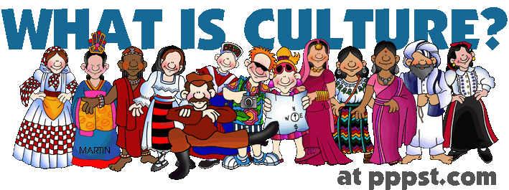

Brainstorm what you think the word culture means

or finish this sentence

‘I think culture is....’.

Image: Martin, P. (n.d) *What is culture*? Retrieved from <http://socialstudies.pppst.com/banner_culture.gif>

**Sorting Chart**

|  |  |
| --- | --- |
| **Examples of Observable Culture**  **( What you can see)** | **Examples of Invisible Culture**  **( What you have to ask about)** |
|  |  |
| **Examples of Culture which could be Observable or Invisible depending on the situation** | |
|  | |
| **Our New Definition of Culture** | |
|  | |

**Climbing the Inquiry Mountain**

**You need to plan to reach the summit!**



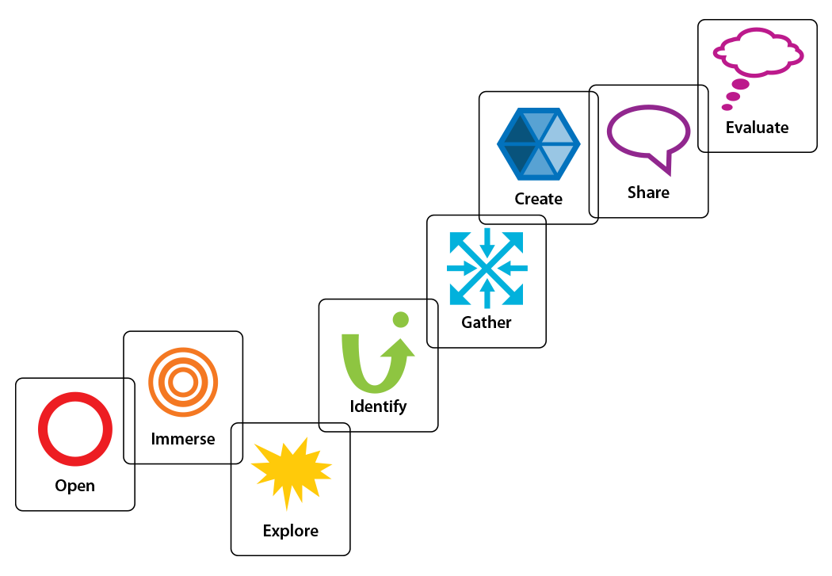****



Adapted from Kuhlthau, Maniotes, & Caspari. (2017). *GID – Guided Inquiry Design* . Retrieved from <http://guidedinquirydesign.com/gid/>

|  |  |
| --- | --- |
| **Inquiry Journal Entry One**  **Reflection on your Learning** | |
| **What have you learned about culture this lesson?** |  |
| **What do you think ‘observable’ and ‘invisible’ aspects of culture area?** |  |
| **What aspects of culture do you find most interesting?** |  |
| **What aspects of culture would you like to learn more about?** |  |