GUIDED INQUIRY DESIGN IL PLAN
by Krista Dowdell, ETL401 201960
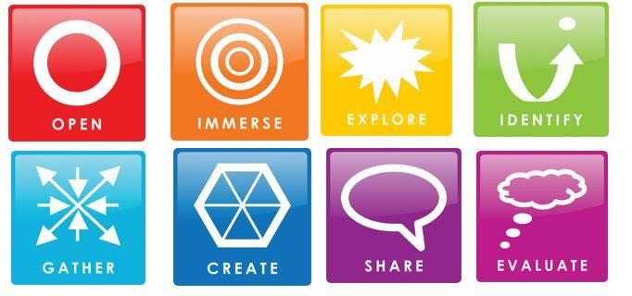  (Guided Inquiry Design Process(Kuhlthau,  Maniotes, & Caspari,  2012)  Guiding Inquiry Question: Where would we be without bees? | Learning Outcomes/Content  descriptions: (Teachers)  Outcomes:  ST2-10LW, ST2-11LW  Descriptors:  ACSSU072, ACSSU073  Elements of the General  Capabilities: (TLs)  Critical and Creative Thinking  Inquiring – identifying, exploring and organising information and ideas  Generating Ideas, Possibilities and Actions  Reflecting on Thinking and  Processes

Guided Inquiry Stage What students are doing

Refer detailed lesson plan below.

IMMERSE: Students build their background knowledge by immersion in the content. Students reflect on the content and select a topic for further investigation.
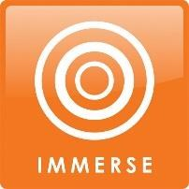
Lesson 1 – Immerse Phase
Guest speaker – local apiarist. Guest speaker elaborates on discussions from previous lesson and engages in a Q&A session with the students. At conclusion of lesson, the guest speaker is invited to return at the end of the unit when students present their projects.
TL displays a slide on the board with several interesting bee facts, such as:
- We rely on bees for much of our food.
- A worker bee can fly while carrying almost her own body weight in pollen and nectar.
S choose one of the facts and join an inquiry circle with other students who have chosen the same fact to discuss and analyse. Within these groups, S will use Bubbl.us to create their own mindmap relating to their chosen fact/topic.
Students begin a broad search on area of interest using TL prepared list of websites that relate to each topic/fact.
Students complete Learning Journal 2 (Immerse) in Google Classroom, eg, what is a synonym for the word immerse? What is one other question you came up with today in your inquiry circle?

Lesson 2 – Immerse Phase
Students make a bee pollinator (see resources)
S conduct an experiment where they make a bee out of a pipe cleaner and a flower out of a paper cup. A second pipe cleaner is used to make the stamens and stigma inside the flower cup. The stamens are dipped into powdered paint. S fly their bees into the cups letting it touch the ‘pollen’ as it searches for nectar.
Conduct WC discussion broken into sections:
Pollination and the Bee
What were the bees looking for and what happened when they found it?
Pollination and the flower
What happened to the flowers when the bees visited?
Pollination and our food
Why do we rely on pollination?
Pollination and the environment
What are the wider impacts of pollination on the environment?

Use Bubbl.us to record and save answers.

S complete Read, view, listen, connect* template in Google Classroom, drawing information from Lessons 1 & 2 of Immerse Phase.
S complete Learning Journal 3 (Immerse) in Google Classroom.

Resources
Lesson 1
Promethean, Guest speaker located through local group: Central Coast Amateur Beekeepers, iPads/Computers

Lesson 2
Pipe cleaners, paper cup, powdered paint/chalk, double-sided tape, scissors, computers/iPads

EXPLORE: Students browse and scan through a wide range and variety of resources to explore interesting ideas around their topic.
Read text ‘The Honeybee’ by Kirsten Hall using think aloud questioning strategy throughout read. WC discussion, linking back and reflecting on information learnt in immerse phase.

S to select and explore one area of interest from the following list:
Anatomy, lifecycle and capabilities; Pollination; Habitat/Diet; Threats to bees; Social structure and adaptations.
Record their topic in Google Classroom.

TL demonstrates how to research and locate appropriate books/resources for this phase of the project.

S use various texts, Oxford Owl online, World Book online, Capilano Honey website (We’re for bees) etc for this phase. Encourage S to avoid using Google at this stage to avoid them becoming too overwhelmed with information. S use KWLH* template to record their findings in Google Classroom.
Students complete Inquiry Reflection Journal in Google Classroom– Use an emoji to demonstrate how you are feeling at this point in the research process and tell me 3 interesting facts you have learnt today.
Resources:
‘The Honeybee’ by Kirsten Hall, computers/iPads for research and reflection purposes, physical and online resources appropriate for task.
Computers/iPads,
KWLH* template for Google Classroom

IDENTIFY: Students develop an inquiry question or questions and form a focus for their research. The question or questions will frame the rest of the inquiry.
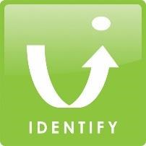
Students identify their area of interest and determine which aspect of bees and/or pollination they want to investigate further. Students will then join with other students who are interested in researching the same subject, forming inquiry circles.

Once in these groups, S will work together to pose potential questions, using the Question Focus Formulation* strategy and then rate questions in terms of their worth in relation to addressing the guiding question of the inquiry unit – Where would we be without bees?

Groups will create a shared workspace in GoogleDocs and import the TL created research template into it.

Students complete Inquiry Reflection Journal in Google Classroom -

Resources
Computers/iPads,
TL created research template in Google Docs - QFF
GATHER: collect detailed information from a variety of information sources
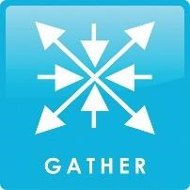
In their inquiry circles, S share their findings so far and categorise shared findings that are relevant to their research question.

S use the Notetaking Grid* template in Google Classroom, whilst gathering more specific, refined information in
relation to their question. S directed to sites such as World Book, Questia and Oxford Owl at this phase.

WC discussion at end of lesson:
What has been the most challenging aspect of the research for you so far?
What are you enjoying the most?

Students complete Inquiry Reflection Journal in Google Classroom.

Resources
Computers/iPads

Physical and online resources for research purposes.

CREATE/SHARE: Organise their gathered information to create their product
PRESENTATION – Create / Share
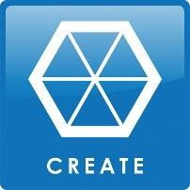
Create
Using a TL created template adapted from the ‘Share’ section of Michael Friermood’s ThinkerBuilder Inquiry Research Template (refer to resources), S will work together to determine the best way to present their findings. They are supplied with a list of various options they could use to showcase their learning, such as using the library Makerspace to construct a model; creating a poster; creating a PowerPoint; writing a song etc.
S will work together to agree on a suitable way of presenting their findings to the rest of the class and the returning guest speaker.
Share
Students will create a multi-modal presentation to share with the class/guest speaker. This presentation will demonstrate and showcase the depth of student knowledge and understanding in relation to their chosen topic.

Resources
Create: Computers/iPads
Share: Access to all materials/resources in the library Makerspace eg: 3D printers, Lego, craft items etc; Computers/iPads; Promethean to display Prezi, PowerPoint, iMovies etc.
EVALUATE: Students reflect on their content learning and the progress through the inquiry process.
Assessment – Evaluate
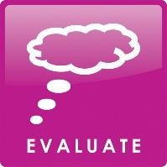
Each group takes part in a round table discussion of their learning* with the CT and TL. The instructional team will pose a higher-order question relating to the group’s initial inquiry question, allowing the IT to gauge depth of student learning.

Students revisit the pre-assessment they completed on Google Forms. Reflection question: Where WOULD we be without bees?
Choose one of the questions in the pre-assessment and answer it again, giving a more detailed and knowledgeable response. How has your understanding of the research process changed whilst doing this project?

Students complete a PQP Peer Review* for each group as they present.

Evidence of achievement of General Capabilities

The following items will be assessed throughout the unit:

- Student participation/contribution in the inquiry project.
- Completed activities and reflections in Google Classroom Inquiry Journals.
- Demonstrated understanding of topic through multi-modal presentation and explanation.

S will have displayed evidence that they have achieved the General Capabilities of CCT by:

- Successfully posing questions and engaging in each phase of the inquiry process.
- Collaborating with others to generate new ideas and gain new knowledge.
- Reflecting on their learning at the end of each phase of the research process and participating in a round table discussion with the instructional team at conclusion of unit.

*Scaffolds sourced and retrieved from: http://guidedinquiryoz.edublogs.org/
** Create phase scaffold sourced from: Friermood, M. (2015). Inquiry research template. Retrieved from
ThinkerBuilder.pdf https://www.thethinkerbuilder.com/2015/11/inquiry-research-moving-students-
toward.html?fbclid=IwAR1Ks5I6cl9LFsvM4Oxqp5movTC3CyAI7ABbdq6CtTmndkQjvjBjPkouZuw

OPEN lesson plan
Legend: Teacher Librarian = TL, Classroom Teacher = CT, WC = Whole class, S = Students, IT = Instructional Team
Activities | What the teaching team is doing – TL and teachers | Student Tasks | Resources
Starter 15 min | Prior to lesson:  TL & CT prepare honey  display  TL has prepared GID visual stimuli (posters) to be displayed in the library. In addition, a PowerPoint will be presented to explain the GID processes. | A display is set up when the children enter the library with different honeys eg: yellowbox, stringybark, honeycomb, manuka, creamed honey etc. Allow S to sample some of the honeys. Discuss the different colours, features and textures of the various honeys. What do you think may cause this? Why? Create a WC mindmap with Bubbl.us, demonstrating programs use.  Students watch and listen as TL goes through PowerPoint presentation and explains how and why students will be using GID during this unit. | *** Check for allergies before  lesson***  Honey display:  Various honeys,  table, tablecloth,  paddlepop  sticks (for sampling), bin.  Promethean  Board  TL pre-prepared posters and PowerPoint presentation.
Worktime 20 min | TL leads WC discussion around the clips and how they link to the overarching inquiry question “Where  would we be without bees?”  TL explains and shows students how to access the individual learning journals (in Google Classroom) that | Students watch following clips:  https://www.youtube.com/watch?v=WdzQD9IP_PA&feature=youtu.be  http://education.abc.net.au/home#!/media/30267/  TL gives S the overarching inquiry question for the unit: Where would we be without bees?  Students complete Constructing Meaningful Choice* scaffold in Google Classroom for future reference. | Media clips as per attachments.  Sticky notes.  Designated  area in library for class display.
 | they will be using throughout the unit. | Students are given 2 sticky notes each in the shape of bees wings. On one sticky note they write 1 interesting fact they have learnt from the clips they have watched. On the other, they write down what part of the GID process they are looking forward to the most. Students place their ‘sticky wing notes’ on a display board that the TL has preprepared with bee bodies on it to create a class display. The GID posters are also included in this display.
Reflection 20 min | CT directs S to Inquiry  Journal Entry 1 (Open)  Scaffold in Google Classroom and demonstrates how to fill the journal in.  CT & TL review journal entries to monitor S understanding of the GID process and task so far. | Students locate and complete Inquiry Journal Entry 1 (Open) scaffold in Google Classroom, answering the following questions:  - What did you find the most interesting in the two clips that you watched today?  - At this early stage, is there anything in particular that you already think you may be interested in researching further?  - What do you think will be the best part of the GID process?  - Use an emoji to tell us how you are feeling about using the GID process? | iPads/Laptops for Google Classroom.
**Note 1: | Inform students that an apiarist will be visiting in the next lesson. Ask S to think of any questions they may have, write them down in preparation for the visit and place them in the class question box. | **Note 2: Prior to commencement of unit, S completed preassessment questions in Google Forms:  - Why do people keep bees?  - Where do bees live?  - What do bees build inside the bee hive?  - Why are bees important?  - Can you name any phases of the research process? | Class question box.  iPads/Laptops to access  Google Forms.

