Guided Inquiry – Depth Study 2: Ancient Greece
Created by Kate Milliken, ETL401, 201960
Stage: Stage 4  Grade: Year 7  Subject: History  Unit Duration: 8 weeks  Teaching Team: Classroom teacher (CT) and teacher librarian (TL) |  |  | Unit Overview
 |  |  | This topic and unit provides students with opportunities to pursue breadth and depth in the study of History. In the process of investigating Ancient Greece, students will develop skills involved in the process of historical inquiry and communication. A primary investigative focus of this unit will be to gain an understanding of the keys roles of people and events in Ancient Greece. Social structure and everyday life will also be a significant area of inquiry for this unit. The unit will culminate in the presentation of students’ work at a PBL afterschool event.
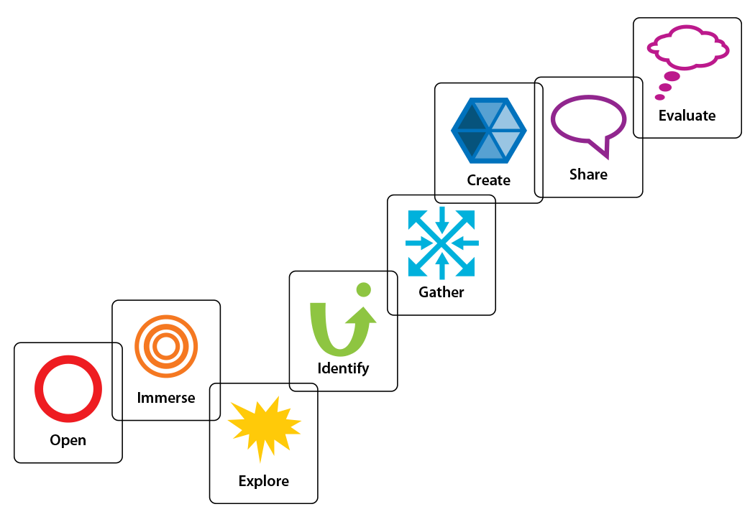
 |  |  | Key Inquiry Questions
- How do we know about ancient Greece?
- Why and where did ancient Greece society develop?
- What were the defining characteristics of ancient Greece society?
- What are the legacies of ancient Greece society?

Curriculum Learning Outcomes |  |  | General Capability Outcomes
- Describes major periods of historical time and sequences events, people and societies from the past (HT4-2).  - Identifies the meaning, purpose and context of historical sources (HT4-5)  - Locates, selects and organises information from sources to develop an historical inquiry (HT4-8).  - Uses a range of historical terms and concepts when communicating an understanding of the past (HT4-9). ➔ Selects and uses appropriate oral, written, visual and digital forms to communicate about the past (HT4-10). |  |  | Critical and Creative Thinking ➔ Organise and process information by analysing, condensing and combining relevant information from multiple sources.  ➔ Apply logic and reason by assessing whether there is adequate reasoning and evidence to justify a claim, conclusion or outcome.  Information and Communication Technology ➔ Generate solutions to challenges and learning area tasks by independently and/or collaboratively creating and modifying digital solutions, creative outputs or data representation/transformation for particular audiences and purposes.
Guided Inquiry Stage | Teaching Strategies |  | Student Tasks | Resources
Stage 1: Open | 10 minutes | - CT gathers the class as a whole group (inquiry community).  - CT formally introduces TL to the class, indicating that for this unit, the TL will also be one of their teachers.  - CT introduces the topic – Ancient Greece – and describes what students will be working toward. Calms students’ anxiety about scale of project etc. and assures them that they will be given adequate time in class. | - Students follow CT and TL instructions by gathering as an inquiry community  - Students listen to CT introduction of the TL.  - Students may be anxious about the scale of the task, but are reassured that they will be given adequate time in class, as well as support from both the CT and TL in order to complete their project. | - Computers/iPads  - Projector/Screen  - Google Forms – Questionnaire  (https://forms.gle/xPmdegteHLpUyUQ 9A)  - Google Docs – Self-reflection journal
Lesson Outcomes
Students:
➔ Begin to process of historical inquiry.
Lesson Objectives | 10 minutes | • TL gives students a visual representation of the Steps of GID and briefly explains each stage, telling students that they will be following the same process a historical investigator follows. | • Students follow along with TL and may wish to inscribe notes about what happens/what they will be doing at every stage.
Students:
- Activate existing knowledge regarding ancient Greece.
- Are introduced to the stages and processes involved in a historical inquiry.
 | 10 minutes | • TL directs students to an online questionnaire. | • Students fill-out questionnaire and seek clarification if needed.
 | 10 minutes | • CT and TL allocates each student in the class a role or person/class from ancient Greek society. Have students role-play with classmates. | • Students receive (verbally) their role and engage in role-play with their classmates.
 | 5 minutes | • CT and TL discuss with students the predictions they made about their roles. | • Students participate in discussion, noting predictions and any noteworthy exchanges.
 | 5 minutes | • CT has students reflect in their project journals. | • Students record their initial thoughts on the project.
ETL401 – Assessment 3: Information Literacy Plan & Reflective Practice

Stage 2: Immerse  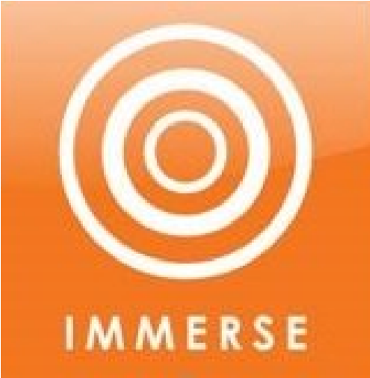 | - CT presents the ‘Big Question’ of the unit with students: ‘What are the legacies of ancient Greek society?’  - CT and TL model breaking down the question with the class, highlighting keywords and alternative phrasings. i.e. ‘How has ancient Greece influenced modern-day society?’  - CT watches The Ancient Greeks documentary and prompts students to answer accompanying pre-set questions.  - TL sets up different stations that introduce students to various resources informing them of the different aspects of ancient Greek society (as required and summarised in the NSW curriculum). Students design questions based on each station.  - Based on questions written by students, TL can discuss superficial questions, teaching and modelling for students how to write more effective questions. | - Students gather as an inquiry community and begin thinking about the ‘Big Question’ of the project.  - Students participate in breaking down the question and rephrasing it in a way that they understand.  - Students watch and answer questions based on the video.  - Students go around to each station and design questions based on each resource’s focus and/or source.  - Students discuss their questions with TL and rewrite them to be more effective.  - Students write in their project self-reflection journals, in regards to new skills, knowledge etc. In particular, they should identify initial area/s of interest. | - Video: The Ancient Greeks: Crucible of Civilisation  (https://www.youtube.com/watch?v=G  2tFoTa-i6w)  - Question worksheet  - Resources curated from the library collection (books, encyclopaedias), as well as websites and videos  - List of possible areas of interest for projects:  - Geographical setting and natural features  - Foundational myths o Government  - Role of law and religion  - Classes o Religion  - Warfare (conquest, treaties) o Death or funerary customs o Inventions  - Specific people e.g. Pericles
Stage 3: Explore | - CT sorts students into inquiry circles based on their area of interest (each group should be no bigger than 4-5 members).  - CT explicitly addresses social group skills.  - TL shows students how to make the most of Google Search and databases by referring back to keywords and alternative phrasing activity, and modelling different search strategies for students (limiting by format, years of publication etc.). Shows them how to use the keyword log  (Appendix 1).  - CT and TL hands out scaffold to each member of the inquiry circle (Appendix 2). | - Students decide on an area of interest for their project and are sorted into inquiry circles.  - Students use the strategies taught to locate 2 interesting sources looking at their interest area.  - Using the various scaffolds at their disposal, students record information and any questions that arise about their topic.  - Students write in their project journals, picking 5 possible research questions/sub-topics. | - Keyword log table (Appendix 1)  - Computers/Internet  - Library resources  - Pens/Pencils/Paper  - Scaffold for recording information on two sources and possible research questions (Appendix 2)  - Google Docs
Stage 4: Identify  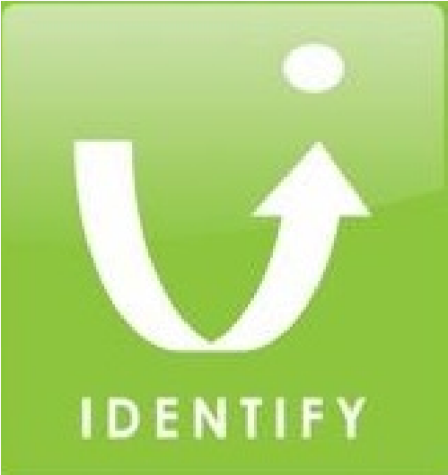 | - CT hands out and explains the assessment (Appendix 3).  - TL explains how to narrow a topic down into different sub-topics. E.g. ‘How did religion and beliefs of Greece influence other societies?’ breaks off into ‘temples and buildings’, ‘gods/goddesses’,  ‘connections between leadership and divine power’, ‘religion in daily lives’ and  ‘religious roles’.  - CT models to students how to create a collaborative concept map in Lucid Chart (www.lucidchart.com).  - CT looks over and makes suggestions regarding each circle’s question.  - TL has a reference interview with each circle, and makes suggestions regarding possible resources/concepts etc. | - Students discuss their five (possible) research questions and/or sub-topics within their inquiry circle, and pick 1 to pursue.  - Students use Lucid Chart to identify and narrow their question into specific parts. Share this online with other group members.  - Students seek approval and suggestions regarding their question from the classroom teacher, making any necessary modifications.  - Students brainstorm keywords and search phrases alongside TL.  - Students complete Questionnaire. | - Assessment notification (Appendix 3)  - Computers/Internet  - Google Classroom  - Google Docs  - Google Drive  - Google Forms – Questionnaire  (https://forms.gle/xPmdegteHLpUyUQ 9A)
Stage 5: Gather  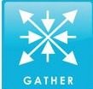 | - TL teaches students about using CRAAP sources in their research. Has each inquiry circle find a high-scoring source, as well as a low-scoring source.  - TL shows students how to cite a source (author, date published, title, date accessed, URL).  - CT instructs students on how to best take notes and/or incorporate evidence and sources into writing.  - CT and TL monitor inquiry circles and individual student progress and give additional guidance where necessary.  - CT and TL plan jigsaw grouping so that inquiry circles can regularly share information, and for peer-to-peer support and feedback. | - Students locate two sources (book or online) on their topic and score them based on the CRAAP test. Share results within inquiry circle.  - Students practice citing sources they use when they begin and continue gathering information related to their topic/question.  - At the conclusion of each gathering sessions, students share and report back to the inquiry circle regarding their findings.  - Students share their research with peers as part of the inquiry community. Peers provide informal feedback. | - CRAAP Test (Appendix 4) • Citing scaffold.  - Note taking scaffold.  - Google Docs  - Computers/Internet  - Databases/Library books
ETL401 – Assessment 3: Information Literacy Plan & Reflective Practice
Stage 6: Create & Share  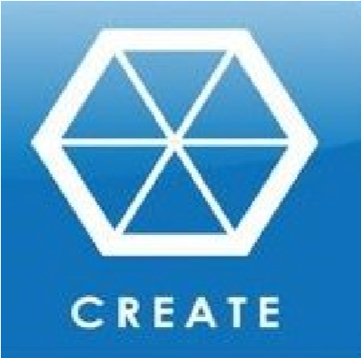 | - CT shows examples of former student work (if possible), or examples found online as possible suggestions for  - CT and TL make sure all inquiry circle members participate equally.  - CT and TL monitor inquiry circle and individual student progress and give additional guidance where necessary.  - CT and TL allow students the freedom to choose what form the sharing of their research will take, but may offer suggestions.  - CT and TL organise the set-up and packup of Ancient Greek Night in the hall.  - CT and TL collect copy of research report and observe at the Ancient Greek Night.  - CT collects copies of project journals. | - Students come together as an inquiry circle to create their research report.  - Students decide upon the manner in wish they are going to share their research with their peers and communityAncient Greek  Night.  - Students submit order requests to CT or TL for approval and ordering.  - Students set up and present their research to peers as an inquiry community.  - Students then repeat this by presenting formally to interested community members.  - Students share project journals with CT for overview. | - Computers/Internet  - Google Docs  - Cardboard/Pencils/Pens/Textas  - Any additional materials purchased through PBL budget (RAM-funded)
Stage 7: Evaluate  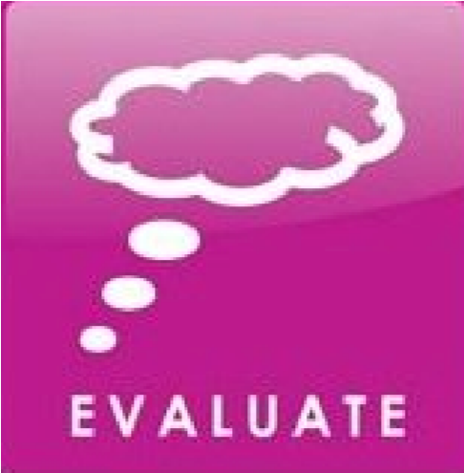 | - CT and TL evaluate program and teaching. High-end and low-end samples of student work collected.  - CT and TL informally survey parents and teachers who attended the Ancient Greek Night.  - CT explains to students how to properly complete an online peer-review (Google Forms).  - TL directs students to complete  Questionnaire 3.  - TL analyses findings from the Questionnaires and how students’ selfassessment of information seeking skills have changed over the course of the unit. | - Students complete an online peer-review of the members of their inquiry circle, as well as themselves.  - Students complete Questionnaire  3. | - Computers/Internet  - Google Forms (peer review, selfassessment)  - Google forms (Questionnaire 3)

