GUIDED INQUIRY DESIGN IL PLAN – Year 9 History – World War I
Created by Amy Fulton, ETL401 201960
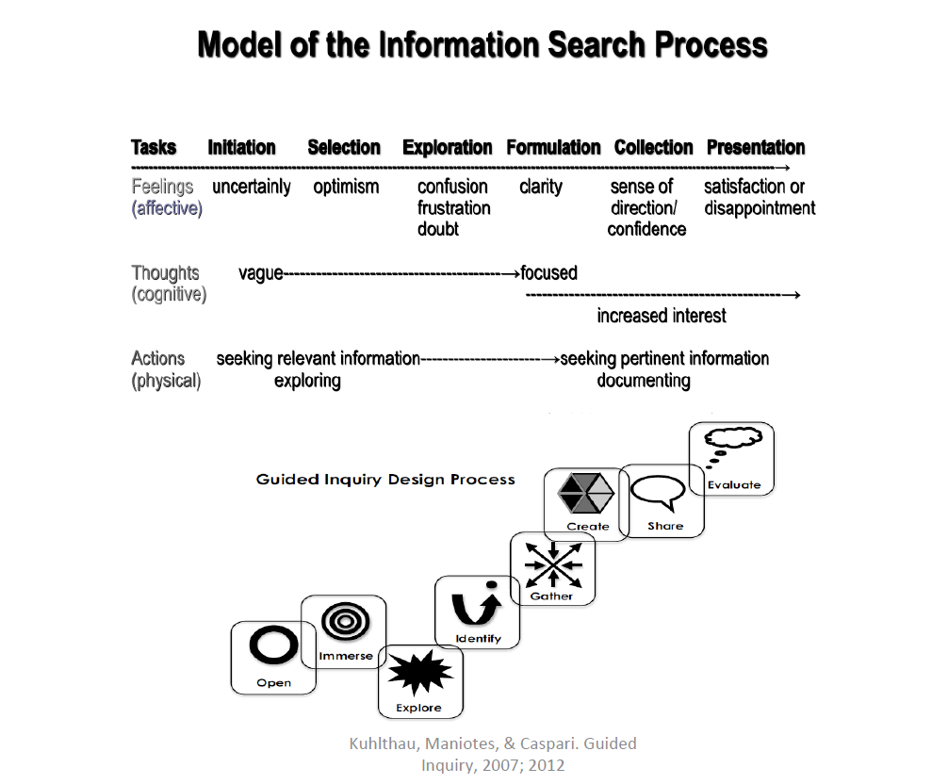 | Learning Outcomes/Content descriptions: (Teachers)  - An overview of the causes of WWI and the Australian experience of the war, including the nature and significance of the war in world and Australian history (ACDSEH021)  - The impact of WWI, with a particular emphasis on Australia (such as the use of propaganda to influence the civilian population, the changing role of women, the conscription debate) (ACDSEH096)  Elements of the General Capabilities: (Teacher Librarian)  - Critical and Creative Thinking (CCT) - Inquiring  - Pose questions (ACHHS166; ACHHS167)  - Identify and clarify information and ideas (ACHHS168; ACHHS169; ACHHS170; ACHHS172; ACHHS173)  - Organise and process information (ACHHS164; ACHHS165; ACHHS171; ACHHS173; ACHHS174; ACHHS175)  N.B. The CCT General Capabilities marry up with many of the Australian Curriculum Historical Skills - noted in brackets beside each CCT above.
Topic statement:

World War I had a significant impact on Australia.

Guided Inquiry Stage | Teaching Strategies | What students are doing
Open    Refer to introductory lesson for this stage at end of document. | Lessons 1-2
Resources:
All scaffolds are modified to the needs of St Andrew’s (STACC) Year 9 History.

Every lesson:
- Laptop
- AndIE
- Blog

Immerse   | Lessons 3-5  ST  - Background on how Australia became involved in WWI – ClickView movie  TL  - Introduce & explain Read View Listen Connect scaffold  ST  - Short and long term causes of WWI.  - 5 Expert groups using NSW Government 100 years of ANZAC and History on the net websites, RVL Connect & Oxford Big Ideas 9 text.  TL  - Revise Mindomo steps to create a concept map.  - Blog entry #2 | - Watch ClickView: Causes of World War I (22:43)  - Expert groups – RVL Connect scaffold one per topic:  - Nationalism  - Imperialism  - Militarism  - Triple Alliance  - Allies: Triple Entente  - Group adds notes to collab. doc on AndIE. 1 student to present group’s information to whole class.  - Design a concept map depicting the short and long term causes of WWI using Mindomo. (Formative).  - Complete blog entry #2 – Why did Australia join WWI? Name one thing you did not already know?
Additional Resources:
- ClickView – Causes of WWI. (Classroom Video, 1999)
- RVL Connect scaffold (Loertscher et al., 2005)
- 100 Years of ANZAC
- History on the Net
- Oxford Big Ideas 9 text (REFERENCE)
- Mindomo

Explore   | Lessons 6-9  ST  - Introduce topics: propaganda, warfare (tactics; trench), Gallipoli Campaign, Western Front, Homefront (role of women), conscription. Students do a broad search on each topic and complete the KWLH scaffold.  - Assist students  TL  - Review searching on Oliver and AndIE Library page with Research link  - Provide students with an example primary source electronically & model Evaluating Information scaffold (refer to CRAP test infographic). Particularly emphasise reliability & bias.  - Revise SLASA (online referencing tool -AndIE Library page). Complete example using previous primary source. | - Complete KWLH scaffold  - Complete Evaluating Information scaffold for 1 primary & 1 secondary source. Use 1 print & 1 electronic.  - Complete SLASA steps with TL  - Complete blog entry #3 – Which source is more reliable and why? Who is in your group? Which topic are you thinking of researching and why?  - Differentiation – 1 secondary source only
Additional Resources:
- KWLH scaffold (Fitzgerald & Sheerman, n.d.)
- Oliver
- 1 primary source
- Evaluating Information scaffold (Researching Together: engaging minds, n.d.)
- SLASA online referencing tool
- CRAP test infographic (Rieger, 2016).
- Frozen loan of print resources.
Identify   | Lessons 10-11  TL  - Teach rules for developing inquiry questions using Developing a big question for your research scaffold  - Support students locating sources for inquiry  ST  - Conference with student groups regarding chosen topics providing guidance and clarification | - Complete Developing a big question for your research scaffold based on overarching statement: World War I had a significant impact on Australia.  Think-pair-share in chosen groups & decide on 1 question.  - Conferencing with ST in groups & start information seeking.  - Complete Reflection #2 & upload to AndIE.  - complete blog entry #4 – your inquiry question and note major points  - Differentiation – provide more scaffolding for students with identified learning needs
Additional Resources:
- Developing a big question scaffold (Fitzgerald & Sheerman, n.d.)
- Frozen loan of print resources.
- Reflection #2 (Todd et al., 2005).

Gather   | Lessons 12-17  TL  - Introduce Google Keep for storing resources  - Instruct group leaders to create & group share a Google Doc for recording references (Include ST & TL). Remember SLASA.  - Note taking using Cornell Note Taking System  ST  - Provide links to chosen topics  - Continue conferencing | - Add Google Keep to Google Drive and add electronic sources found  - Keep list of sources in APA format in shared Google Doc – minimum 6 sources – (minimum 2 primary). Remember CRAP & SLASA.  - Use Cornell Note Taking scaffold from AndIE -1 per source either electronically or handwritten  - Inquiry circles – share sources of information, how to find them, are they reliable & why? Share inquiry hot tips with peers.  - Complete blog entry #5 – how are you feeling? Are you making progress? Do you feel confident about your learning?  - Differentiation – vary the number of sources according to ability
Additional Resources:
- Google Keep
- Cornell Note Taking scaffold (The Cornell Note-taking System, 2001)
- SLASA
- Frozen loan of print resources.
- Google Docs

PRESENTATION – Create / Share   | Lessons 18-25  ST  - Review PEEL paragraph structure using guide.  TL  - In-text citations – ‘how to’, examples & sentence starters for scripts/ presentations  - Suggest presentation modes: google slides, PowToon, gameshow, interview, news report  - Reminder to include primary sources in presentation | - use evidence and notes from research to create multi-modal presentation 3-5 minutes (400-600 words). Include in-text citations in your script, bibliography, at least 2 primary sources. Can be pre-recorded.  Lessons 22-25  - present multi-modal presentation to the class. Can be pre-recorded and submit script through AndIE  - complete Review of peers’ final presentations scaffold during presentations.
Additional Resources:
- PEEL paragraph scaffold
- Modified Peer Review slip
- In-text citations ‘How to’ scaffold
- Review of peers’ final presentations scaffold (Fitzgerald & Sheerman, n.d.).

Assessment – Evaluate   | Lessons 26-30  - ST & TL to complete Assessment Rubric:  - ST – Knowledge & Understanding  - TL – CCTs  - ST & TL MM presentation & blog  Culmination conversation (teaching team)  ST and TL to evaluate:  - Strategies:  - effective vs ineffective  - improvements/remove  - possible future GI activities  - overall effectiveness of GI unit for individual students and whole class e.g. student engagement, knowledge learnt, achievement outcomes. | - Complete Reflection #3 (Todd et al., 2005) & upload to AndIE.  - Complete self-evaluation survey on AndIE  - round-table class culmination conversation using Talk Tickets to ensure all students are heard  - complete blog entry #6 – Do you believe you have achieved a good level of understanding of WWI? Could you teach someone else about your chosen topic? What did you enjoy most throughout the GI process?
Additional Resources:
- Reflection #3 (Todd et al., 2005).
- PQP peer review scaffold (Fitzgerald & Sheerman, n.d.).
- Self-evaluation survey (AndIE).
- Talk Tickets
- Assessment Rubric
Evidence of achievement of Knowledge & General Capabilities:
- inquiry blog entries (Formative)
- observation of participation/engagement in class activities: think-pair-share x 2; expert groups; inquiry circles; general group work; culmination conversation (Formative)
- Presentation Rubric (Summative)

Introductory lesson plan Year 9 History WWI

Guided Inquiry Phase: OPEN

Learning intentions:

Students will:
- have increased background knowledge and understanding of WWI
- understand the Guided Inquiry process

Success Criteria:
Students will:
- identify the who, when, where, why, what and how of WWI
- explain the steps involved in GID and describe how this will relate to our topic.

Location: Senior Library Glass Classroom
Team: Subject Teacher (ST) and Teacher Librarian (TL)
Lesson Length: 2 x 40 minutes (double)
Resources: Scaffold sheets adapted for St Andrew’s (STACC) Year 9 History. All located on AndIE Class page.

Activities | What the teaching team is doing – TL, Teachers & Students | Resources
Starter  Time: 10 min | ST:  - Introduce topic and learning outcomes  - Refer students to AndIE class page where all resources will be located  - Distribute Assessment task (digital & print) – In groups of 2-3 you are to research, create and present a multi-modal presentation on a subtopic of your choice proving or disproving the overarching statement: World War I had a significant impact on Australia. | - laptops  - AndIE class page  - Assessment task sheet
Worktime  Time: 20 min | ST:  - Think-Pair-Share using Building Background scaffold - what do students already know about WWI? Class discussion - ST note-take on whiteboard & students add to scaffold  - Background information on WWI: 5Ws+H PowerPoint. Students download (AndIE) and complete 5Ws+H scaffold | - Building Background scaffold (Loertscher et al., 2005)  - 5Ws+H scaffold  - 5Ws+H PowerPoint  - Laptops
Worktime  Time: 30 min | TL:  - What is inquiry-based learning? (YouTube)  - What is GID? Use the Research River PowerPoint adapted from Fitzgerald (2017) to explain GID. Students use Lucidchart to design a flow chart of the GID (Formative)  - game of Heads & Tails Questioning on the GID process. (Formative) | - What is inquiry-based learning? (Spencer, 2017) (4:37)  - Research River PowerPoint  - laptops  - Lucidchart  - lollipops for prizes  - Head & Tails questions
Reflection  Time: 10 min + 10 min | TL & Students:  - Download and complete Reflection Sheet #1 (SLIM Toolkit). Upload to AndIE when finished.  ST:  - Set up blog spaces and discuss journaling expectations (headings, 1st person etc). Explain - ongoing process throughout the unit and will contribute to formative & summative assessment.  Students:  - Complete blog entry #1 – What are your feelings/thoughts regarding this unit of work? Did you learn anything new today? Do you think the GID process will make learning the content easier?  ST set Homework:  - Finish blog entry #1 and reflect on today’s lesson. | - Reflection Sheet #1 (Todd et al., 2005).  - AndIE/blog  - laptops
Notes | ST and TL discuss lesson positives/negatives, students’ engagement levels and consider adjustments for future lessons. | Record discussion notes.

Assessment Rubric Student Name:
CRITERIA |  | A | B | C | D | E
Knowledge and Understanding  (ACDSEH021)  (ACDSEH096) |  | analysis of the causes and effects of events and developments and make discerning judgments about their importance. | analysis of the causes and effects of events and developments and make informed judgments about their importance. | analysis of the causes and effects of events and developments and make judgments about their importance. | explanation of the causes and effects of and description of why they are important. | statements about the causes and effects of events and developments.
 |  | comprehensive explanation of the impact of WWI, with emphasis on Australia in the chosen topic. | detailed explanation of the impact of WWI, with emphasis on Australia in the chosen topic. | explanation of the impact of WWI, with emphasis on Australia in the chosen topic. | description of the impact of WWI, with some emphasis on Australia in the chosen topic. | statements about the impact of WWI, with little or no emphasis on Australia in the chosen topic.
Critical and Creative Thinking - Inquiring | Pose questions | pose questions to critically analyse complex issues and abstract ideas. | pose questions to analyse complex issues and abstract ideas. | pose questions to illustrate issues and ideas. | pose questions to explain issues and ideas. | pose questions to identify issues and ideas.
 | Identify and clarify information and ideas | clarify complex information and ideas drawn from a range of primary and secondary sources. | justify information and ideas drawn from primary and secondary sources. | discuss information and ideas drawn from some primary and mostly secondary sources. | summarise information drawn from mostly secondary sources. | identify information from secondary sources.
 | Organise and process information | critically analyse independently sourced information to determine bias and reliability. | analyse independently sourced information to determine bias and reliability. | analyse mostly independently sourced information to determine bias and reliability. | explain collaboratively sourced information to determine bias and reliability. | identify collaboratively sourced information with assistance to determine bias and reliability.
Multi-modal presentation | Communication | purposeful organisation and presentation of justified conclusions. | effective organisation and presentation of informed conclusions. | organisation and presentation of conclusions. | partial organisation and presentation of partial conclusions. | fragmented presentation of partial conclusions.
 | Referencing | accurate acknowledgement of sources using appropriate conventions. | acknowledgement of sources using appropriate conventions. | acknowledgement of sources. | partial acknowledgement of sources. | lists of sources.
Journaling Blog |  | development of discerning understanding of WWI and GID. | development of informed understanding of WWI and GID. | development of understanding of WWI and GID. | development of aspects of understanding of WWI and GID. | statements about WWI and GID.

Comments: __________________________________________________________________________________________________________
____________________________________________________________________________________________________________________
____________________________________________________________________________________________________________________
Subject Teacher: ____________________________________ Teacher Librarian: __________________________________________

