Key components of Guided Inquiry
From Guided Inquiry: Learning in the 21st Century, 2nd Edition. (Kuhlthau, Maniotes & Caspari, 2015)
- Based in empirical research
- Framework for designing inquiry learning
- Student research embedded in inquiry learning
- Learning team approach
- Concepts-based information literacy curriculum
- Five kinds of learning
- Wide range of resources, museums and experts
- Inquiry tools for guiding and assessing
From Kuthltau, C., Maniotes, L. & Caspari, A. (2015) Guided Inquiry: Learning in the 21st century, 2nd edition. Santa Barbara, CA: Libraries Unlimited. P9
- The research base:
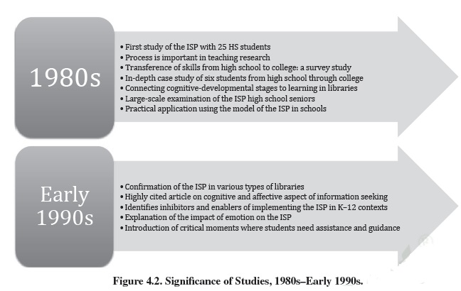
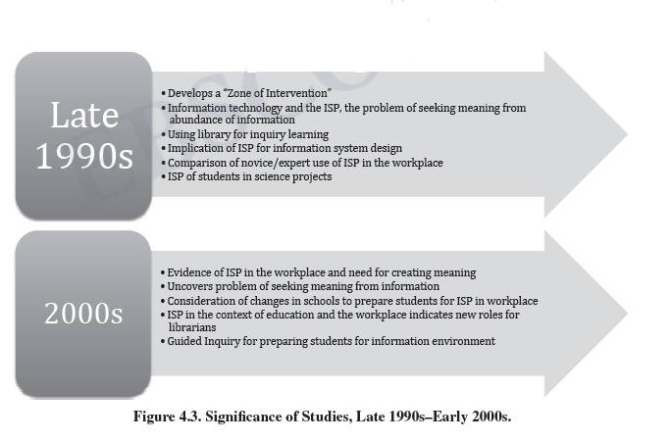

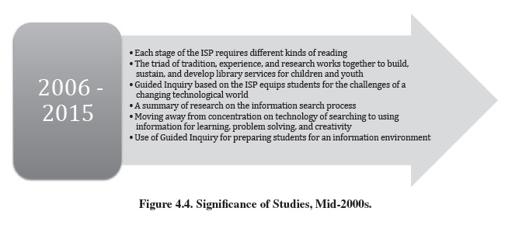
From Kuthltau, C., Maniotes, L. & Caspari, A. (2015) Guided Inquiry: Learning in the 21st century, 2nd edition. Santa Barbara, CA: Libraries Unlimited. P46-47
- Framework for designing inquiry learning:
The Information Search Process and the Guided Inquiry Design process
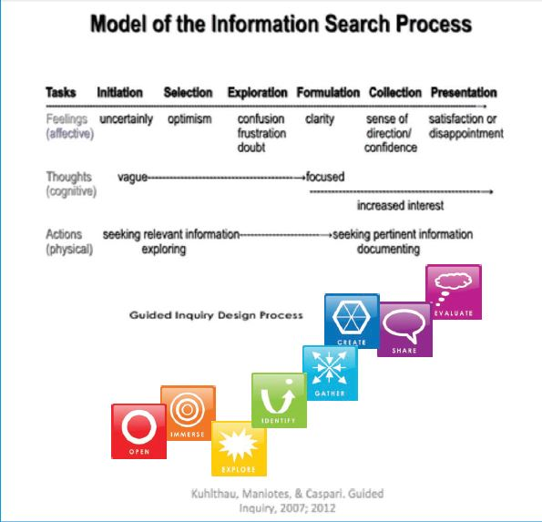

How they operate together and with the Critical and Creative Thinking General Capability.
Critical and Creative Thinking Organising Elements | What student is doing in ISP | Stage of ISP | Phase of Guided Inquiry | What the Inquiry community is doing in Guided Inquiry
Inquiring: identifying, exploring and organizing information and ideas  - Pose questions  - Identify and clarify information and ideas  - Organise and process information. | Initiating the research project | Initiation | Open | Invitation to inquiry  Open minds  Stimulate curiosity
 | Selecting a topic | Selection | Immerse  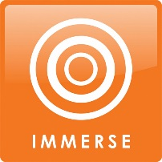 | Build background knowledge  Connect to content  Discover interesting ideas
 | Exploring information | Exploration | Explore | Explore interesting ideas  Look around/dip in.
Generating ideas, possibilities and actions  - Imagine possibilities and connect ideas  - Consider alternatives  - Seek solutions and put ideas into action | Formulating a focus | Formulation | Identify  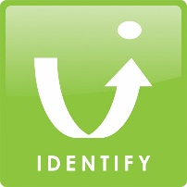 | Pause and ponder  Identify inquiry question  Decide direction
 | Collecting information on focus and seeking meaning | Collection | Gather | Gather important information  Go broad  Go deep
Analysing, synthesising and evaluating reasoning and procedures  - Apply logic and reasoning  - Draw conclusions and design a course of action  - Evaluate procedures and outcomes | Preparing to present | Presentation | Create  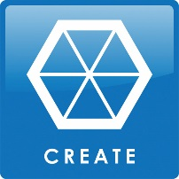 | Reflect on learning  Go beyond facts to make meaning.  Create to communicate
 |  |  | Share | Learn from each other  Share learning  Tell your story
Reflecting on thinking and processes: Throughout GI process  - Think about Thinking (metacognition)  - Reflect on processes  - Transfer knowledge into new contexts | Assessing the process and the product | Assessment | Evaluate  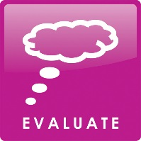 | Evaluate achievement of learning goals  Reflect on content  Reflect on process
Adapted by Lee Fitzgerald from Kuhlthau, Maniotes & Caspari,(2012). Guided Inquiry: A framework for inquiry in your school, p38, Figure 2.3)
- Student research through inquiry learning

Third space
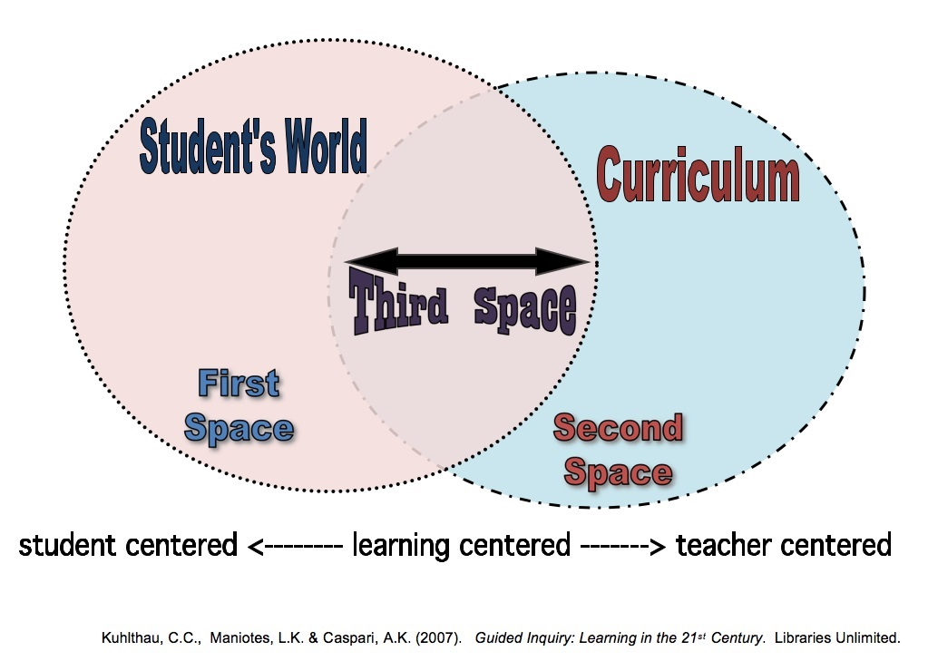

The Six C’s of Construction
Collaborate | Work jointly with others.
Converse | Talk about ideas for clarity and further questions.
Compose | Write all the way along, not just at the end: Keep journals
Choose | Select what is interesting and pertinent
Chart | Visualise ideas using picture, timelines, and graphic organisers.
Continue | Develop understanding over a period of time.
From Kuthltau, C., Maniotes, L. & Caspari, A. (2015) Guided Inquiry: Learning in the 21st Century, 2nd edition. Santa Barbara, CA: Libraries Unlimited. Figure 10.2 Intervention strategies for Guided Inquiry, p139
- The learning team approach
The Guided Inquiry team
- Understands the constructivist approach.
- Embraces the team approach to teaching.
- Includes Principals and other school leaders.
- Considers inquiry central to curricular learning.
- Commits to developing information literacy.
- Allocates time for team planning.
- Defines clear roles for each team member.
- Designs assignments that enable and enhance inquiry learning.
- Allocates time for extended learning.
- Commits to guiding students throughout learning.
- Adopts a flexible approach.
- Endorses innovation and creativity.
From Kuthltau, C., Maniotes, L. & Caspari, A. (2015) Guided Inquiry: Learning in the 21st century, 2nd edition. Santa Barbara, CA: Libraries Unlimited. P133, Figure 9.5
Role of teacher librarian
Resource curator | Curates resources for inquiry  Provides high quality library resources  Extends access to outside resources
Information literacy specialist | Provides information literacy expertise  Promotes learning from a variety of sources  Models lifelong learning
Collaboration catalyst | Provides a technology infused learning environment  Collaborates on all learning teams  Keeps communication flowing.
From Kuthltau, C., Maniotes, L. & Caspari, A. (2015) Guided Inquiry: Learning in the 21st century, 2nd edition. Santa Barbara, CA: Libraries Unlimited. P129, Figure 9.4

- Concepts based Information literacy curriculum
Central Concept 1: Information that is organized provides access to facts, ideas and multiple perspectives
Guided Inquiry Information Literacy Concepts
Central Concept 1 | Information that is organized provides access to facts, ideas, and multiple perspectives.
 | 1.1 A vast array of sources can be either organized or linked.
 | 1.2 A library is a collection of sources that have been organized according to a classification system, whereas the Internet is a universe of electronic resources that can be linked by attributes that may have nothing to do with their content.
 | A. Knowing the title or author of a book is a straightforward way to locate the source.
 | B. Keywords are terms and phrases you think best represent a topic.
 | C. Subject headings are consistent terms and phrases that a professional has assigned to sources.
 | 1.3 Search strategies provide ways to forge a path through information on an inquiry journey.
 | A. A variety of search strategies enable you to find a wide range of sources of information.
B. Different types of searches have different purposes and are appropriate for different points in the inquiry
process.
 | C. Managing inquiry to keep track of sources requires a systematic approach.
Figure 7.1. Guided Inquiry Information Literacy Concept 1.
Kuhlthau, Maniotes & Caspari (2015) p74

Central Concept 2: Valuable information prompts curiosity, reflection, and enlightenment
Guided Inquiry Information Literacy Concepts
Central Concept 2 | Valuable information prompts curiosity, reflection, and enlightenment.
 | 2.1 The purpose of evaluating sources of information is to choose the highest quality and most useful to accomplish a task.
 | A. Choosing information in different formats fosters multiple ways of thinking and learning.
 | B. The structure of a source offers clues for evaluating the usefulness of the information.
 | 2.2 Sources have distinct characteristics that will help you evaluate the quality and usefulness of the information.
Figure 7.1. Guided Inquiry Information Literacy Concept 1.
Kuhlthau, Maniotes & Caspari (2015) p75

Central Concept 3: Thoughtfully interpreting information over time leads to deep learning
Guided Inquiry Information Literacy Concepts
Central Concept 3 | Thoughtfully interpreting information over time leads to deep learning.
 | 3.1 Inquiry is a process of learning and building understanding.
 | A. The process of learning from a variety of information sources occurs in a series of phases.
 | B. Formulating a focused question is the turning point of the inquiry process.
 | C. Managing inquiry to keep track of information and ideas requires a systematic approach.
D. Deciding what content is most important in an information source is essential for constructing deep
learning.
 | E. Deciding how much information is enough for a given project is an essential task of inquiry.
 | F. Deep learning requires interpreting facts, creating connections, and organizing ideas.
 | G. Sharing learning requires ethical, thoughtful, and productive practices.
 | 3.2 Sharing research contributes to the knowledge base of a community, reinforces learning, and helps others to learn.
Figure 7.1. Guided Inquiry Information Literacy Concepts.
Kuhlthau, Maniotes & Caspari (2015) p76
- Five kinds of learning through Guided Inquiry
Information Literacy | Concepts for locating, evaluating, and using information.
Learning how to learn | Self-directed learning and personal interaction within the inquiry process.
Curriculum content | Constructing new knowledge, interpreting, synthesising and applying facts and ideas.
Literacy competence | Reading, writing, speaking, listening, viewing and presenting.
Social skills | Interacting, co-operating, collaborating, habits of mind, dispositions in action.
From Kuthltau, C., Maniotes, L. & Caspari, A. (2012) Guided Inquiry Design: A framework for inquiry in your school. Santa Barbara, CA: Libraries Unlimited. Figure 1.3 Five kinds of learning through Guided Inquiry, P9
- Wide range of sources – (See p101-115 Guided Inquiry: Learning in the 21st Century.)
Possibly the most important thing is to provide easy overview sources to begin with, so that students don’t get overloaded with information, with Clickview and online and print encyclopedias the best place to start. Students at Explore are looking for relevant information and to get an idea of the shape of the topic. Then Tls work with individual inquiry circles and individuals to help them locate the pertinent information they need for answering their inquiry questions. Then resources will be individual, specific, and students will need help in reading and understanding them.
- Inquiry tools for guiding and assessing

Inquiry Community – Large group (Class)

*(

Inquiry circles
(small groups)

From Kuthltau, C., Maniotes, L. & Caspari, A. (2012) Guided Inquiry Design: A framework for inquiry in your school. Santa Barbara, CA: Libraries Unlimited. Figure 3.3 Interdependence of inquiry tools, p47
Inquiry Chart
(Individual)

Inquiry log (Individual)
Inquiry Journal (Individual)

Five kinds of learning/Inquiry tools: Questions for assessment
Five kinds of learning through Guided Inquiry |  | Guiding questions for assessment of learning | Inquiry tools
INFORMATION LITERACY | Concepts for locating, evaluating, and using information | How are students growing their understanding of information literacy concepts, about how to locate, evaluate and use information? | Journal  Log  Chart
LEARNING HOW TO LEARN | Self-directed learning and personal interaction within the inquiry process | What do students understand about the inquiry process? What strategies support them to learn through inquiry? | Journal  Log  Chart  Circle  Community
CURRICULUM CONTENT | Constructing new knowledge, interpreting, synthesizing and applying facts and ideas | What is the evidence that students are developing an understanding of the concepts under study?  What are they learning?  What misconceptions are they holding onto? | Journal  Chart  Circle  Community
LITERACY | Reading, writing, speaking, listening, viewing and presenting | How are student expressing their ideas and articulating the concepts? Is their articulation clear to the intended audience? | Journal  Log  Chart  Circle  Community
SOCIAL SKILLS | Interacting, cooperating, collaborating, habits of mind, dispositions in action | How are students collaborating to learn in multiple contexts? | Joural  Circle  Community
From Kuthltau, C., Maniotes, L. & Caspari, A. (2015) Guided Inquiry: Learning in the 21st century, 2nd edition. Santa Barbara, CA: Libraries Unlimited .Figure 11.1 Five kinds of learning: Questions for assessment, p153
Reflection
The SLIM Toolkit provides useful questions to pose to students at Open, Explore/Identify and at Evaluate. It can also be used by teacher librarians to analyse the learning of students as evidence-based practice. It is by no means the only way to reflect. The toolkit can be built into the process steps for the GI. Here are the questions:
REFLECTION SHEET 1
Name
1. Take some time to think about your topic. Now write down what you know about it.
2. How interested are you in this topic? Check () one box that best matches your interest.
Not at all not much quite a bit a great deal
3. How much do you know about this topic? Check () one box that best matches how much you know.
Nothing not much quite a bit a great deal
4. When you do research, what do you generally find easy to do? Please list as many things as you like.
5. When you do research, what do you generally find difficult to do? Please list as many things as you like.

REFLECTION SHEET 2
Name
1. Take some time to think about your topic. Now write down what you know about it.
2. How interested are you in this topic? Check () one box that best matches your interest.
Not at all not much quite a bit a great deal
3. How much do you know about this topic? Check () one box that best matches how much you know.
Nothing not much quite a bit a great deal
4. Thinking of your research so far - what did you find easy to do? Please list as many things as you like.
5. Thinking of your research so far - what did you find difficult to do? Please list as many things as you like.
REFLECTION SHEET 3
Name
1. Take some time to think about your topic. Now write down what you know about it.
2. How interested are you in this topic? Check () one box that best matches your interest.
Not at all not much quite a bit a great deal
3. How much do you know about this topic? Check () one box that best matches how much you know.
Nothing not much quite a bit a great deal
4. Thinking back on your research project, what did you find easiest to do? Please list as many things as you like.
5. Thinking back on your research project, what did you find most difficult to do? Please list as many things as you like.
6. What did you learn in doing this research project? Please list as many things as you like.
Todd, R., Kuhlthau, C. & Heinstrom, J. 2005. Center for International Scholarship in School
Libraries, Rutgers University.

