Swedish and Australian teachers reflect on Guided Inquiry
The role that the teacher librarians play in a Guided Inquiry project
After attending an in-service training about Guided Inquiry that started in the beginning of this school year (August, 2015) I have now, in the beginning of March, started my first Guided Inquiry project in two of my English classes (high school level). After having planned the project, resulting in an outline of my idea, I started a collaboration with our two very experienced teacher librarians, as I wanted to avoid possible “problems”, doing this for the very first time. My outline went back and forth between me and our librarians, and we discussed what to change, what to add and what to omit. I got so much good advice from them, so I really do think that the librarians play a huge role in this. I myself felt so confident after discussing different aspects of my project and my outline, which of course my students will notice. What I feel is that letting my students know that our librarians know “everything” about my project, and also inviting our librarians to my classroom to teach my students how to search for scientific articles, takes the project to another level than I would have managed on my own. From the very start – a day or so after my open – my students can feel as “safe” as it is possible when you start a new project, when I tell them that they are welcome to go to our librarians any time for help, and when I tell them that our librarians know about the task and the whole project. I would not want to, and will not in the future, start this kind of project without a collaboration with our school library.

The aspect of time and the guidance from the teacher
As mentioned above, my experience of Guided Inquiry is very limited indeed, so I will probably have a lot more things to reflect on in June, in the end of this term, as I have chosen to give my students quite a lot of time to work with this. However, what I have understood is that it is crucial, to give the students a lot of time, to give them time to find a field of interest that they are really interested in. Not very rarely tasks given to students are expected to be done or handed in rather quickly. I feel so comfortable by being able to tell my students that we are not in a hurry at all, that I want them to take their time. Another aspect that I would not have thought of myself without the input from this training, is how very important it is not to give the students topics, but to encourage them to search for something they truly are interested in and truly want to find out. As I am in the beginning of my first project, next step will be to guide and support my students to come up with a topic by themselves, without giving them too much information.

The Open
Another thing that I find so interesting is the teacher’s role when it comes to the Open. I have this far only planned one open, and the challenge is not to give the students too much input, or not to give them too little, or something that is not engaging enough, but just right. Personally I find this part so interesting, and the other day a new aspect of the open came up. A discussion with one of my students made me think of another way of using the open. This student had actually already found a topic, but wanted some help to think of more possible topics, in case she changes her mind. She wanted to know how to think. After a couple of minutes I started showing my student some of the pictures that I had chosen for my Open and shown a week before. Very quickly she said that her problem was solved. Then I realized that it might, actually, be useful to show the students the open about a week after the start of the project, when they (hopefully) have understood the task, which might take some days. When they have understood the task it might be very fruitful to go back to the source of inspiration. What really also interests me is to find different kinds of openings and compare how they work with the students.
Finally, I am really excited about having started my first Guided Inquiry and will probably very soon find other very interesting things to reflect on.

Best regards,
Gabriella Garemark

- When guiding students performing their information searches I have always felt partly helpless and partly frustrated. When I first became familiar with the ISP I felt as if I had found the missing pieces of the puzzle; someone who had written down the stages we go through and explained our feelings and thoughts when we search for information. The next step of course is helping the students to overcome various difficulties in their searches, and her GI seems to be a good way to do so. Explaining, helping them see where they are in the process and helping them handling these different stages.
- Yes, I think there is a good fit between GI and our curriculum, since our curriculum stresses the ability to search for information, choose relevant information and use it in a critical way in the students’ work.
- Since this is my first year at this school, I am fairly new with GI, and so far I have taken part in a study group where we have read texts, discussed and shared experiences with each other. I still have not done a complete GI project work, but I have used some methods that we have talked of in our study group, like immersing the students into the subject, letting them make choices based (at least partly) on their own interests, asking them to structure their search and discussing it in groups after each session. So far it seems like an excellent method to me, and it gives me the possibility to really help the students with something that has hitherto been “hidden from” or invisible to me. I urgently feel the need for some kind of structure in this kind of work, and I can see that GI offers just that.
- The obstacle I am still battling inside my head has to do with time and the free choice. I often feel it is rather stressful to have time for all the things I see as necessary in my students’ courses, and there is a lot of specific information that I want to give them. At the same time, however, I know that I have to battle these feelings. It is always better to work in depth with something than just listening to your teacher giving lectures, although of course you cannot work in depth with everything.
- ?
- The teacher librarian is needed to help informing both teachers and students about information searching, both as a process and concretely with ideas and advice. Many teachers feel very unsure when it comes to information searching, especially on the Internet, and although we talk of our students as a generation who have grown up with computers and smartphones, so are they. Also, when you just do information searches now and then, and in your own field, you will always feel a bit helpless and forget how things are done now and then. The teacher librarian will have great knowledge of different databases, search engines etc that ordinary teachers do not have. I see the teacher librarian as both a teacher with me in the classroom and as a partner for discussion, giving advice.
- Oh, I have lots of questions! I feel that I just got started! I think a lot about how I will fit bigger projects into my course plans and how I can really make sure that my students understand the point in going through this process with me, for example.
Petra Sarnhammar

- Outline
My understanding of guided inquiry is very closely connected to the ISP table*
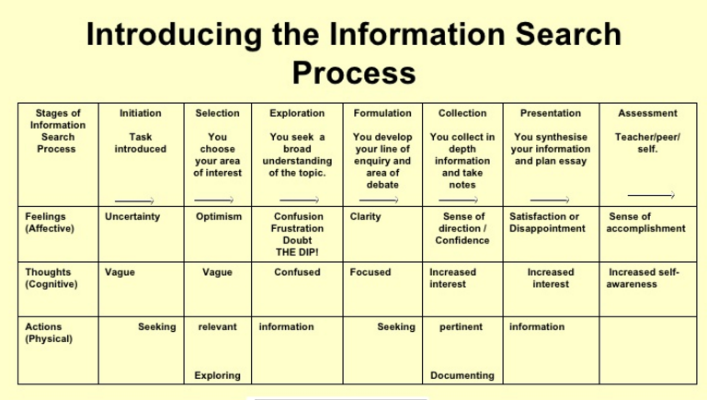

I have learned a lot from this summary table. What comes to mind are the different levels like thoughts and feelings. My experience is that if you show students that it is natural to feel confused at certain stages in the process, this will alleviate the emotional pressure that they may experience, since they are about to embark on a journey towards new insights.
Another thing that initially fascinated me with the model was the stage-sequential structure which conveys that there are different phases which belong to an enterprise of this kind.
A third thing that I noticed while spending time with GI was that it presented me with a question:
Is there anything I can do (more than I am doing today) to guide students on their journey towards a goal, where they can acquire more knowledge?
Even though my initial answer was no, I later realized that the answer was yes.
It came to me when I viewed GI as a continuum where I could be more or less of a guide. More or less active. I realized then that I had gradually started to move more and more into a direction where I did slightly less than what was in my capacity.
I have since then experienced raised activity, from my part, in my role as a teacher. I am more active in the class-room, I have a greater portion of faith in my students, and our encounters have become more meaningful.
Where I previously was inclined to stay slightly more passive, my activity has risen to a level which is more comforting to my students.

- Good fit GI and scientific approach
I would definitely say that there is a close match between the scientific approach and GI/ISP.

- Experience in our school
In our school there is a large amount (I would guess 10-15) of teachers and teacher librarians who believe that this method is valuable, and useful.

- Obstacles for GI
The greatest obstacles for the GI is that the school-life is quite stressful, or at least in danger of becoming so, and that many teachers feel that they will have to tick off another thing of the one thousand things that they are supposed to complete. I can speak for myself. If it hadn’t been for the fact that our librarian took the time to summarize GI for me during an hour, I would never had applied to join our school’s GI-course. Also during the course I wondered if this was a good investment of my time. I am still not completely befriended with the ISP model and have therefore felt a need to accompany the model with a complementary model **
**
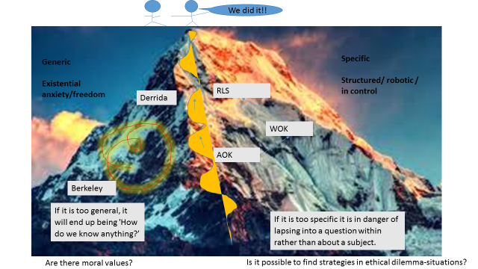
Without going to deep into this picture, to summarize, I think that the process of exploring is less linear and more wind-like in the sense that thoughts and emotions like confusion, vagueness, focus and self-awareness are more fluctuating states. They come and go.
- Benefits of GI for school projects
Once teachers and teacher librarians have befriended themselves with the method it is my firm belief that it will be to the benefit of the entire school
- Role of teacher librarian
Immensely important as the holder of the Torch.
Good luck with your research.
/Johan Lindkvist

Can you outline your understanding of the ISP which supports Guided inquiry?
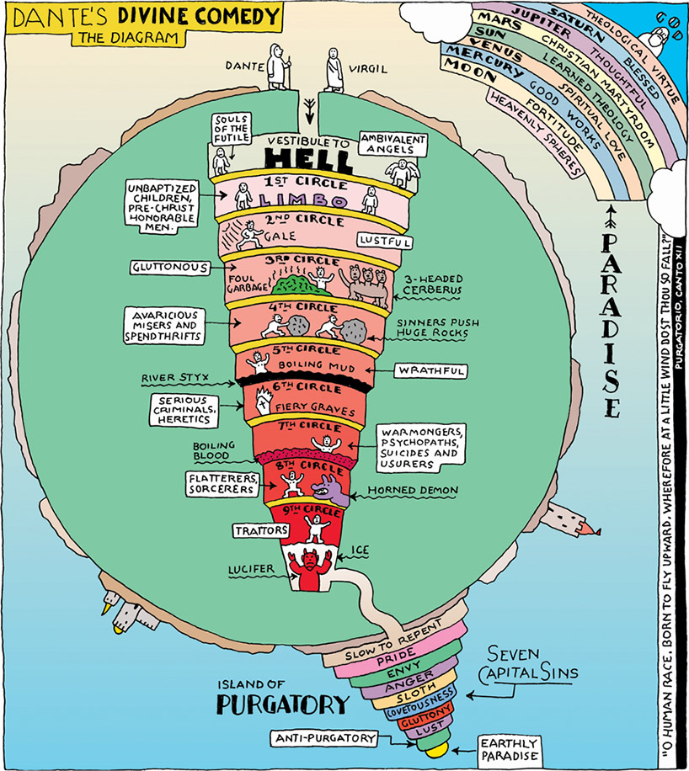

This is a picture I´ve stolen on the internet (fair use?) and which I´ve used when I illustrate to the students how I sometimes think of the ISP. The opening towards hell has a wide entrance, and it gets worse the further down you come – but when you find you question (met Lucifer) you have your turning point and you can start to move up again towards the earthly paradise and a completion of your work.
Do you think there’s a good fit between Guided Inquiry and the scientific approach which underlies the curriculum in your country? Why/ why not?
Oh yes – at least in theory. Critical thinking is encouraged, end in Swedish you should read huge amounts of texts to be able to find what´s relevant to use in your own production. In the central/national test you will be given a couple of sources, so in that case you do not need to find them yourself.
What has your experience been thus far of Guided Inquiry in your school?
A lot of experimenting and many different ways to do it. But most people seem to believe in Guided Inquiry as a method.
What obstacles do you see in the way of Guided Inquiry?
Lack of time and students who are stressed to get the highest grades. Students want to get highest possible grades with the least effort which is understandable thinking of how many courses they take.
What benefits do you see of approaching school research projects with the ISP/GID?
It encourages students to think for themselves and to learn for real, not just to get a grade, and it prepares them for university studies.
What role do you see the teacher librarian playing?
Support, inspiration and guidance. The school librarian can sometimes be some sort of “fairy godmother” who can help students find what they need to make their visions come true. And they do it with magic…
What further questions do you have about Guided Inquiry?
What does the education for which we prepare our students look like? Will their choices of topics be limited by for example what specialties their university professors have? The last time I wrote a paper at a university (2014) I thought that the most difficult part was to cope with my supervisor. More difficult than navigating in the hell of Dante.
Anonymous

My understanding of ISP/GI
ISP is the process that you as a student/researcher/curious person process when you search for information to explore or answer a question. Kuhlthau’s description of ISP is the start of a construction of a theory concerning this process, and it involves different phases in a research/information search work where thoughts and feelings are connected to the different parts of the process, which gives a holistic picture, according to me.
GI is according to me another description of the different phases in the process, but focuses on method and purpose to support practical supervision/guidance of people who are in the ISP.

Does GI fit with our curriculum national and IB?
Yes, GI fits both our national curriculum (and IBO’s missions statement and learner profile). When it comes to the national standards it is mainly the focus on scientific approach which makes GI suitable as a method. (SLR is a good example of how you can use GI to create a scientific approach for example.) And at our school we need to prepare all our students for higher academic studies and therefor we need to make them practise independent research and a scientific approach.
When it comes to IB their learner profile looks like this.

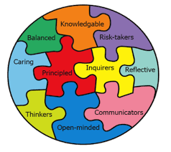

The students should become: Thinkers, Open-minded, Reflective, Inquirers, Risk-takers etc.
To start a GI-project takes open minds, thinking, curious/inquisitive
Students who dare to take risks.
I would say: perfect match.

What are your experiences so far of GI?
I have tried GI as a guidance in different types of projects and I have seen that it often raises the quality of the students work. These are good experiences which mainly are based on the fact that the group reaches a wider variety in the topics they choose if you allow Third Space to be an explicit factor in the project. Even ”forcing” students to read and orally present their sources and ”forcing” them to reflect when they have finished a session of information search do create an awareness in the students regarding how they actually arrive to a deeper understanding. The first sources are rarely the most interesting ones.

Problems with GI?
It takes a lot of planning before you get started and it tends to need longer periods of time in a course if it should not get too broken up and too far between the lessons. Sometimes there is so much to do as a teacher and so many classes to administrate that it is easier to plan for a week at a time, and this means that I do not use the method to the extent that I actually think I would like to.

Advantages with GID/ISP
The answer is partly in my text above. The quality and the variety is often better. I think it has to do with the fact that it is mainly longer projects with clear instructions. I´m not really sure what generates the higher quality.
The most positive part is that it is possible to guide students to third space and help the students find the assignment interesting for real. I think that´s a truly high value…
Another great advantage is that we as teachers make them practise their independence to become more prepared for the university courses. Clearly they are better prepared for university studies.

What is the role of the school librarian?
When I have planned my projects the librarians have had many different roles: someone to test my ideas on and a coach for me, as an expert and guide into the information search process and specific data bases. They have also presented books and articles for open/immerse, and helped the students get material in the library and from outside. They have probabaly done more but this is what I can think of now.

What further questions do you have on GI?
I don´t know if I have that many questions now. My big struggle at the moment is how to cope with how the students handle their reading of their sources. My concern and genuine experience is that the students find it harder and harder to manage and understand the texts they find. And if they don´t the entire movement towards deep understanding stops, and the true value of GI, as I think of it, is lost. That’s it for now / David

I have attended the GI-education because I think that my students cannot do proper searches. To be able to help them better I must learn it better myself. I think the part of the education where an introductory instruction in different search methods and how different data bases work has been very useful. Because of this I started a project this fall where I have asked students to present articles every week. Mainly general press articles but as the students read more and more I notice that they tend to find more and more advanced texts. I feel much more comfortable now when I am supervising them. Anonymous

For your reflection
Your name: _____________________________________
- Can you outline your understanding of the ISP/GID which supports Guided Inquiry?

- Do you think there’s a good fit between Guided Inquiry and the inquiry learning favoured in the Australian Curriculum? Explain why/why not?

- What has your experience been thus far of Guided Inquiry in your school?

- What obstacles do you see in the way of Guided Inquiry?

- What benefits do you see of approaching school research projects with the ISP/GID?

- What role do you see the teacher librarian playing?

- What further questions do you have about Guided Inquiry?

