Inquiry Journal, log and chart

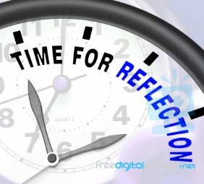

There are three vital inquiry tools any researcher needs. They are:
- An Inquiry journal – for keeping notes and reflections
- An inquiry log – a record of sources you’ve used, and
- An inquiry chart – a mind-map which helps you to draw together the themes of your research, in order to answer your inquiry question.
You will use your inquiry journal to reflect at three key points of your research – at the beginning, at Identify/Gather and at Evaluate. This is to help you express your growing understanding of the topic and as a way of letting your teacher and teacher librarian know if you need help9.

First reflection at Open/Immerse:
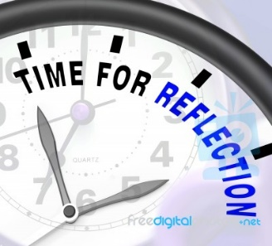

- Take some time to think about your topic. Now write down what you know about it
- How interested are you in this topic? Very/not very
- How much do you know about this topic? Nothing/Not much/ a little/A great deal
- When you do research, what do you generally find easy to do?
- When you do research, what do you generally find difficult to do?
Questions are from the SLIM Toolkit . They are designed to help you think about how your research is going, and how to get help if required.
You may want to reflect in some other way, or your teacher will ask questions for you to respond to.

It is not necessary to use your inquiry journal for notemaking at Open and Immerse. Just listen as your teacher engages you in the topic, and the parameters of the task. Your only job at this stage is to get curious, and to consider what you already know about this topic.

At Explore, you will have the chance to explore overview sources on your topic. Your aim is to get a broad idea of what the whole topic is about, so that you can choose an aspect that appeals to you for deeper research. You do not need to take notes at this stage, but do keep a record of the sources you use. Maybe use a scaffold like this (bearing in mind, the way you take notes and remember the sources you use is a personal choice).

Inquiry log at Immerse
Source
Page number or URL | Ideas and questions | Use yes/no
Source
Page number or URL | Ideas and questions | Use yes/no
Source
Page number or URL | Ideas and question | Use yes/no
Add rows as required

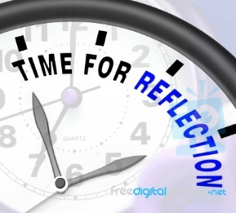
At Identify, you now know what aspect of the topic you want to explore further, and have consulted enough sources to be able to frame an inquiry question. This question may change as you get into deeper sources at Gather.

Your proposed inquiry question:

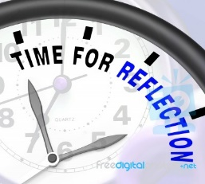
It is time at Identify to reflect to help you synthesise what you’ve learnt, and to seek help from teacher or teacher librarian, if you need it.
Take some time to think about your topic. Now write down what you know about it
How interested are you in this topic? Very/not very
How much do you know about this topic? Nothing/Not much/ a little/A great deal
When you do research, what do you generally find easy to do?
When you do research, what do you generally find difficult to do?

It is at Gather that the heavy lifting of research is required. You now know what you want to find out, and what is relevant and what isn’t. You will be involved now in specific sources, culled to meet the requirements of your inquiry question. The information is likely to be deeper and harder to read. It may cause you to refine your inquiry question.

Now is a good time to use a Cornell notemaking scaffold – or one of your own devising. Or an online notetaking facility like Evernote.

An example follows. Use one of these for every source you consult.

Inquiry question
Bibliographic details: Author/date/title/URL/Publication

Questions/ideas | Notes –  Key facts/opinions.  Quotes to use (keep page number, if relevant)
Summary: In a few sentences, write the key ideas and why this source adds to your understanding.

This is where you need to use an inquiry chart to pull together your understanding and to answer your inquiry question. This can be butcher’s paper, if that suits you, or it can be a mind map or a lotus diagram, such as the one below. There are many online mind mapping tools, e.g. Bubble.us.

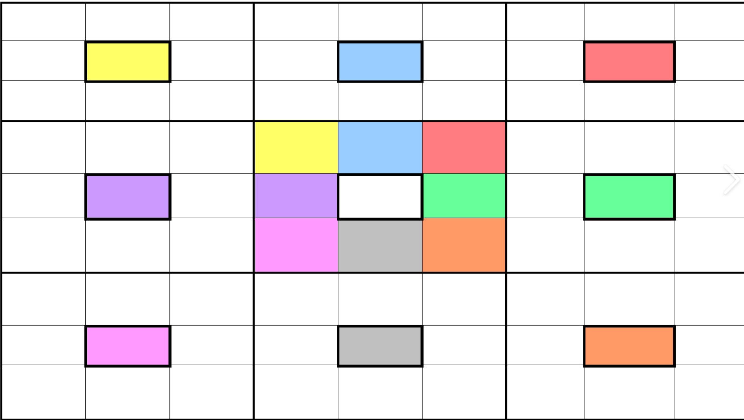

The final product of your research might be an essay, or a multimodal presentation, or a speech. Please refer to materials from ERGO (State Library of Victoria) for help in creating your product.

Creating your bibliography
It is now, at Create, that you will be very glad that you’ve kept details in your inquiry log to help you create the required bibliography and in text citations required. Your school will have its own format to use, whether Harvard or APA, and will also probably have an online bibliography maker, such as Cite this for me or Easybib. Alternatively, you can use the References tab in Microsoft Word to create your bibliography.
Here is a scaffold that might suit you:
Books | Author | Date (Year only) | Title | Place of publication (City and country) | Publisher

Internet sites/ | Author (Person, group or organization responsible for site – NA if not available) | Date (created, revised or updated) | Title | Retrieved from: Internet address

Articles | Author (Person, group or organization responsible for site) | Date (created, revised or updated) | Title | Journal title, issue number, page numbers | Available at: Internet address

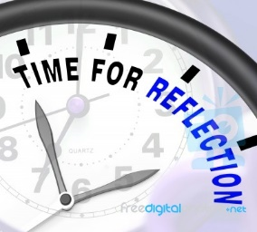
At Evaluate, you will have received feedback from your teacher on your assessment. Now is a good time to reflect again on the SLIM questions (or others of your own, or your teacher’s devising).

Take some time to think about your topic. Now write down what you know about it
How interested are you in this topic? Very/not very
How much do you know about this topic? Nothing/Not much/ a little/A great deal
When you do research, what do you generally find easy to do?
When you do research, what do you generally find difficult to do?
What did you learn doing this research unit?

