Teacher(s) |  |  |  | Subject group & discipline
Unit Title |  |  |  | MYP Year |  |  |  | Unit Duration (hrs)
Middle Years Program (MYP)
Key Concept: |  |  | Related Concept(s) |  |  |  |  |  | Global Context:
IB Learner Profile  attributes (up to 3) |  |  | Christian Perspectives |  |  |  |  |  | Interdisciplinary links:
Statement of Inquiry
Unit Overview
Inquiry Questions:
Learning Spaces |  |  |  |  |  | Learning Relationships

NESA Outcomes | MYP Objectives

Assessment Overview | MYP Objectives |  |  |  | NESA Outcomes
Outline of the task(s)
Formative/Process
Summative

Relationship between summative assessment tasks(s) and the Statement of Inquiry?
Approaches to Learning (ATL)

Guided Inquiry Design Stage | Content | What the teaching team is doing -  Teaching, learning and assessment. | What the students are doing | Scaffolds and resources
 | Teachers give enticing and interesting topic overview.  Inform students of inquiry parameters  And overarching inquiry question. | Invitation to inquiry  Open minds  Stimulate curiosity.  Teacher introduced inquiry task.  Teacher librarian introduces inquiry process and scaffolding. | Open to curiosity | e.g. student overview of inquiry task;  What an inquiry process is for  Information process arrangements.  Complete Reflection sheet 1 to show level of knowledge of topic and attitudes at outset.
 | - Build background knowledge  - Connect to content  - Discover interesting ideas | Teachers take as long as necessary to immerse students in the content of the topic, its sub topics, providing an essential overview of the topic. | Students listen, and ask questions | Teacher led inspiration. TL not really needed at this stage.  Consider a visiting speaker.  Interesting video which condenses the topic into its elements.
 | ● Explore interesting ideas  ● Look around  ● Dip in | Teacher and TL oversee students using overview resources. | Students begin their inquiry, using overview resources only  Object is to find a part of the topic that interests them the most. | That’s interesting/ Questions I have scaffold, or similar  TL resources topic in stations – resources must be overview only.  Reflection sheet 2 – TL/ T to feedback.  At Explore, it is usual to experience a Dip in confidence.
 | - Pause and ponder  - Identify inquiry question  - Decide direction | Teachers and TL assist with inquiry circle formation (if having them) around similar sub topics | Students work in inquiry circles with other people interested in the same area, to condense what they know already about their topic.  Student input on question formation  Work together to create inquiry questions. | Complete and submit That’s interesting scaffold.  Question focus formulation technique
 | - Gather important information  - Go broad  - Go Deep | Teacher and TL feedback on difficulties identified in Reflection Sheet 1;  Work with inquiry circles to ensure difficulties don’t arise, work is shared, nobody is dominating etc.  TL provides deeper and broader resources for this stage, dependent on the inquiry questions. | Students investigate deeply and broadly to find pertinent information to answer their inquiry question.  Take notes – Inquiry journal  Keep references – Inquiry log | Further work in inquiry process journal taking notes and keeping references.  Scaffolds such as how to read more complex sources will help at this stage.
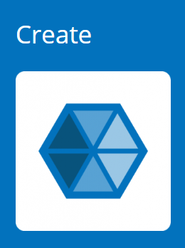 | - Reflect on learning  - Go beyond facts to make meaning  - Create to communicate  - Learn from each other  - Share your learning  - Tell your story | T and TL work with students to help them move from information to their product.  TL and T organize jigsaw to share inquiry circles knowledge on every sub topic of the major topic. | Students synthesise their learning to present group/solo presentation on their inquiry question  Students listen, take notes to answer overarching question of unit  Peer evaluation | Scaffolding such as mind mapping/storyboarding.  If individual product – scaffolding such as From Notes to PEEL.  Notes while listening
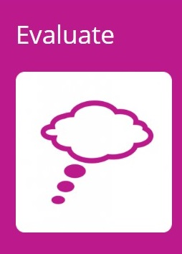 | - Evaluate the achievement of learning goals  - Reflect on content  - Reflect on process | Teacher responsible for content assessment  TL for process submission  Share management of culmination conversation (if having)  Have a conversation about the unit, what worked, what didn’t, how to improve. | Students might have an in class task e.g. essay to show knowledge of overarching inquiry question  Take part in a culmination conversation showing level of understanding of topic | Reflection sheet 3 – what have I learnt about this topic? What have I learnt about me as an inquirer.

Reflecting and evaluating: Considering the planning, process and impact of the inquiry
Registration Form

Teacher (Date): | Print your name, sign and date here.
Head Teacher (Date): | Print your name, sign and date here.

