Year 7 Inquiry Community explores the world!
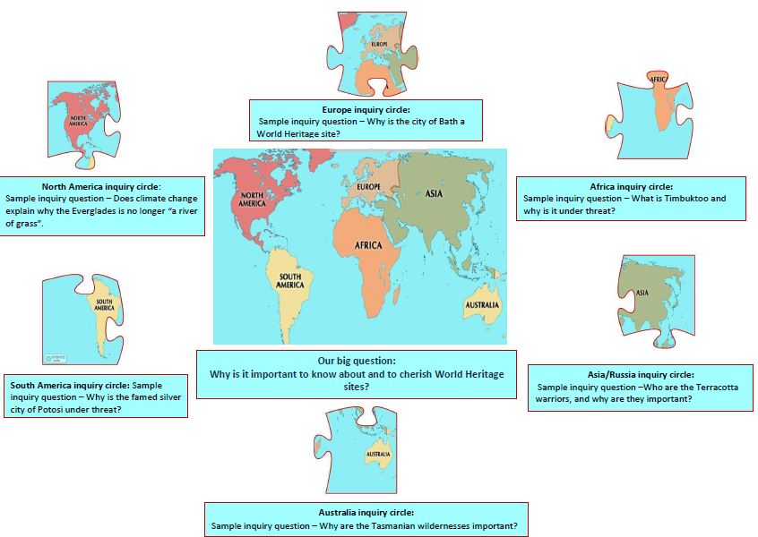

My Inquiry Journal

My name:_____________________________

Stage of Guided Inquiry Process:

YOU ARE INVITED:
- to inquire!
- to open your minds, get curious.....
- to explore the world!

Your task: You are an inquiry community dedicated to finding out the answer to our BIG QUESTION:

Why is it important to know about, and cherish, World Heritage sites?

Step 1: Your teachers will introduce you to World heritage sites around our world.
While you are watching and listening to your teachers, jot down a couple of thoughts:

That’s interesting:

I didn’t know that:

I want to find out about:

Questions I have:

Write down 3 things you learnt today:

GLOSSARY OF TERMS (match the correct term with its definition)
TERM | DEFINITION
 | United Nations Educational, Scientific and Cultural Organisation
 | That which is inherited from past generations, maintained in the present, and bestowed to future generations.
 | Monuments, groups of buildings or sites of outstanding universal value from the point of view of history, art or science.
 | A natural or man-made site, area, or structure recognized as being of outstanding international importance and therefore as deserving special protection
 | The distinctive characteristics belonging to any given individual, or shared by all members of a particular group.
 | Natural physical or biological sites or species that are of outstanding universal value, are under threat, or are of great interest to science, conservation or natural beauty.
 | Animals and plants that are facing threats to their survival, and may be at risk of extinction.
 | The seven most spectacular man-made structures of the ancient world.
 | The protection of plants and animals, natural areas, and interesting and important structure and buildings, especially from the damaging effects of human activity.
 | An international agreement that defines the kind of natural or cultural sites which can be considered for inscription on the World Heritage List
 | The protection, preservation, management, or restoration of natural environments and the ecological communities that inhabit them.
 | The term used to describe the variety of life found on Earth and all of the natural processes.
 | A group of plants, animals and bacteria that work together to remain healthy
 | The disappearance of a species from the Earth
 | Meeting the needs of the present without compromising the ability of future generations to meet their own needs.
World Heritage site 7 wonders of the world Cultural heritage

UNESCO Heritage Natural heritage

Identity Conservation Environmental conservation

Biological diversity Ecosystem Extinction

Sustainable development



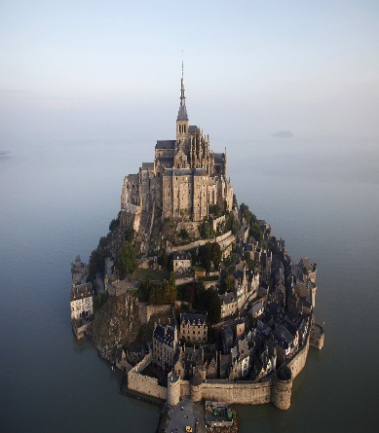

Some basic facts:
- The New Kingdom (c.1550-1070 B.C.) was a most glorious period in Ancient Egyptian history.
- During the New Kingdom period some of the most familiar pharaohs ruled over ancient Egypt, including Ramesses II, Tuthmose III, and Akhenaten.
- Military conquests, empire building, prosperity and wealth, developments in art and architecture, and religious innovations marked the New Kingdom period.

Below is a map showing the maximum territorial extent of the New Kingdom of Egypt, c. 1450 BC.
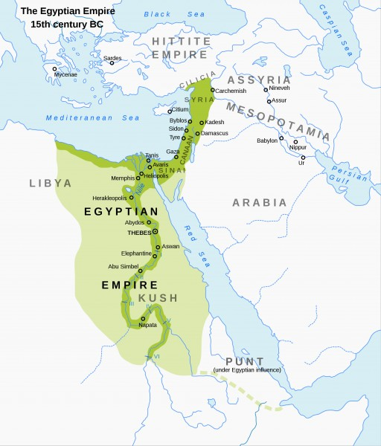

Stage of Guided Inquiry process:
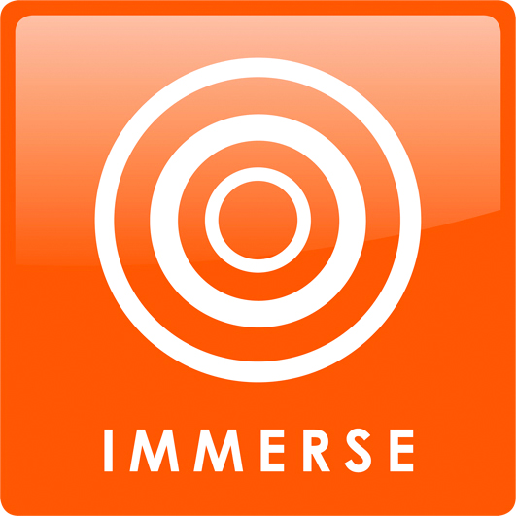
Step 2: You will develop some background knowledge in class time.
Let’s see what you already know about this topic
Then have a broad search to discover interesting ideas.
DO NOT SEARCH TOO DEEPLY! Use Encyclopedias, simple non-fiction, Clickview and Youtube videos. Do NOT use Google at this stage.

What do I already know about this topic?

Where will I look for information?

What search terms will I use to look for information?


Step 3: The Year 7 Inquiry community will pull apart the jigsaw of life in New Kingdom Egypt, and each student will join an inquiry circle on ONE of the areas pictured below. Choose your area!

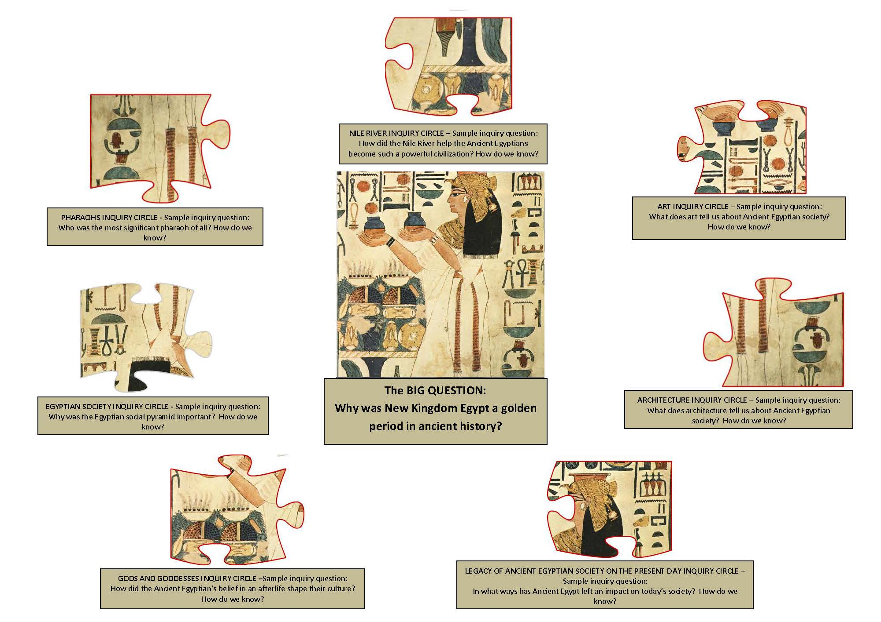

Now, working alone, you are to explore the ideas you think are interesting.
Focus? Following YOUR interest.
Look around and dip in.

Stop and jot
While you’re browsing resources to find what interests you most, and you do find something interesting, fill this in.
Source:  Page number/URL | Ideas and questions
Delete or add rows as you need them.

Figure 6.1 Stop and Jot. Guided Inquiry Design. From Guided Inquiry design: A framework for inquiry in your school. Carol C.Kuhlthau, Leslie K. Maniotes and Ann C Caspari. Santa Barbara, CA: Libraries Unlimited 2012.

First of all, share what you’ve found out in your inquiry circle. Sit and talk about it.
Next , it’s time to work together to identify your inquiry question. Use the sample question given to you for your inquiry circle as a model.
Working together in Inquiry circles, do the Question focus formulation activity

The rules
- Brainstorm many questions as you can about the topic
- Do not stop to discuss, judge or answer the questions.
- Write down every question exactly as it is stated.
- Change any statement into a question.
Record them here:

Categorise them according to whether they are:
- Closed-ended questions: They can be answered with YES or NO or with ONE WORD. Example: Is this going to be on the exam?
- Open-ended questions: They require an explanation and cannot be answered with YES or NO or ONE WORD. Example: What will be on the exam?
Mark the questions above with a C or an O
Prioritise the questions
Choose the three questions that you think will be best for your inquiry
1.
2.
3.
Now write down your inquiry question: (Remember you must include How do you know? at the end of it).

Rothstein, D., Santana, L.(2011) Teaching students to ask their own questions. Harvard Education Letter, 27/5
What search terms will we use for finding information to answer your inquiry question?

Where will we look for deep information to answer our inquiry question?

Inquiry journal – individual
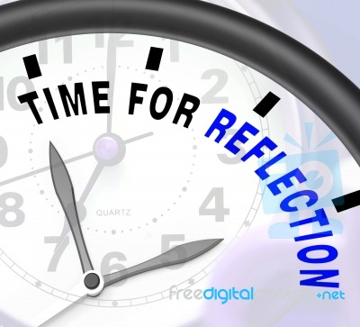
How do you feel about your inquiry project now?

You’ve identified your area of interest, and created your inquiry question – What is it about this particular part of the topic that interests you?

What difficulties are you having?

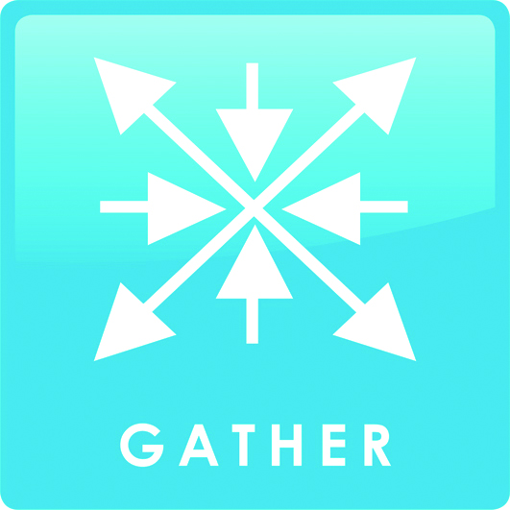
Gather important information
Go deep
Now you are working with your inquiry circle to gather ONLY the information that answers your inquiry question. Remember to work together to record your sources in Easybib.

My notes: (Share the work of researching and notetaking)

Source:  Page number/URL | Jot down relevant information here – Just the main ideas, in dot points.
Delete or add rows as you need them.

For the How do you know part of your inquiry question – You must use primary sources – four for the whole group. Share the work of gathering the information from the primary sources.
PRIMARY SOURCE

Source Reference | What does this source tell me about my inquiry question?
This picture is/ describes/ shows……

Key features:

It tells us about ancient Egypt……


Share with your inquiry partner
Mind map your ideas
Create the answer to your inquiry question
Share it with the Inquiry Community.
It’s time to help each other get ready to create your answer to your inquiry question – Inquiry circles. You will use this mind map to tell other inquiry circles what you know.

Create your inquiry chart.
- Put your inquiry question in the middle
- Use the other circles to add information about the main answers to your inquiry question.
- Add more circles if you need them.

Jig saw – After the jigsaw activity in which you share your knowledge about your area of expertise, and hear about what other inquiry circles have found out, jot down what you’ve learnt from them.

Inquiry circle 1
Inquiry circle 2
Inquiry circle 3
Inquiry circle 4
Inquiry circle 5
Inquiry circle 6
Inquiry circle 7

Create and share – continued...
Why was New Kingdom Egypt a golden period in Ancient History?
Make a plan for your response to the Big Question:
Introduction:

P
E
E
L

P
E
E
L

P
E
E
L

CONCLUSION:

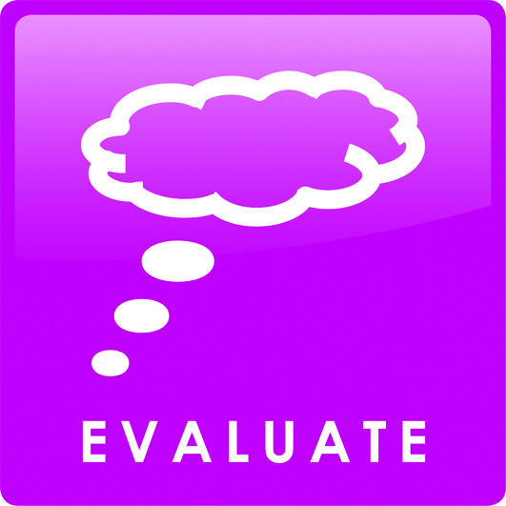
Evaluate achievement of learning goals
Reflect on content
Reflect on process.
Achievement of learning goals:
- Look at your marks for the project – process and content on the last page of this booklet and talk to your teacher and teacher librarian.

Inquiry journal – individual

Reflect on your process:
How did you feel as you went through the stages of the Guided Inquiry process?

Final reflection
This is the way I learn:
Tick the statements that most reflect how you learn:
- I need to talk to others about my ideas
- I need to have some quiet time alone
- I need some time to think before I write anything down
- It helps me to draw or chart my ideas
- I need some help getting going
- I need to move around.
My inquiry tools
Complete the sentence:
Writing in my inquiry journal helped me to

My inquiry circle helped me to

My inquiry process:  This was easy for me | because
This was hard for me | because
Something I will do differently next time is | because
Figure 11.2 Student Self-Reflection on Inquiry. Guided Inquiry Design. From Guided Inquiry design: A framework for inquiry in your school. Carol C.Kuhlthau, Leslie K. Maniotes and Ann C Caspari. Santa Barbara, CA: Libraries Unlimited 2012.

Marking criteria and learning goals – Content
HT4-2 describes major periods of historical time and sequences events, people and societies from the past.
HT4-3 describes and assesses the motives and actions of past individuals and groups in the context of past societies
HT4-4 describes and explains the causes and effects of events and developments of past societies over time
HT4-7 identifies and describes different contexts, perspectives and interpretations of the past
HT4-9 uses a range of historical terms and concepts when communicating an understanding of the past
HT4-10 selects and uses appropriate oral, written, visual and digital forms to communicate about the past

Marking Criteria - PEEL

- Outstanding understanding of the nature of New Kingdom Ancient Egyptian society, including using historical terms and concepts with perception  - Outstanding understanding of the contribution of primary sources to supporting an argument.  - Outstanding evidence of understanding the contribution of each of the inquiry circles to a picture of life in New Kingdom Ancient Egypt.  - Highly competent use of the PEEL structure to design an answer to the Big question. | 21 – 25  A
- Strong understanding of the nature of New Kingdom Ancient Egyptian society, including some use of correct historical terms and concepts.  - Strong understanding of the contribution of primary sources to supporting an argument.  - Strong understanding of the contribution of each of the inquiry circles to a picture of life in New Kingdom Ancient Egypt.  - Competent use of the PEEL structure to design an answer to the Big question. | 16 – 20  B
- Understanding of some aspects of New Kingdom Ancient Egyptian society, with errors of use of historical terms and concepts.  - Primary sources are used to contribute to argument  - Knowledge from the point of view of some inquiry circles is patchy.  - Attempt made to use PEEL structure to design an answer to the Big question. | 11 – 15  C
- Limited understanding of some aspects of New Kingdom Ancient Egyptian society.  - Primary sources do not add to arguments used.  - Knowledge from the point of view of some inquiry circles is patchy or missing.  - PEEL structure not well understood or applied. | 6 – 10  D
- New Kingdom Ancient Egyptian society not understood  - Primary sources are either not used at all, or show no analysis.  - Knowledge from other inquiry circles is not evident.  - Poor attempt to use the PEEL structure. | 0 – 5  E
Your mark:

Comment:

Marking criteria and learning goals - Process
HT4-8 locates, selects and organises information from the sources to develop an historical inquiry
Marking Criteria - Process – this booklet

- Outstanding use of inquiry journal to demonstrate engagement with the Guided Inquiry process.  - Evidence of strong development of inquiry skills in locating and using information, including primary sources.  - Leader/engaged participant in inquiry circles activities  - Outstanding use of reflection to show awareness of own process of research. | 21 - 25  A
- Excellent use of inquiry journal to demonstrate engagement with the Guided Inquiry process.  - Evidence of development of inquiry skills in locating and using information, including primary sources.  - Clear evidence of engagement in inquiry circles activities  - Competent use of reflection to show awareness of own process of research. | 16 - 20  B
- Uneven use of inquiry journal to demonstrate engagement with the Guided Inquiry process may be  - Some evidence of development of inquiry skills in locating and using information, including primary sources.  - Engagement with inquiry circles activities  - Uses reflection to show awareness of own process of research. | 11 – 15  C
- Limited use of inquiry journal to demonstrate engagement with the Guided Inquiry process may be  - Little evidence of development of inquiry skills in locating and using information, including primary sources.  - Little engagement with inquiry circles activities  - Uneven use of reflection to show awareness of own process of research. | 6 – 10  D
- Inquiry journal not used much, or at all.  - No evidence of the development of inquiry skills in locating and using information, including primary sources.  - No engagement with inquiry circles activities  - Poor use of reflection to show awareness of own process of research. | 0 – 5  E
Your mark:

Comment:

