Year 11 English Extension 1: Texts, Culture and Value – Related Research Project
By Felicity Sandral, ETL401 Student 202230.

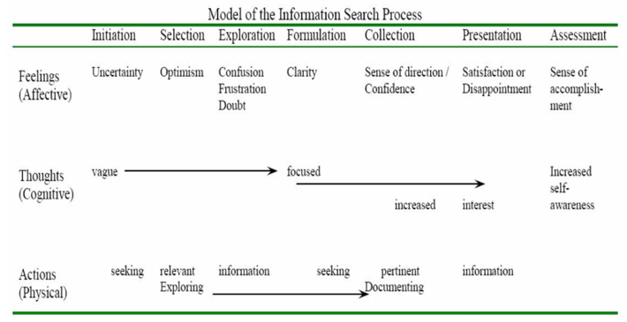
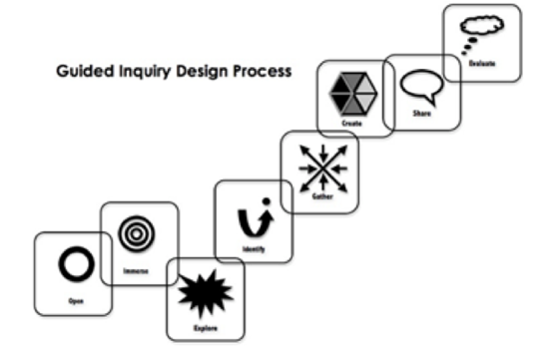
(Kuhlthau, et. al., 2012, pp.2-19)
Inquiry questions: How and why do composers borrow from past texts to communicate the values of their own times? Which is more valuable: the original text or its manifestations?

Learning scenario: Students will explore how and why contemporary manifestations of key texts present similar, contrasting or alternative cultural values to the originals, and evaluate the relative cultural value of their chosen texts. Students will select and analyse a key text and a manifestation from different contexts, forms and media, then investigate and compare how effectively they express the values of their composers’ contexts. To aid their inquiries, students will learn and use a range of information literacy strategies.
Curriculum Skills (NSW NESA Preliminary HSC - Stage 6 English Extension 1 syllabus)
- EE11-1: demonstrates and applies considered understanding of the dynamic relationship between text, purpose, audience and context, across a range of modes, media and technologies
- EE11-3: thinks deeply, broadly and flexibly in imaginative, creative, interpretive and critical ways to respond to, compose and explore the relationships between sophisticated texts
- EE11-4: develops skills in research methodology to undertake effective independent investigation
- EE11-5: articulates understanding of how and why texts are echoed, appropriated and valued in a range of contexts

General Capabilities (ICT Capabilities; Critical and Creative Thinking – CCT)
- Investigating with ICT (ICT Capabilities)
- Inquiring: identifying, exploring and organising information and ideas (CCT)
- Reflect on thinking processes (CCT)

Lesson Plan

Activities  55 min lesson | What the teaching team is doing  Teacher Librarian (TL)  Classroom Teacher (CT) – | Resources
Starter  10 minutes | - Multimodal provocation to prompt curiosity & discussion: As students enter the library learning space, a looped slide presentation shows images of key texts & contemporary manifestations, e.g. Dickens’ A Christmas Carol (1843) and The Muppet Christmas Carol (Henson, 1992), with the provocation “Which is more valuable?” prominent on each slide.  - CT: Think, pair, share: What are some contemporary manifestations (of classics) that you value & why? Learning community writes responses on sticky notes & places on whiteboard. CT takes photo of responses and uploads to Google Classroom.  - CT leads brief discussion based on sticky note responses and the provocation. | - Slide show: ‘Which is more valuable?’  - Library learning space  - Laptop  - Projector/screen  - Sticky notes  - Whiteboard  - Mobile device  - Google Classroom
Worktime  Time: 35 min | - CT briefly introduces the overarching inquiry question, the learning scenario and assessment.  - CT allocates students to Inquiry Circles.  - TL introduces the Guided Inquiry (GI) process, emphasising its iterative nature. TL also explains the purpose of Inquiry Circles.  - TL uses ‘Research River’ analogy to make explicit the emotional dimension of the task.  - TL introduces the GI journal.  - TL: Explains and briefly models evaluative activity:  - Students browse the TL’s curated text-sets & select one per inquiry circle (e.g. Pride & Prejudice + manifestations), returning with it to workspace.  - Inquiry circles discuss & agree how they would rank each text-set according to value.  - Inquiry circles then discuss to what extent each text reflects the time in which it was created, writing key points on sticky notes.  - Inquiry circles briefly share their rankings and contextual reflections with the Learning Community.  - CT asks inquiry circles to question the bases of their text rankings: were they influenced by personal experience; general knowledge; author’s name; cover images / information? Were decisions founded on cultural, social, historical, economic or personal notions of value?  - CT & TL observe & take notes on students’ initial engagement and insights. | - Assessment notifications – hard copies  - Guided Inquiry (GI) slide presentation  - Research River SlideShare presentation (Fitzgerald, 2014)  - GI journal  - Curated text-sets, each consisting of a key text and a contemporary manifestation:  - Pride and Prejudice (Austen, 1813); Pride & Prejudice (Wright, 2005)  - Dracula (Stoker, 1897); Buffy the Vampire Slayer (Whedon, 1997)  - The Taming of the Shrew (Shakespeare, c.1590); 10 Things I Hate About You (Junger, 1999)  - Cinderella (Perrault, 1697); Cinderella (Jackson et al., 1950)  - Sticky notes & pens
Reflection  Time: 10 min | - Students write an initial reflection on ideas/questions arising from the lesson in their GI journals (GIJ). | - Physical GI journals (GIJ)  - Pens

GID Stage | Teaching Strategies | Student Activities
T1, Wk 1  1 period | - Refer to lesson plan (above).
Resources

T1, Wk 1-3

4 periods

 | - CT & TL explain assessment requirements in more detail.  - TL explains and models reflections, including SLIMs, emphasising their purpose (activate prior knowledge, track progress) & importance.  - TL & CT read and code students’ SLIM reflections.  - TL briefly models article annotation, using a page from Hutcheon’s A Theory of Adaptation  - TL reminds students of Socratic circles etiquette. CT & TL observe and record notes on students’ participation & insights.  - TL introduces a curated physical text display of key texts & manifestations, plus pathfinders. Teaching team emphasises that these are to guide, not limit student choice.  - CT and TL observe, note and assist.  - CT holds individual conferences with students regarding their choice of classic text and manifestation, recording their preferences. | - Ask questions; take notes.  - Fill out first SLIM reflection; all SLIMs put in GIJs.  - Watch Linda Hutcheon clip & discuss in Inquiry Circles.  - Read & annotate Hutcheon extracts (homework).  - Socratic circle discussions on Hutcheon extracts in inquiry circle groupings. Summarise and reflect in GIJs.  - Explore display and pathfinders, following own paths of inquiry if they arise.  - At least once per lesson: reflect on ideas, experiences and emotions relating to inquiry process in GIJs.  - Discuss and finalise their text choices with CT, writing a reflection on choice in GIJs.  - Begin reading/viewing texts.
Resources
- SLIM reflection 1 (Todd et al., 2005)
- Linda Hutcheon on Adaptations and Remakes (TIFF Originals, 2011)
  - Extracts from A Theory of Adaptation (Hutcheon, 2013): pp. 1-9 & 27-29; pp.85-95; pp. 142-148; & Epilogue by Siobhan O’Flynn, pp.179-189.

  - A broad entry-point pathfinder for key texts and manifestations, e.g. novels, film, graphic novels

  - Text/concept-based pathfinders including:
    - key texts &/or authors, e.g. Shakespeare; Dracula (Stoker, 1897)
    - fairy tales and legends, e.g. Cinderella; Arthurian legends
    - popular manifestations, e.g. Ever After (Tennant, 1998); Easy A (Gluck, 2010)
    - interesting archetypes, e.g. the muse; the vampire

  - Curated physical text display: key texts and manifestations
  - Library learning space

T1, Wk 3-6

6 periods

 | - CT models how to annotate/take notes on key moments when undertaking literary/film analysis.  - TL: explicit instruction re: citations (including brief refresher on MyBib) and digital search techniques, including:  - Key word searches  - ‘Advanced Search’ in literary/film databases, e.g. Literary Reference Centre  - Google Scholar  - Google (Eight Tips, including Boolean operators) & SIFT (Caulfield, 2019) evaluation  - Wikipedia (overview & footnotes)  - “Berrypicking” search techniques, e.g. forward & backward chaining; area scanning; author searching (Bates, 1989)  - Skimming & scanning sources  - TL: explicit instruction re: modified Cornell notes for secondary sources - insights not summaries in lower section.  - TL: explicit teaching and modelling of ethical note taking/annotation practices, paraphrasing, quoting & in-text referencing.  - CT & TL continue to observe, note and assist, monitoring journals for regular, effective reflections and ethical, purposeful notetaking practices. | - Take notes on/annotate key textual moments.  - Search for secondary sources, noting bibliographic details in MyBib.  - Read sources.  - Take notes using modified Cornell Notes technique.  - Inquiry circles discuss their progress & debrief on emotions.  - Continue to document process and reflect in GIJs.
Resources
- School databases
- Library learning space
- Laptops, Wi-Fi
- Eight Tips to Google Like a Pro (News Literacy Project, 2021)
- SIFT – interactive tutorial (Western New York Library Resources Council, n.d.)
- Improving Cornell Notes with Sketchnoting Techniques (Verbal to Visual, 2016)

T1, Wk 6-7

2 periods

 | - TL explicitly teaches and models inquiry question development using Bloom’s Taxonomy questioning scaffold. Students encouraged towards analysis and evaluation.  - TL & CT observe and assist, recording notes.  - CT holds conferences with individual students to help them refine questions.  - TL & CT read and code SLIM reflection 2. | - Develop & refine questions in Inquiry Circles.  - Confirm and refine questions in individual conference with teacher.  - Complete SLIM reflection 2.
Resources
- Library learning space
- Bloom’s Taxonomy questioning scaffold
- SLIM reflection 2 (Todd et al., 2005)

T1 Wk 7-9

4 periods

 | - CL refreshes students’ knowledge of multimodal presentation form and shows models.  - CT & TL observe, note and assist, checking that students are using a range of effective and ethical strategies.  - Check GIJs and give feedback on process. | - Continue searching & note-taking.  - Discuss progress with inquiry circles & reflect in GIJs.
Resources
- Multimodal presentation models
- Laptops, projector, screen, library learning space
- Students’ GIJs

T1, Wk 9-11

4 periods

 | - CT re-emphasises key details of the presentation to students.  - TL holds individual student conferences to provide feedback on citation.  - CT & TL – individual student conferences to give feedback on draft presentations.  - CT & TL view and take notes on students’ multimodal presentations. | - Edit citations post-feedback.  - Discuss final presentation plans with Inquiry Circle, then with CT & TL.  - Finalise and submit multimodal presentations. Submit in-text referenced transcripts to Turnitin.  - Showcase: Play multimodal presentations to the learning community and year 10 students considering the course.
Resources
- Draft transcripts and bibliographies
- Multimodal presentations, laptops, projectors
- Library learning space

T1, Wk 11

1 period

 | - CT & TL observe and facilitate evaluations and discussions.  - After lesson:  - TL reads students’ GIJs, transcripts and bibliographies; checks Turnitin reports.  - CT & TL read & code final SLIMs reflections; discuss & finalise assessment marks.  - CT & TL: culminating conversation evaluating unit. | - Complete peer evaluations of presentations by other students in inquiry circle, using a final presentation review scaffold.  - Learning Community conducts round table discussion. Provocation: What is the point of adaptation?  - Complete final SLIM reflection.  - Submit completed journals, in-text referenced transcripts and bibliographies.
Resources
- Final presentation review scaffold
- SLIM reflection 3 (Todd et al., 2005)
- Journals, transcripts, bibliographies
- Marking criteria

General Capabilities Assessment Criteria
Assessed on student engagement with the inquiry process, including in-class work/discussions, conferences, journal/log, and all citations.
Weighting: 25% of the total mark (5/20). Also meets outcome EE11-4.

GC | Investigating with ICT | Inquiring – identifying, exploring and organising information and ideas |  | Reflecting on thinking and processes
A - 5 | Systematic, ethical and meticulously documented information search process, using advanced search and evaluation skills to identify highly relevant sources. | Development of an original and fertile question highly relevant to the inquiry. | Analysis and synthesis of meaningful and evaluative insights from a good range of sources. | Consistent, perceptive and evaluative reflections on thinking processes, demonstrating awareness of complexities, e.g. multiple perspectives, emotions, ambiguities and weaknesses.
B - 4 | Thorough, ethical and well-organised information search process, using proficient search and evaluation skills to identify relevant sources. | Development of a probing question relevant to the inquiry. | Analysis and synthesis of valid insights from a good range of sources. | Regular, thoughtful and sometimes evaluative reflections on thinking processes, demonstrating good awareness of a range of complexities.
C - 3 | Satisfactory, ethical and organised information search process, using sound search and evaluation skills to identify an adequate range of relevant sources. | Development of a sound question relevant to the inquiry. | Identification of clear and valid ideas from a sufficient range of sources. | Regular, clear reflections on thinking processes, demonstrating sound awareness of some aspects of complexity.
D - 2 | Underdeveloped/inconsistently organised information search process, using some search skills to identify some relevant sources. | Identification of a question with some relevance to the inquiry. | Some identification of ideas; mostly summaries of sources. | Some clear reflections on thinking processes.
E - 1 | Limited and under-documented information search process. | Question has limited relevance to the inquiry. | Summaries and/or descriptions of sources. | Some attempt(s) to reflect on thinking processes.
0 | Non-attempt

