Homelessness in Melbourne

Guided Inquiry Design Information Literacy Plan
Unit Overview
Guided Inquiry Design (GID) Process and Model of Information Search Process (ISP) (Kuhlthau, Maniotes, & Caspari, 2012)  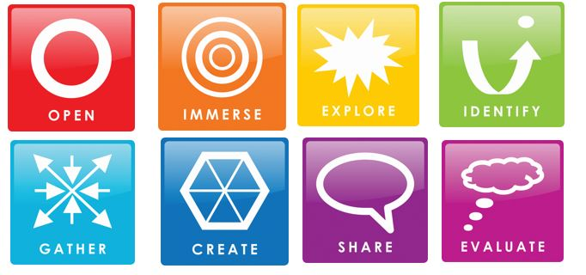 | Title of unit: Sleeping Rough on the Streets of the Lucky Country: An Inquiry into Homelessness in Melbourne  Subject/Year level: Year 7 SEEK Cultures (English and Humanities)  Teaching and Learning Team:  - Teacher Librarian (TL)  - Classroom Teacher (CT)  Key Inquiry/Essential Questions:  - Why are there so many homeless people in Melbourne?  - Why is homelessness still an issue in Australia (the ‘lucky country’)?  - How can we help people sleeping rough on the streets of Melbourne?
Australian Curriculum: English Content Descriptions  ACELT1805, ACELY1720, ACELY1725 (ACARA, 2015b) | Australian Curriculum: Geography Content Descriptions  ACHGK042, ACHGK044, ACHGK046, ACHGS053L (ACARA, 2015d)
Australian Curriculum: General Capabilities Elements  - CCT: Inquiring – identifying, exploring, and organising information and ideas (ACARA, 2015a)  - CCT: Reflecting on thinking and processes (ACARA, 2015a)  - ICT: Creating with ICT (ACARA, 2015e) | Learning Scenario:  Throughout this unit, students explore the issue of homelessness in Melbourne as an Inquiry Community (IC). They are part of Inquiry Circles, and conduct independent research in response to their own inquiry questions. This unit builds skills in critical thinking, researching, communicating, and reflecting.
Assessment:
Formative: Students maintain Inquiry Journals and complete Inquiry Logs, Inquiry Charts and SLIM reflections. They partake in conferencing, participate in discussions and provide peer feedback.
Summative: Students create a multimodal resource to communicate their findings (published in a Kingsnet virtual gallery). A rubric, assessing elements of General Capabilities on the Australian Curriculum, is marked by the teaching and learning team (TL and CT).

Introductory Lesson Plan
OPEN:  Lesson 1 | Learning Intention: To establish our inquiry community and spark curiosity about the issue of homelessness in Melbourne.  Success Criteria:  - Participate in teaching and learning activities  - Learn about the GID process  - Use Inquiry Journals to write a reflection
Activities | What the teaching team (TL and CT) are doing | Resources
Starter:  10 minutes | TL and CT welcome students and perform Acknowledgement of Country (GSP slide 2)  CT reads learning intention and success criteria (GSP slide 3)  CT asks students to “draw a homeless person” on a piece of paper (GSP slide 4)  TL hands out paper to students, informs they have 5 minutes to draw response | Open Google Slides presentation (GSP)  Laptop and projector to display GSP  Blank piece of paper for all students and pencils
Worktime:  35 minutes | CT asks students: “did you draw someone like this?” and displays images (GSP slides 5-10). CT and TL facilitate discussion about stereotypes, what homeless people ‘look’ like and what the students drew on their paper  TL collects papers from students  CT launches Kahoot quiz about homelessness in Melbourne. Displays game pin on projector (GSP slide 11)  TL shows YouTube video from Launch Housing (GSP slide 12)  CT prompts students to complete ‘think, ink, pair and share activity’ on their devices: (GSP slide 13)  CT and TL facilitate discussion of answers, hearing different student responses  TL introduces GID process (GSP slides 14-19) and uses the analogy of a car journey and research roadmap  TL provides overview of all GID stages and emphasises that it’s okay to feel apprehensive. Reminds that it is a guided process with inquiry community support. Clarifies that this is the ‘Open’ stage of the GID process  TL reads key inquiry questions for unit (GSP slide 20). Discuss as a group  CT hands out pieces of paper from the start of the lesson. “Turn over your piece of paper and have another go at drawing a homeless person.”  CT asks: “What is different about the two drawings?” | Students need their iPads to participate in Kahoot by SBS Learn and Vinnies  YouTube video from Launch Housing  Students to write down answers on their devices (will later insert into IJs)  GID process visual  Visuals of car journeys and roadmaps  Hand back paper from start of lesson
Reflection:  15 minutes | TL introduces Inquiry Journals (IJ)  TL asks students to explore IJ and put their name on the first slide  CT explains reflection activities:  - Take a photo of both drawings of homeless people and upload to IJ (slide 10). Note any differences between the two drawings  - Copy and paste answers for ‘think, ink, pair and share’ activity (slide 9)  - Complete emoji reflection for Stage 1: Open (slide 11)  CT and TL bring lesson to a close and check IJs during/straight after lesson for student learning and engagement | Each student receives their own IJ (link to master template) for use throughout the unit
Notes: | CT and TL can access IJs in real time and provide feedback to check that students are on track  See Appendix A for Introductory Lesson slides and Appendix B for IJ slides

 | Guided Inquiry Stage |  | Teaching and Learning Activities |  |  | What the students are doing
 |  |  | See introductory lesson plan
 | 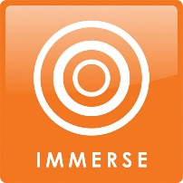 |  | IC watches Rough Sleepers: Homelessness Documentary  CT and TL introduce online game ‘Spent’ about poverty and homelessness. CT leads discussion after game.  IC attends in-person education workshop at The Big Issue Hub in Melbourne, facilitated by an educator and a guest speaker who has experienced homelessness.  Students pick one area of interest:  - Factors influencing homelessness in Melbourne  - Experiences of homeless people in Melbourne  - Strategies to prevent homelessness in Melbourne  - Actions to support homeless people in Melbourne  CT and TL create Inquiry Circles of 4-5 students, based on preferences for areas of interest.  Introduce SLIM Reflection 1  CT and TL check IJs (and conference with students as needed) |  |  | Students respond to 3-2-1 debrief questions in IJ (slide 14)  Students play ‘Spent’, participate in discussions and complete debrief questions (IJs slide 16)  IC attends excursion to The Big Issue in Melbourne  Following the workshop, students complete a KWL chart (IJ slide 18)  Students meet with their IC for the first time and update IJs (slide 20)  Students complete SLIM Reflection 1
 | Resources: Inquiry Journals, YouTube, Spent game, excursion booking, 3-2-1 debrief questions, KWL chart, SLIM Reflection 1
 |  |  | TL shows IC Library collection of physical The Big Issue editions, for students to access.  CT launches Homelessness Web Quest  TL outlines CRAAP Test for use with sources from Web Quest  CT introduces Inquiry Chart 1  TL shows students Digital Resource Guide to help them with exploring different resources, as they fill out their Inquiry Logs.  Inquiry Circle check-in with question prompts (IJ slide 28)  CT asks students to write IJ reflection (using three of these prompts)  CT and TL check IJs (and conference with students as needed) |  |  | Students read The Big Issue editions, noting ideas and areas of interest (IJ slide 23)  Students complete Web Quest  Students use CRAAP test to assess 5 sources used in Web Quest (IJ slide 25)  Students complete Inquiry Chart 1: Brainstorm Keywords  Students fill out Inquiry Logs using Digital Resource Guide  Students discuss ideas in Inquiry Circles  Students pick from Inquiry Journal prompts
 | Resources: Inquiry Journals, The Big Issue editions, Web Quest, Inquiry Chart 1, CRAAP Test, Digital Resource Guide, Inquiry Logs, Inquiry Journal prompts
 |  |  | In Inquiry Circles, students complete Harvard Zero’s Question Starts activity  CT introduces Inquiry Chart 2: Developing a Question  TL and CT model pair activity (Pair and Share Protocol) and then students complete in pairs  TL and CT conference with students to focus inquiry questions  CT prompts students to complete SLIM Reflection 2  CT and TL check IJs |  |  | Participate in Inquiry Circles activity (IJ slide 32)  Students complete Inquiry Chart 2  Pair activity: Pair and Share  Conferencing with TL and CT  Students complete SLIM Reflection 2
 | Resources: Inquiry Journals, Question Starts, Inquiry Chart 2, Pair and Share Protocol, SLIM Reflection 2
 |  |  | TL teaches search strategies using search engines and online databases, and models process (e.g. using key terms). TL also guides students through physical library resources (e.g. non-fiction collection).  TL and CT assist students as they conduct independent research.  TL prompts students to evaluate resources using CRAAP Test  TL shows students SLASA online APA referencing generator and Bibliography Template  CT and TL check IJs (and conference with students as needed) |  |  | Students conduct research, adding to their Inquiry Logs (update research sources to reflect inquiry question focus)  Students use CRAAP Test to evaluate information sources  Students create bibliographies  Inquiry Circles check-in (IJ slide 41)
 | Resources: Inquiry Journals, Inquiry Logs, CRAAP test, search strategies, online referencing generator, bibliography template
 |  |  | CT prompts students to consider answers to their inquiry question  CT explains creative task (students create a multimodal resource communicating research findings with a bibliography)  TL shows students where the resources will be exhibited virtually on Kingsnet  Place students in pairs to give peer feedback  TL and CT facilitate Inquiry Circles feedback session and check IJs  IC holds launch event in the Library to showcase the virtual exhibition of student work on Kingsnet  TL and CT to notify Kingswood College community via email about virtual exhibition, so they can access online |  |  | Students complete Inquiry Chart 3  Information about creative task in IJs (slide 44)  Students create their multimodal resources and bibliographies using Inquiry Logs  Students give each other Praise, Question, Polish (PQP) feedback (IJ slide 45)  Inquiry Circles check-in  Submit multimodal resources and bibliographies to be published online  Attend launch event
 | Resources: Inquiry Journals, Inquiry Logs, Inquiry Chart 3, Kingsnet, peer feedback, Library for showcase event
 | 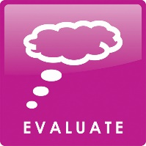 |  | TL and CT lead IC reflection discussion about student experience of inquiry process, how they overcame challenges and strategies for next time.  TL and CT assess students using GID Process Rubric  Culmination conversation with each student. TL and CT refer to assessment rubric, IJs, SLIM Reflections and Self-Reflection on Inquiry |  |  | Students complete SLIM Reflection 3  Students complete Self-Reflection on Inquiry  Students join culmination conversations
 | Resources: Inquiry Journals, Guided Inquiry Design Process Rubric, SLIM Reflection 3, Self-Reflection on Inquiry
Guided Inquiry Design Process Rubric: General Capabilities Elements

Assessment based on: Inquiry Journal, Inquiry Log, SLIM reflection tasks, participation in Inquiry Circles, peer assessment, observation, and conferencing.

General Capabilities Elements |  | Emerging |  | Developing | Proficient |  | Accelerating
Critical and Creative Thinking: Inquiring – identifying, exploring, and organising information and ideas |  | Student suggests questions to investigate issues. Student provides some information when exploring issues. Student begins to analyse information.  1 mark |  | Student poses questions to investigate issues. Student provides information and ideas when exploring issues. Student begins to analyse information and evidence.  2 marks | Student poses questions to investigate complex issues. Student explains information and ideas when exploring issues. Student analyses information and evidence according to criteria such as validity and relevance.  3 marks |  | Student poses insightful questions to investigate complex issues. Student clarifies information and ideas when exploring issues. Student critically analyses information and evidence according to criteria such as validity and relevance.  4 marks
Creative and Creative Thinking: Reflecting on thinking and processes |  | Student begins to reflect on the inquiry process, thinking about decisions. Student demonstrates some capacity to transfer knowledge to other contexts.  1 mark |  | Student reflects on the inquiry process, thinking about strategies and decisions. Student demonstrates some capacity to transfer knowledge to other contexts.  2 marks | Student thoughtfully reflects on the inquiry process, thinking about strategies and decisions. Student demonstrates capacity to transfer knowledge to other contexts.  3 marks |  | Student critically reflects on the inquiry process, evaluating strategies and decisions made. Student demonstrates strong capacity to transfer knowledge to different contexts.  4 marks
Information and Communication Technology: Creating with ICT |  | Student is beginning to use ICT to generate ideas and develop plans. Student designs a multimodal creative output for an audience or purpose.  1 mark |  | Student uses some ICT to generate ideas and develop plans. Student designs a multimodal creative output for an audience and purpose.  2 marks | Student uses appropriate ICT to collaboratively generate ideas and develop plans. Student designs a multimodal creative output for an audience and purpose.  3 marks |  | Student uses highly appropriate ICT to collaboratively generate ideas and develop sophisticated plans. Student designs a multimodal creative output, targeted for an audience and purpose.  4 marks
Overall Marks |  | 1–3 = Emerging |  | 4–6 = Developing | 7–9 = Proficient |  | 10–12 = Accelerating

Rubric descriptors adapted from the Learning Continuum of General Capabilities for Information and Communication Technology, and Critical and Creative Thinking at Levels Four and Five (ACARA, 2015c).

References

Australian Curriculum, Assessment and Reporting Authority. (2015a). Critical and creative thinking capability (Version 8.4). Australian Curriculum. https://www.australiancurriculum.edu.au/f-10-curriculum/general-capabilities/critical-and-creative-thinking/

Australian Curriculum, Assessment and Reporting Authority. (2015b). English content descriptions (Version 8.4). Australian Curriculum. https://www.australiancurriculum.edu.au/f-10-curriculum/english/

Australian Curriculum, Assessment and Reporting Authority. (2015c). General capabilities (Version 8.4). Australian Curriculum. https://www.australiancurriculum.edu.au/f-10-curriculum/general-capabilities/

Australian Curriculum, Assessment and Reporting Authority. (2015d). Geography content descriptions (Version 8.4). Australian Curriculum. https://www.australiancurriculum.edu.au/f-10-curriculum/humanities-and-social-sciences/geography/

Australian Curriculum, Assessment and Reporting Authority. (2015e). Information and communication technology capability (Version 8.4). Australian Curriculum. https://www.australiancurriculum.edu.au/f-10-curriculum/general-capabilities/information-and-communication-technology-ict-capability/

Australian Curriculum, Assessment and Reporting Authority. (2022). School profile. My School. https://www.myschool.edu.au/school/46202
Baker, N., Grantham, C., & Jenkins, S. (2022). Online referencing generator. School Library Association South Australia. https://org.slasa.asn.au/apa/middle

Bonanno, K. & FitzGerald, L. (2015). F-10 inquiry skills scope and sequence and F-10 core skills and tools. Eduwebinar Pty Ltd. https://eduwebinar.com.au/wp-content/uploads/2015/03/curriculum_mapping_scope_sequence_skills_tools.pdf

Catalina, J. (2022). Cool squares presentation theme. Slides Carnival. https://www.slidescarnival.com/titania-free-presentation-template/949

FitzGerald, L. (2015a). Opportunity knocks: The Australian Curriculum and Guided Inquiry. Access, 29(2) 4-17.

FitzGerald, L. (2015b). Guided Inquiry in practice. Scan, 334(4), 16-17.

FitzGerald, L. (2018). Guided inquiry goes global: Evidence-based practice in action. ABC-CLIO, LLC.

FitzGerald, L. (2021). Inquiry learning and the teacher librarian: You can’t have one without the other. Access, 35(3), 16-22.

Flynn, H. (2018). Rough sleepers: Melbourne homelessness documentary [Video]. YouTube. https://www.youtube.com/watch?v=iGnes7PyMuw

Guided Inquiry in Australia. (n.d.). Guided Inquiry Design Scaffolds. Retrieved May 17, 2022 from https://guidedinquiryoz.edublogs.org/guided-inquiry-process/
Kingswood College. (2021). 2020 Community Report. https://www.kingswoodcollege.vic.edu.au/wp-content/uploads/2021/05/2020-Kingswood-College-Annual-report-FINAL.pdf
Kingswood College. (2022a). Kingsnet. https://kingswood.fireflycloud.net.au/

Kingswood College. (2022b). LATTICE. https://www.kingswoodcollege.vic.edu.au/learning/lattice/

Kuhlthau, C. C., Maniotes, L. K., & Caspari, A. K. (2012). Guided inquiry design: A framework for inquiry in your school. ABC-CLIO, LLC.

Kuhlthau, C. C., Maniotes, L. K., & Caspari, A. K. (2015). Guided inquiry: Learning in the 21st Century (2nd ed). Libraries Unlimited.

Launch Housing. (2018). Australian homelessness monitor 2018 [Video]. YouTube. https://www.youtube.com/watch?v=3cE233XvbEY

Loertscher, D. V., Koechlin, C., & Zwaan, S. (2005). Ban those bird units. Hi Willow Research and Publishing.

Lupton, M. (2012). Inquiry skills in the Australian Curriculum. Access, 26(2), 12-18.

Lupton, M. (2014). Inquiry skills in the Australian Curriculum v6: A bird's-eye view. Access, 28(4), 8-29.
Maniotes, L. K., & Kuhlthau, C. (2014). Making the shift. Knowledge Quest. 43(2), 8-17.

McKinney. (2011). Spent [Online Game]. https://playspent.org/

Merga, M. K. (2022). School libraries supporting literacy and wellbeing. Facet Publishing.

Meriam Library. (2010). Evaluating information: Applying the CRAAP test. California State University. https://library.csuchico.edu/sites/default/files/craap-test.pdf

Project Zero. (2019). Question starts. Harvard Graduate School of Education. http://www.pz.harvard.edu/sites/default/files/Question%20Starts_0.pdf

Special Broadcasting Service Learn, & St Vincent de Paul Society New South Wales. (2018). Homelessness in Australia [Online Quiz]. Kahoot. https://create.kahoot.it/share/homelessness-in-australia/2b518aa8-bd6c-42c0-b73f-c657b4016fdd

State Library of Victoria. (2022). Locate information. Ergo. https://ergo.slv.vic.gov.au/learn-skills/research-skills/locate-information

The Big Issue. (2022). Education workshops. https://thebigissue.org.au/our-programs/education/

Appendices

Appendix A: Introductory Lesson Google Slides Presentation

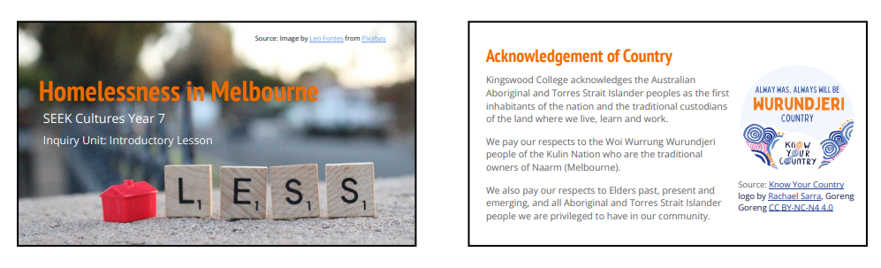
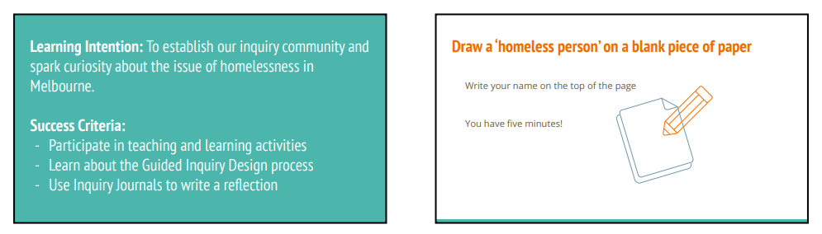

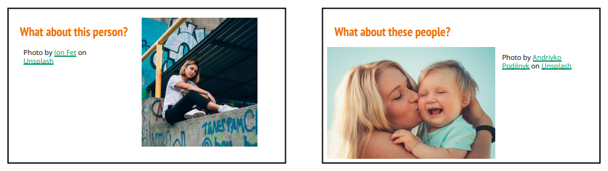
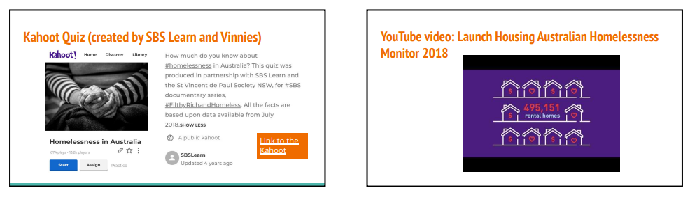
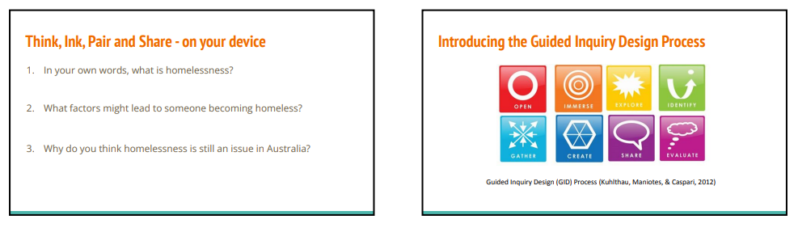
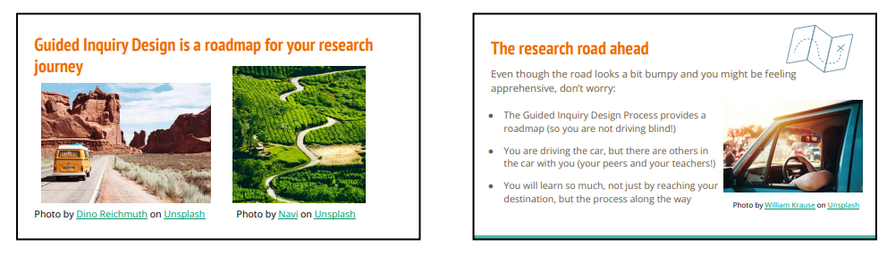
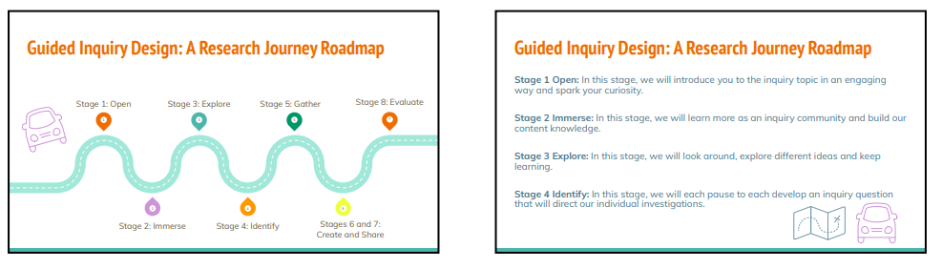
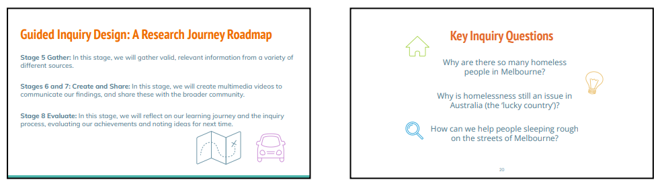
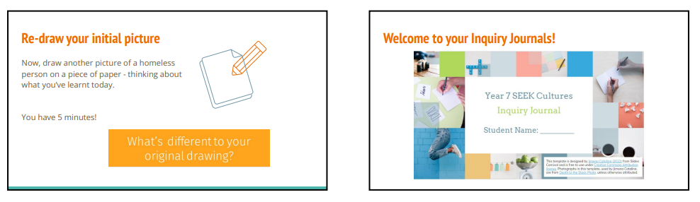
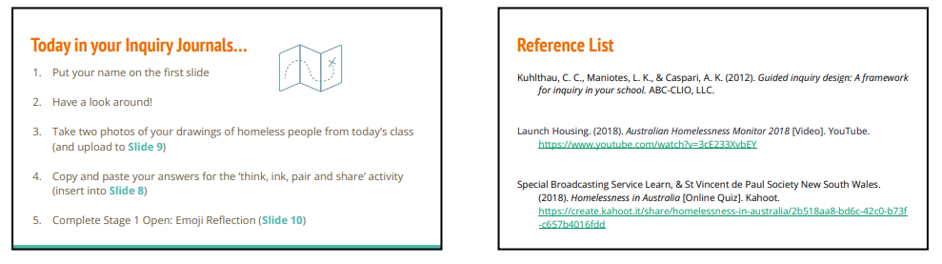

Appendix B: Inquiry Journal Slides

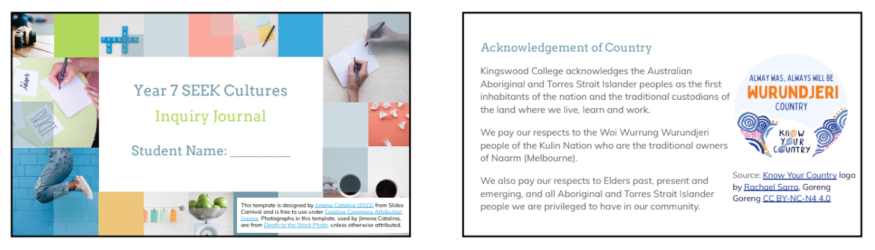
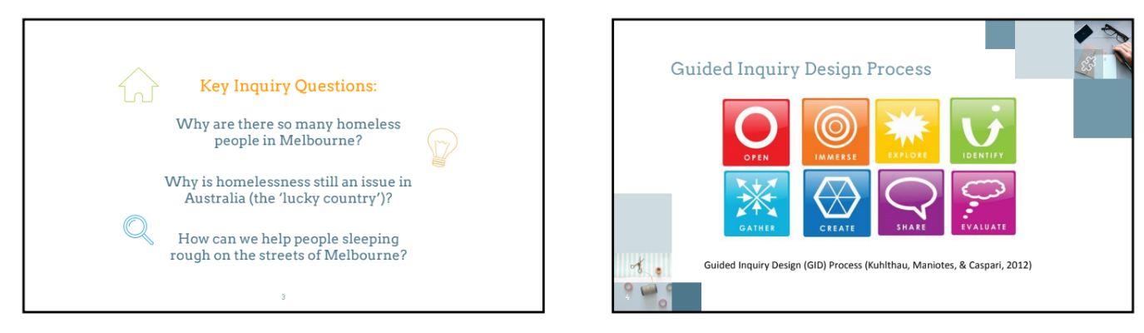
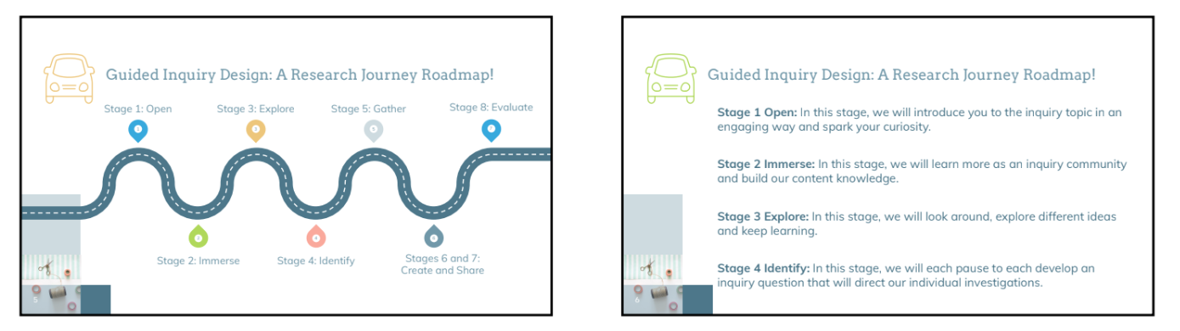
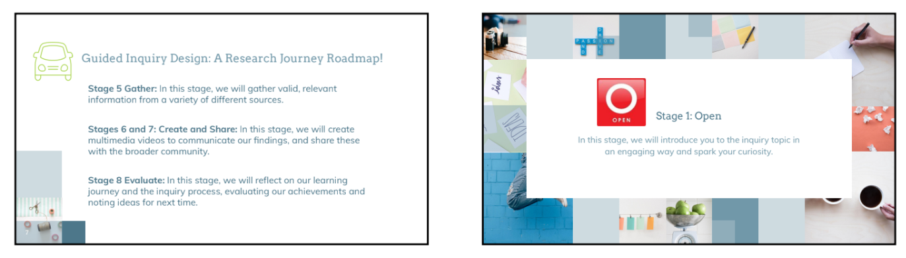
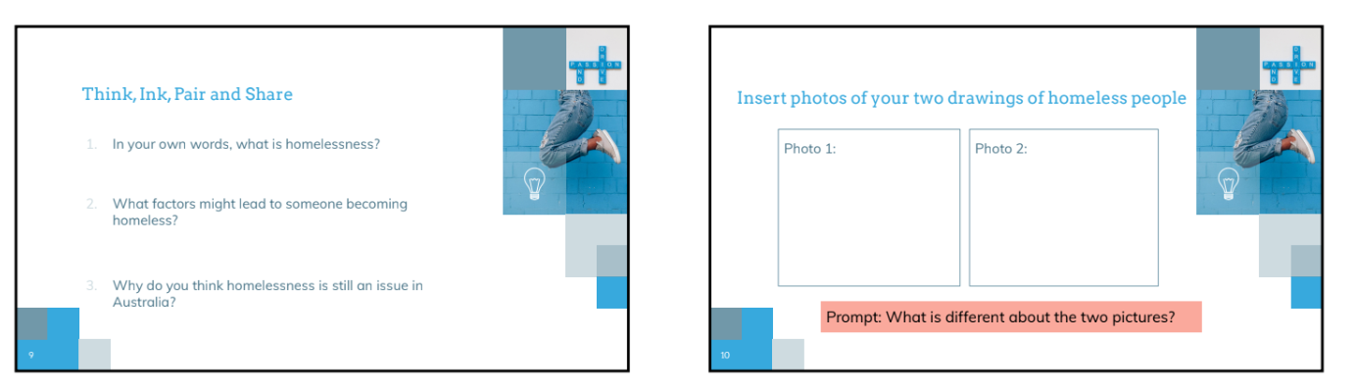
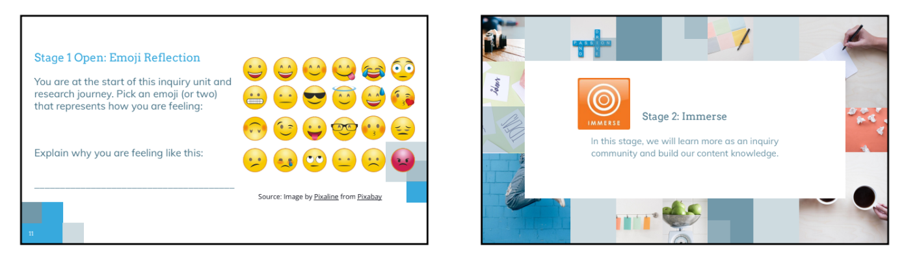
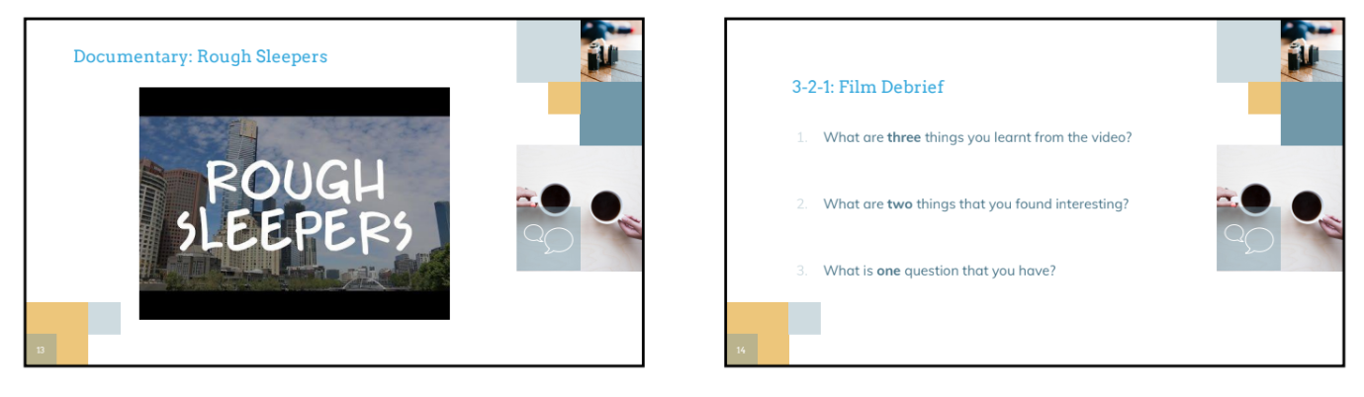
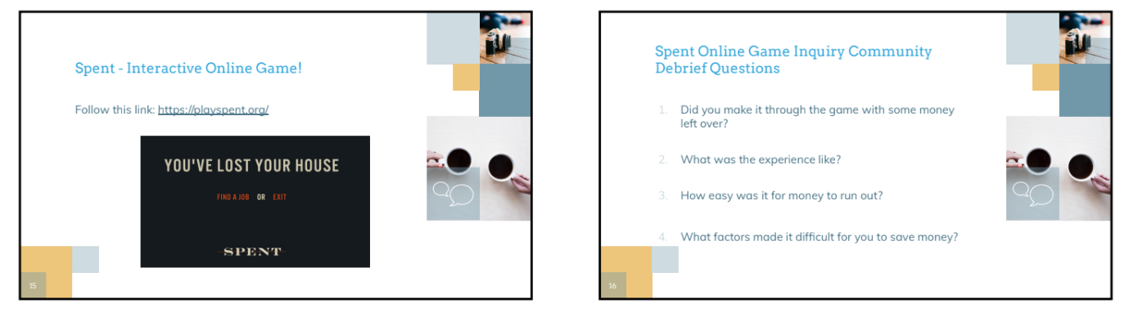
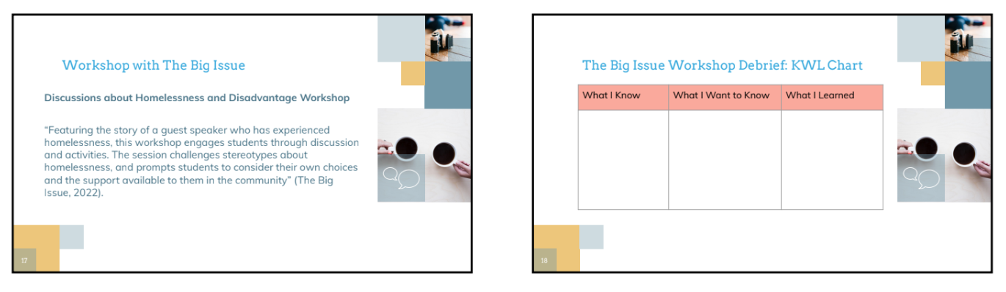
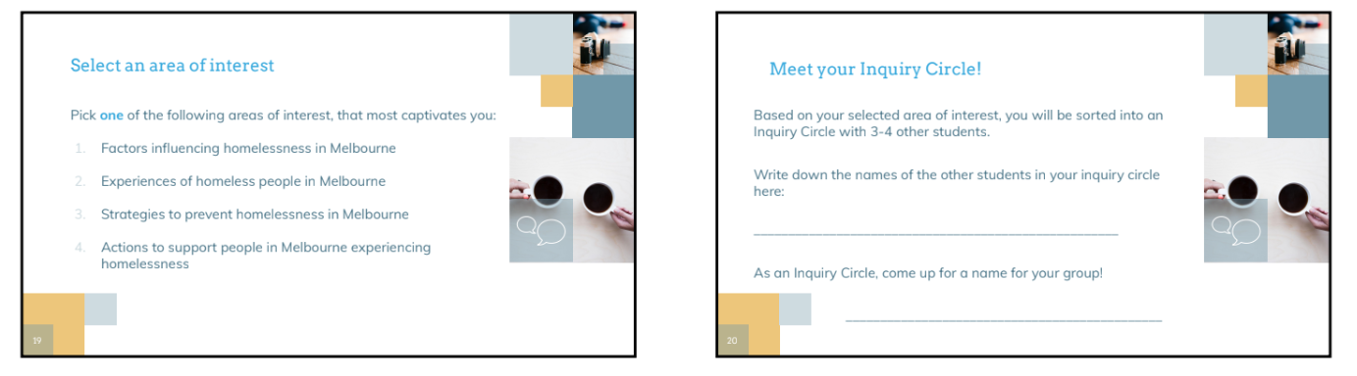
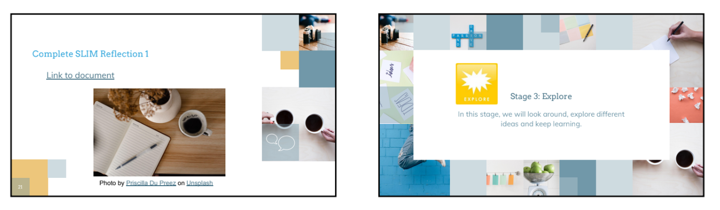
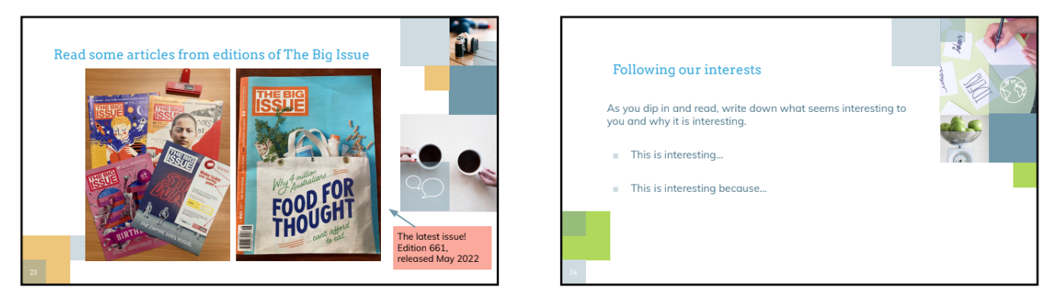
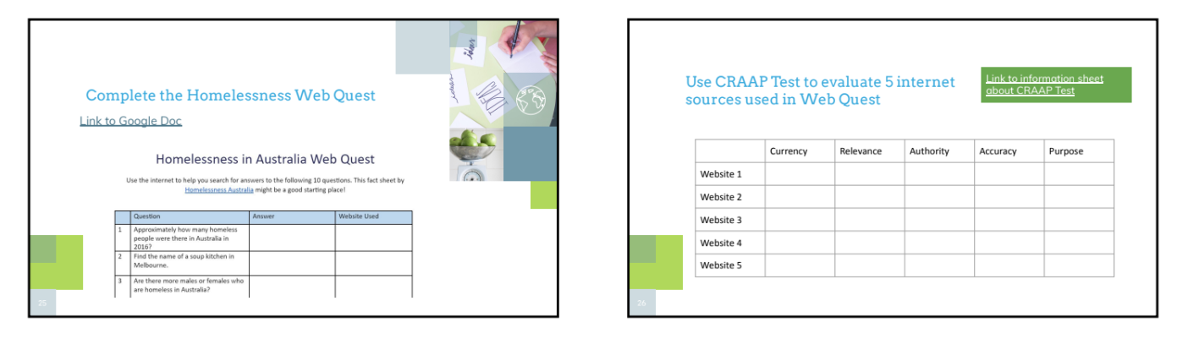
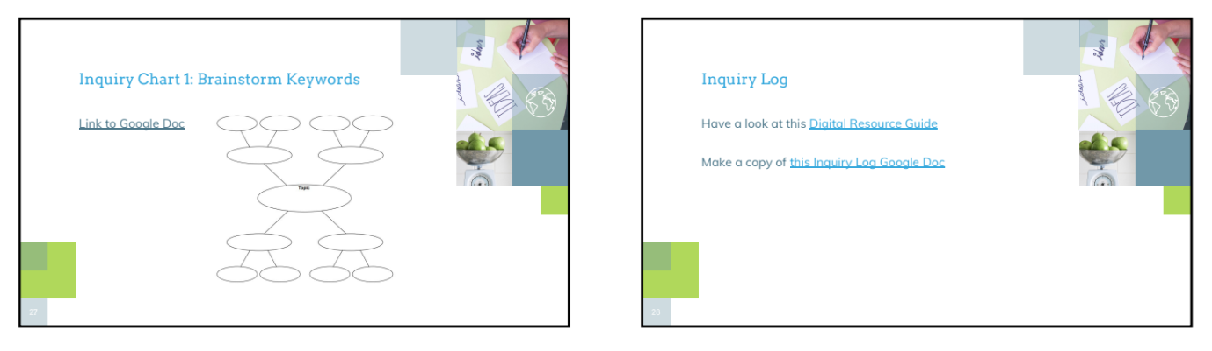
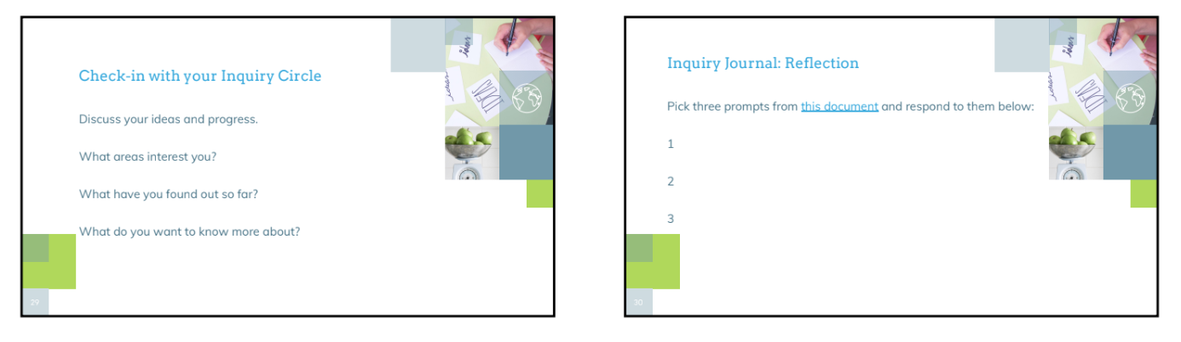
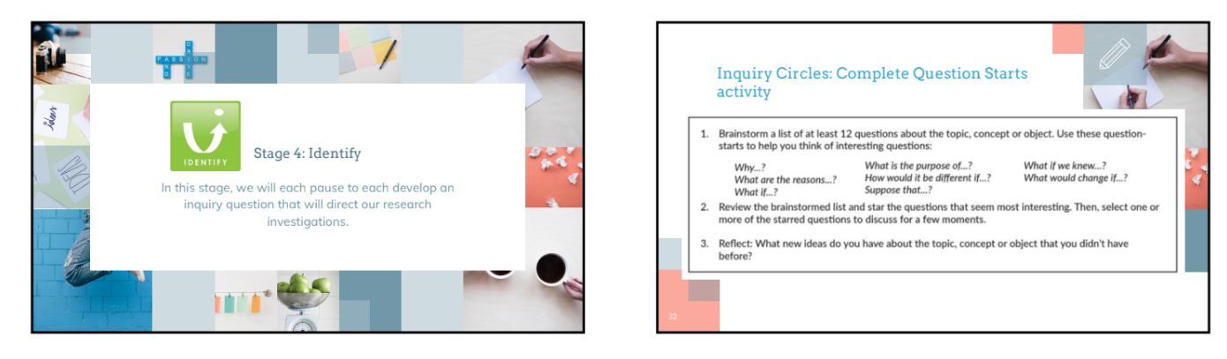
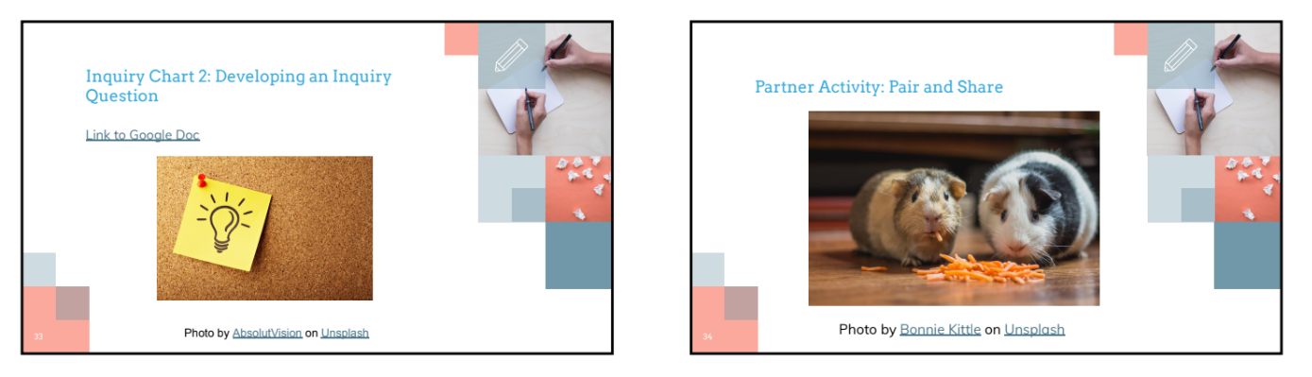
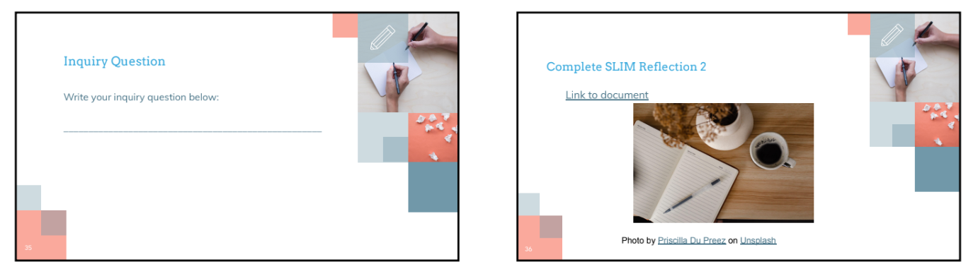
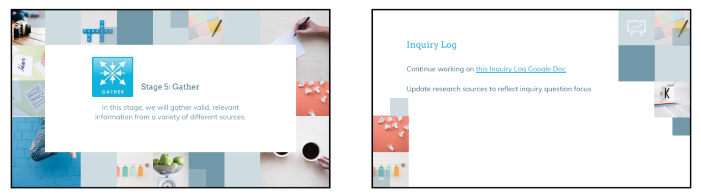
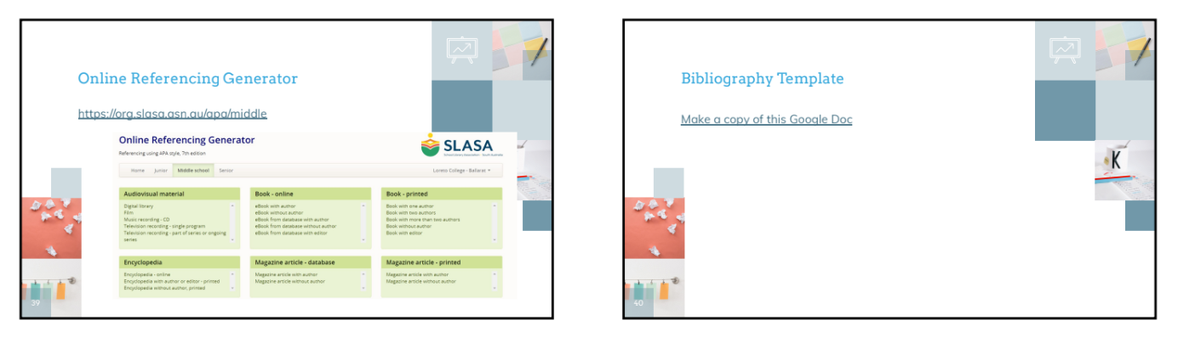
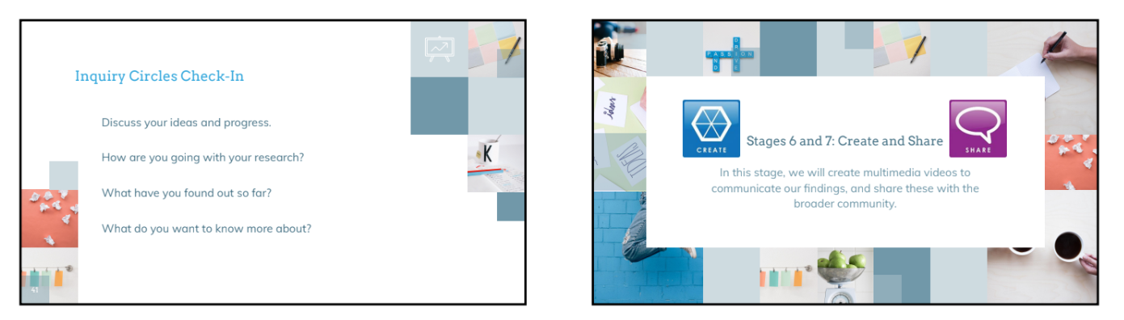
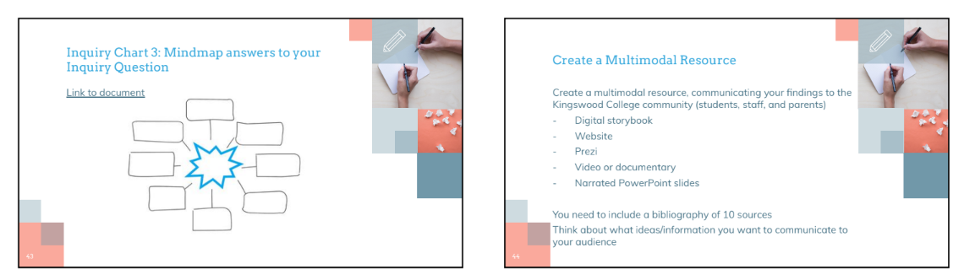
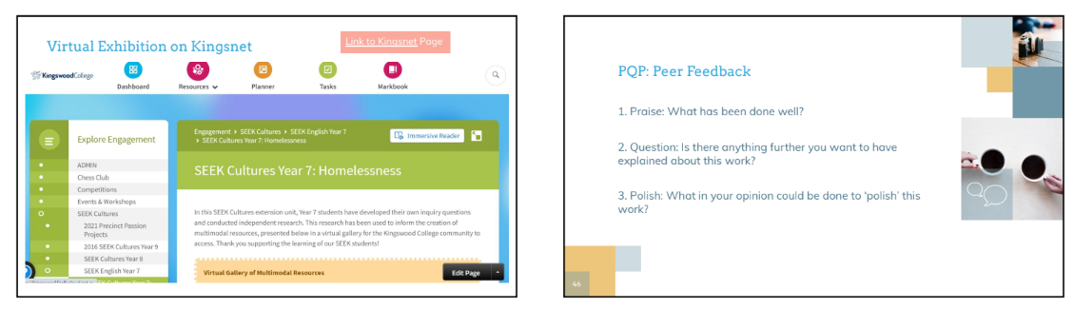
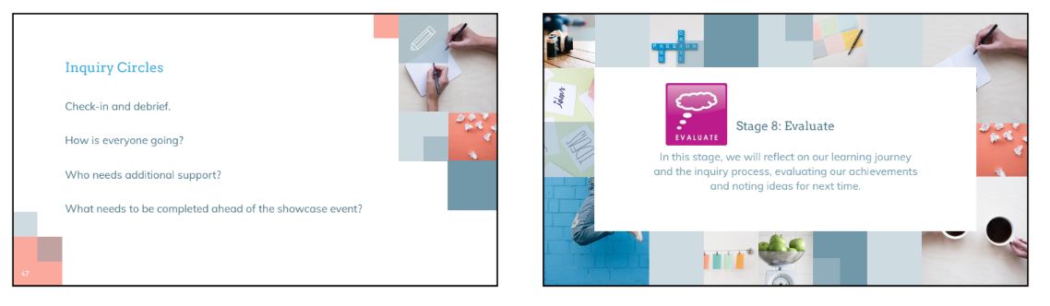
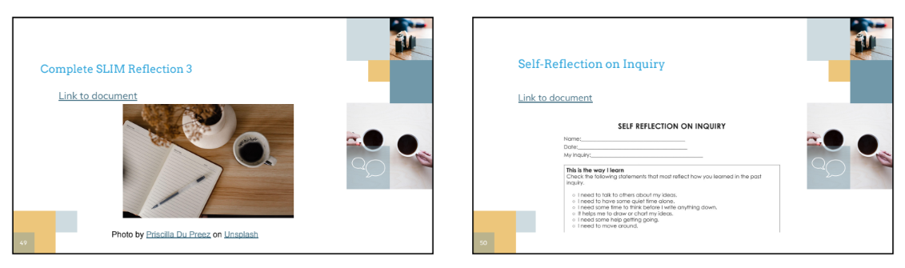

Appendix C: SLIM Reflection 1

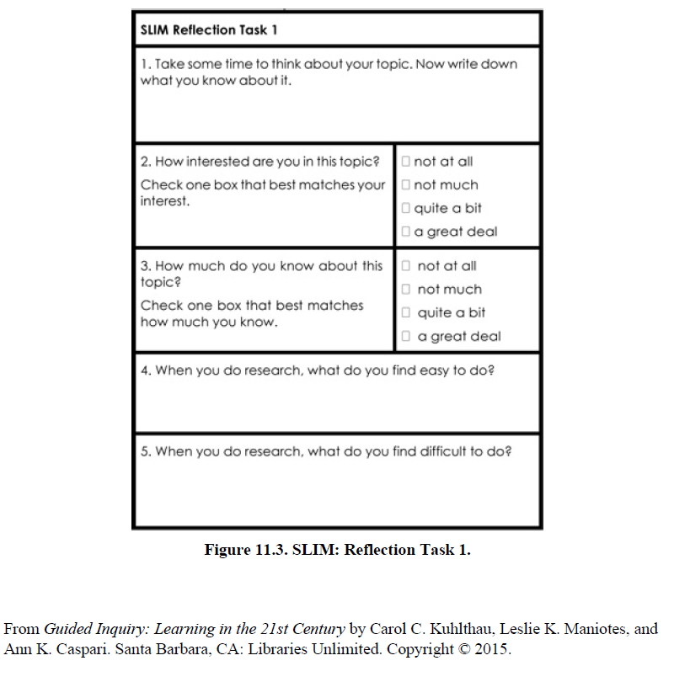

Appendix D: SLIM Reflection 2

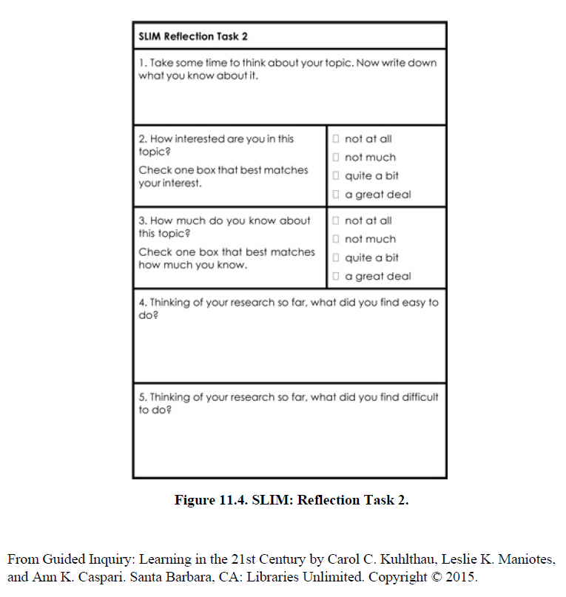

Appendix E: SLIM Reflection 3

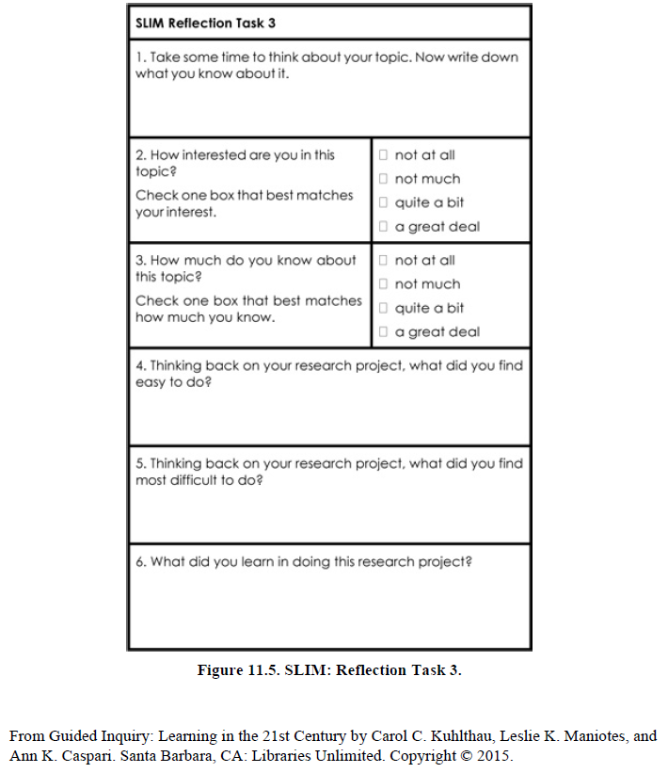

Appendix F: Homelessness Web Quest

Homelessness in Australia Web Quest

Use the internet to help you search for answers to the following 10 questions. This fact sheet by Homelessness Australia might be a good starting place!

 | Question | Answer | Website Used
1 | Approximately how many homeless people were there in Australia in 2016?
2 | Find the name of a soup kitchen in Melbourne.
3 | Are there more males or females who are homeless in Australia?
4 | On any given night, how many people are homeless in Australia?
5 | What is one of the leading causes of youth homelessness?
6 | What is the name of one organisation in Melbourne that supports people experiencing homelessness?
7 | Which state in Australia has the highest rate of homelessness?
8 | What is one reason why people are homeless in Australia?
9 | What is the name of one famous Australian who has experienced homelessness?
10 | What is one thing you could do to help someone who is homeless?

Photo by Jon Tyson on Unsplash

Appendix G: Inquiry Chart 1

Inquiry Chart 1: Brainstorm Keywords

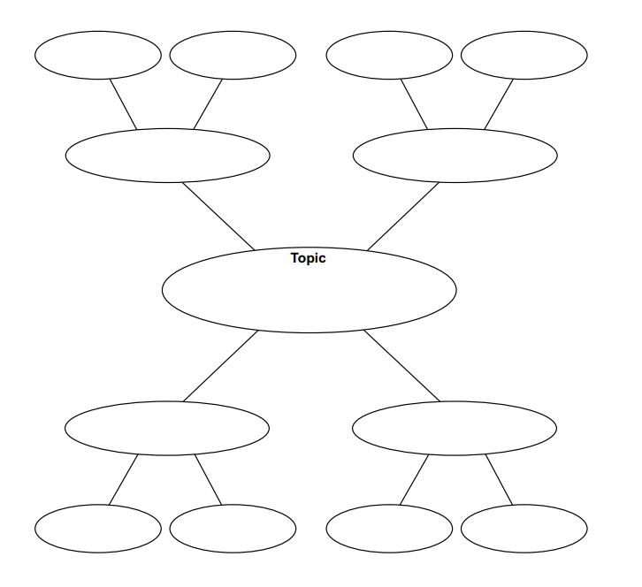

Appendix H: Inquiry Chart 2

Inquiry Chart 2: Developing an Inquiry Question

What I already know about the topic area I am interested in researching | This unit starts off with what you already know about your topic. Please fill that in here.
That’s interesting… | Add to this chart as you find out more. You will then be in a position to think about a question to investigate.
I didn’t know that…

I want to know more about…

My area of special interest is…

This scaffold has been developed from: Loertscher, D. V., Koechlin, C., & Zwaan, S. (2005). Ban those bird units. Hi Willow Research and Publishing.

Appendix I: Inquiry Chart 3

Inquiry Chart 3: Mindmap answers to your Inquiry Question
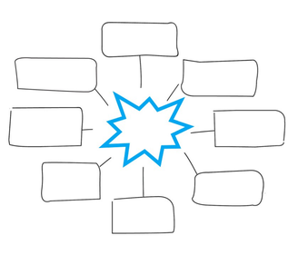

Appendix J: Digital Resource Guide

Digital Resource Guide: Dip in or Go Deep!

Use any of these research links to help you as you fill out your Inquiry Logs, and do your own research!

Mission Australia
https://www.missionaustralia.com.au/what-we-do/ending-homelessness

Launch Housing Resources
https://www.launchhousing.org.au/student-teacher-resources
https://cms.launchhousing.org.au/app/uploads/2019/09/High-School-infographics.pdf

Homeless Australia Resources
https://homelessnessaustralia.org.au/homelessness-resources/
https://homelessnessnsw.org.au/resource/nsw-census-data-and-hnsw-factsheets/

Australian Institute of Health and Welfare: Housing Assistance
https://www.aihw.gov.au/reports-data/health-welfare-services/housing-assistance/overview

SBS Filthy Rich and Homeless Fact Sheets
https://www.sbs.com.au/sites/sbs.com.au.home/files/sbs_learn_frh_homelessness_types_fact_sheet.pdf
https://www.sbs.com.au/sites/sbs.com.au.home/files/cald_fact_sheet_final.pdf

Vinnies CEO Sleepout
https://www.ceosleepout.org.au/

The City of Melbourne: Homelessness Information
https://www.melbourne.vic.gov.au/community/health-support-services/social-support/Pages/homelessness.aspx

Orange Sky Laundry
https://orangesky.org.au/

Ask Izzy website and mobile app
https://askizzy.org.au/

City Futures (UNSW)
https://cityfutures.ada.unsw.edu.au/research/projects/australian-homelessness-monitor-2020/

Appendix K: Inquiry Logs

Inquiry Log: SEEK Cultures Year 7
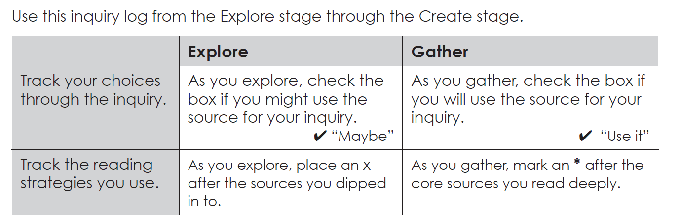

Cite all your sources in the table below:

 | Source Citation | Maybe  ✔ | Notes:  What makes it useful? | Use it  ✔
 |  | Dip in  x |  | Go deep *
1
2
3
4
5
6
7
8
9
10

From Guided Inquiry Design: A Framework for Inquiry in Your School by Carol C. Kuhlthau, Leslie K. Maniotes, and Ann K. Caspari. Santa Barbara, CA: Libraries Unlimited. Copyright © 2012.

Appendix L: Inquiry Journal Prompts

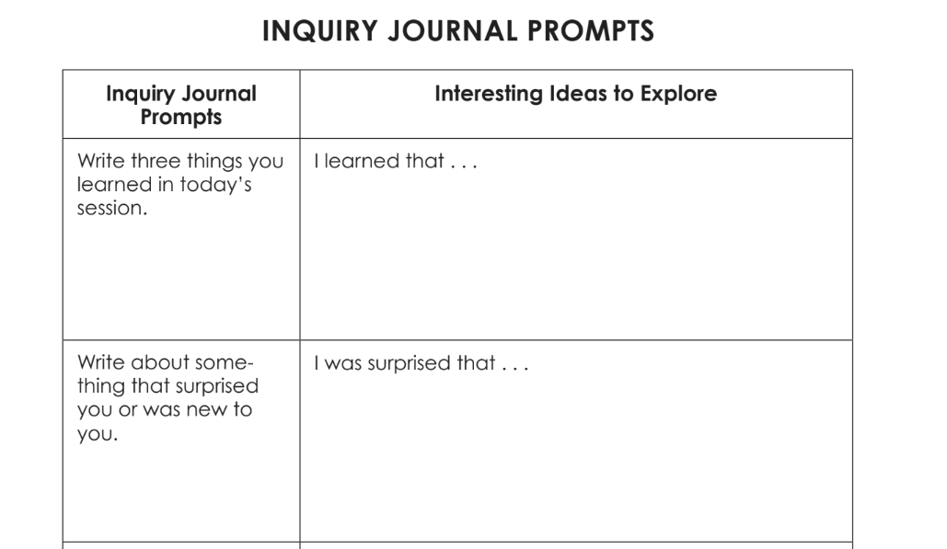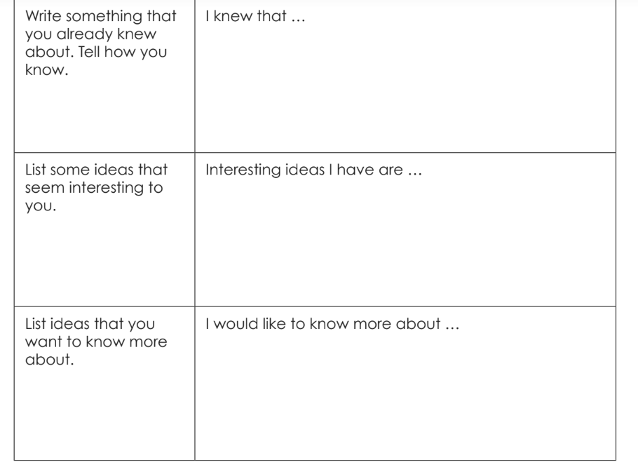
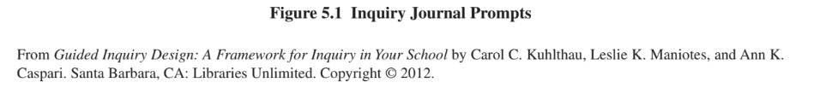

Appendix M: Project Zero Question Starts

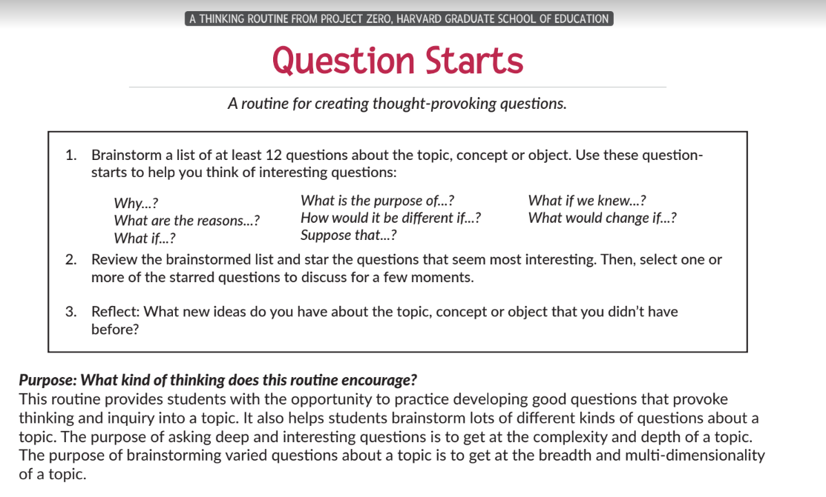
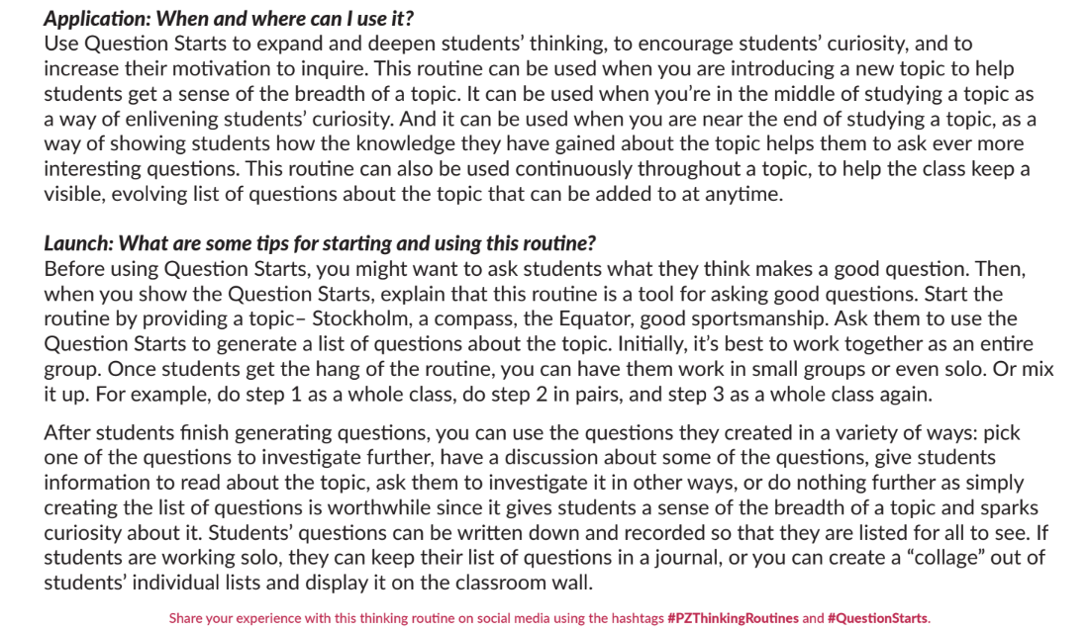
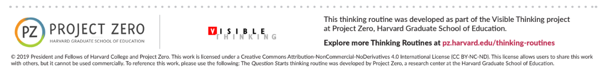

Appendix N: Pair and Share Protocol
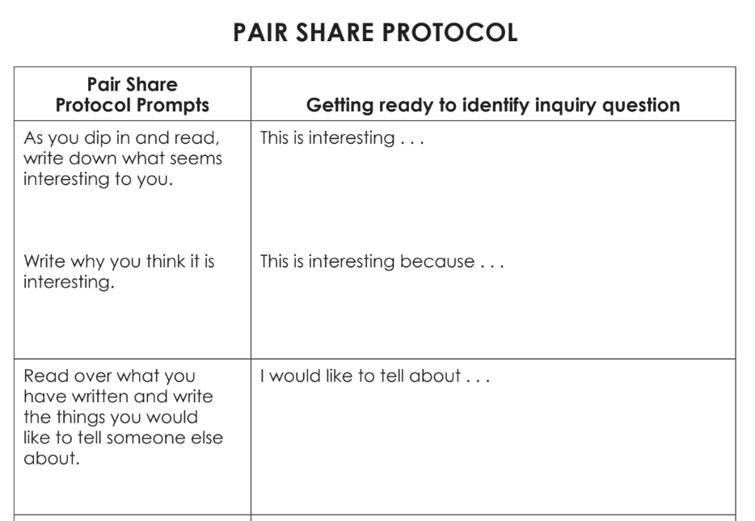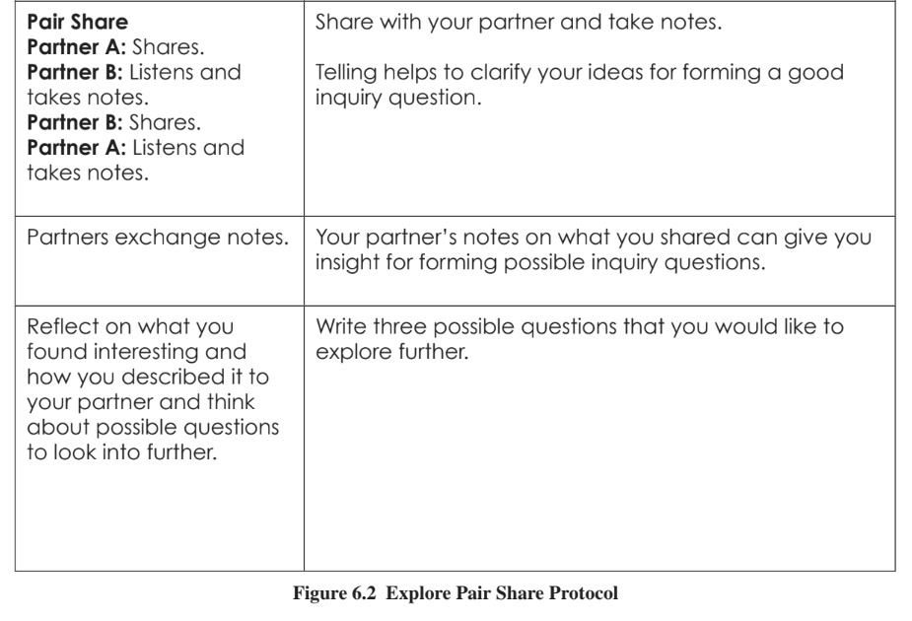

Appendix O: Applying the CRAAP Test

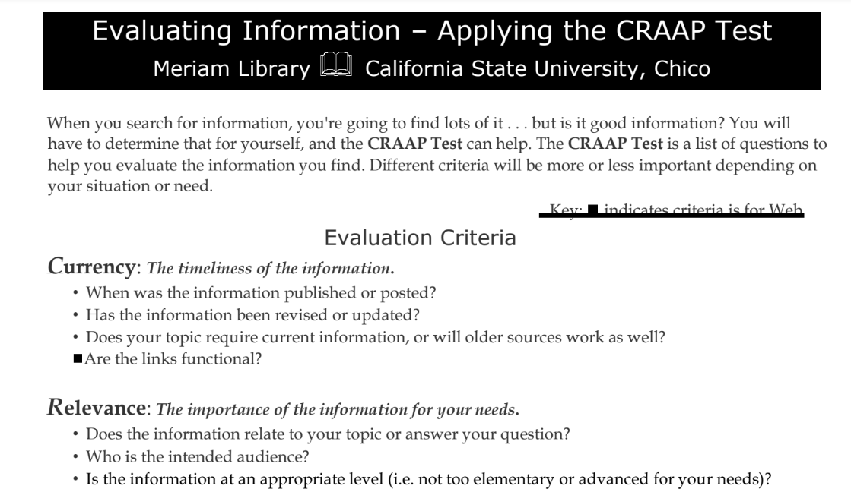
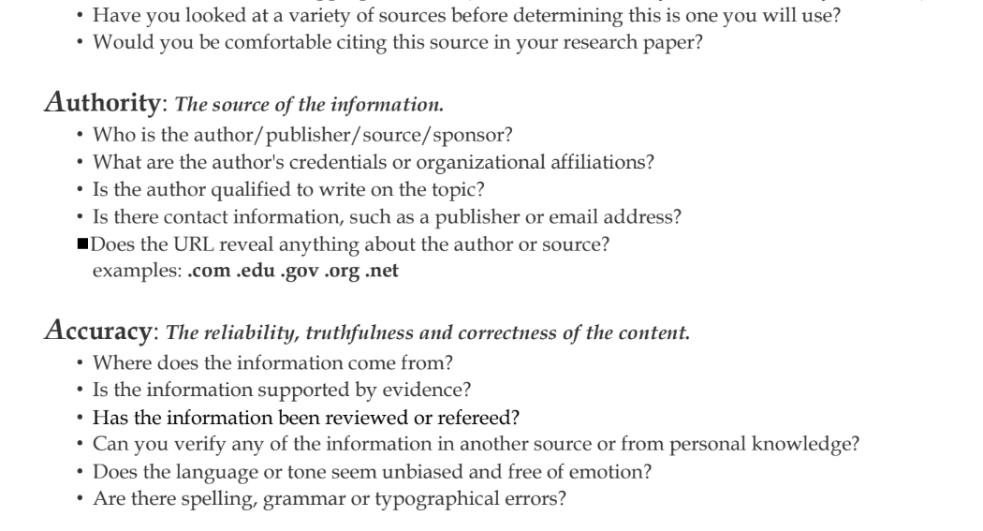
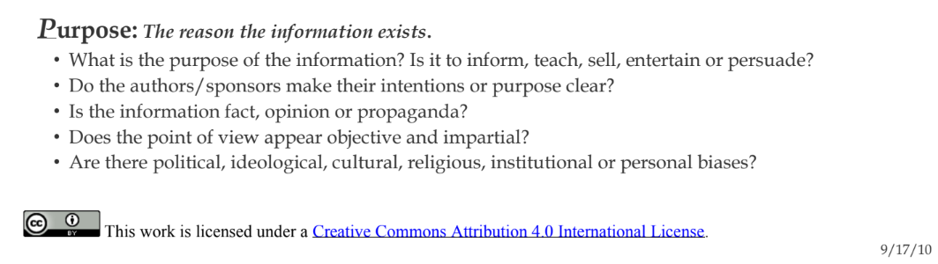

Appendix P: Bibliography Template

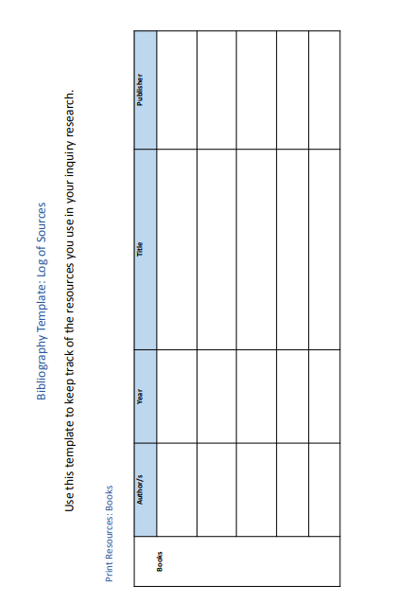
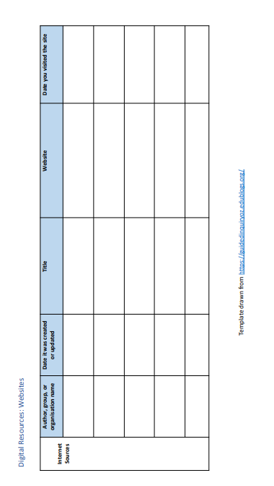

Appendix Q: Student Reflection on Inquiry

